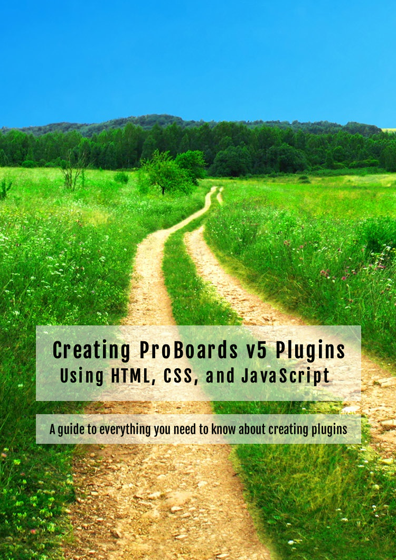

Credits

Author

Peter
https://github.com/PopThosePringles
https://pixeldepth.net

I want to say thanks to the following people who offered their valuable time to help with the book.

Elli

http://ellimccale.com
http://ebbymac.tumblr.com

Luv

http://townsquareexiles.boards.net

Pastuleo

Patrick Clinger

http://www.patrickclinger.com
https://proboards.com

Tinselled Loki
Plugin Files and Code

You can get all the sample code and plugin files from the GitHub repository below.

https://github.com/PopThosePringles/ProBoards-Book

ProBoards

ProBoards is a registered trademark of ProBoards, Inc. and is used with permission.

https://proboards.com

Images Used

The images used in the example plugins are from Kenny.

http://kenney.nl

Front cover photo is from Pexels.

https://pexels.com

Support / Questions

If you need help or have questions, please visit the ProBoards Support forum and post a thread.

http://support.proboards.com

Table of Contents
Chapter 1: Plugin Basics 1
Admin Control Panel 2
Plugin Editor 4
Settings 5
Components 8
JavaScript 8
CSS 10
Global Header & Footer 10
Main Header & Footer 11
Category Header & Footer 12
Board Header & Footer 13
User Interface 14
Images 15
Keys 15
Export 16
JavaScript Plugin Basics 20
Chapter 2: UI Components 24
UI Tab 25
Author Tools 26
Field 28
Text Area 32
Color Field 33
Selection 35
Sortable List 38
Image Select 42
Forum Search 47
Key Permissions 50
Code Box 51
Auto Form 53
Default Values 58
Chapter 3: Keys 61
Key Setting Guideline 62
Key Sizes 62
Key Types 63
JavaScript Key Basics 64
Key API 65
Get 65
Set 66
Set On 68
Append 69
Decrement 70
Increment 72
Pop 72
Prepend 74
Push 74
Shift 76
Unshift 76
Can Read 78
Can Write 78
Type 79
Callbacks 80
Chapter 4: Pet Picker 83
Creating The Plugin UI 84
Breaking It Down 87
JavaScript Plugin Template 87
Fleshing Out 89
Profile Button 91
Who Can See The Button 91
Creating A New Button 92
Creating The Dialog 94
Building The Dialog HTML & CSS 97
Saving Pet Name & Selection 100
Setting The Dialog Defaults 102
Adding Pet To Mini Profiles 104
Mini Profile Routes 104
Fetching Mini Profiles 105
Handling Page Change 109
Final JavaScript 110
Final CSS 114
Chapter 5: ProBoards API 117
Data 118
Page 120
Board 120
Category 122
Member 122
Thread 123
User 125
Events 127
Text 128
Capitalize 129
Escape HTML 129
Mono 129
NBSP 129
New Lines 2 BR 129
Window 129
Alert 130
Confirm 130
Error 131
Chapter 6: Additional Topics 133
Yootil 134
ECMAScript 6 134
Security 134
Common Mistake 135
Solutions 136
Stale Key Data 137
User To User 137
Owner Data 138
Syncing Owner Data 138
Sync Class 139
Route Caching 141
ProBoards JavaScript Style 141
Conclusion 142

What this book covers

This book covers everything you need to know to make ProBoards version 5 plugins from start to finish. You will learn what all the UI components do, how they work, and how to interact with them using the ProBoards JavaScript API.

In chapter 4, you will be walked through the full build process of a plugin from start to finish.

This book will not teach you HTML, CSS, JavaScript, or jQuery; however, some things may get explained if I feel it is needed. A solid understanding of JavaScript is recommended.

Throughout this book the browser console will be used, so it’s advised to understand how to open the console and view the log output area. In most browsers this is F12.

What you need for this book

- Web Browser (e.g., FireFox, Chrome)
- ProBoards forum to test your plugins
- An editor to write your code (e.g., Notepad, IntelliJ)
- Basic HTML knowledge
- Basic CSS knowledge
- Good JavaScript knowledge
- Basic jQuery knowledge

Who this book is for

Do you want to create plugins for the community, or maybe have a fantastic idea for a new feature for your members? Maybe you have already written some plugins but are struggling to progress into larger and complicated ones? If so, then this book gives you everything you need to create and improve your plugins.

This book will assume you have basic HTML, CSS, and jQuery knowledge, and a good understanding of the JavaScript language.

This book is not really aimed at beginners who have never written JavaScript before.

Conventions

This book will have a few different styles of text to distinguish between different kinds of information. Below are some examples of what these will be.

Any blocks of code will appear in a style such as:

var title = "hello world";

Any elements, variables, functions, methods, or properties used in text will be shown as follows:

"We will use the isArray method to determine whether my_items is an Array."

Anything important will be bold just like this.

 | Any warnings will appear like this with a warning icon before it.

 | Any tips or tricks will appear like this with a light bulb icon before it.

ProBoards

ProBoards was founded and is owned by Patrick Clinger.

"ProBoards is a free, remotely hosted message board service that facilitates online discussions by allowing people to create their own online communities"

Source: https://en.wikipedia.org/wiki/ProBoards

ProBoards is a registered trademark of ProBoards, Inc. and is used with permission.

https://proboards.com

I’ve been an active member of ProBoards since February, 2002. I owe a lot to Patrick Clinger and the ProBoards’ community. Without them, I doubt I would be undertaking this project or even be a programmer.

I started learning JavaScript in 2002 because I needed to change something on a forum. It was said to be impossible at the time, as modding with JavaScript was in its very early days. I stuck with it, helped out in the community, and here I am today sharing what I know.

HTML

"HyperText Markup Language (HTML) is the standard markup language for creating web pages and web applications. With Cascading Style Sheets (CSS), and JavaScript, it forms a triad of cornerstone technologies for the World Wide Web. Web browsers receive HTML documents from a web server or from local storage and render them into multimedia web pages. HTML describes the structure of a web page semantically and originally included cues for the appearance of the document. "

Source: https://en.wikipedia.org/wiki/HTML

Having basic HTML knowledge will help when you want to inspect elements on the page. You will be looking at elements on the page we can target via JavaScript, or elements that you have created yourself and added to the page from within your own plugin.

All HTML can be created with a plugin. This is my preferred method for the examples in this book. However, for big chunks of HTML, it would be better to use the global / main header & footer components.

CSS

"Cascading Style Sheets (CSS) is a style sheet language used for describing the presentation of a document written in a markup language. Although most often used to set the visual style of web pages and user interfaces written in HTML and XHTML, the language can be applied to any XML document, including plain XML, SVG and XUL, and is applicable to rendering in speech, or on other media. Along with HTML and JavaScript, CSS is a cornerstone technology used by most websites to create visually engaging webpages, user interfaces for web applications, and user interfaces for many mobile applications."

Source: https://en.wikipedia.org/wiki/Css

Having basic CSS knowledge will help when you want to style certain elements created by your plugin. Having this knowledge will also help you when getting a reference to specific elements on the page (e.g., selectors) using JavaScript and jQuery.

JavaScript

"JavaScript is a high-level, dynamic, untyped, and interpreted programming language. It has been standardized in the ECMAScript language specification. Alongside HTML and CSS, JavaScript is one of the three core technologies of World Wide Web content production; the majority of websites employ it, and all modern Web browsers support it without the need for plug-ins. JavaScript is prototype-based with first-class functions, making it a multi-paradigm language, supporting object-oriented, imperative, and functional programming styles. It has an API for working with text, arrays, dates and regular expressions, but does not include any I/O, such as networking, storage, or graphics facilities, relying for these upon the host environment in which it is embedded.

Although there are strong outward similarities between JavaScript and Java, including language name, syntax, and respective standard libraries, the two are distinct languages and differ greatly in their design. JavaScript was influenced by programming languages such as Self and Scheme."

Source: https://en.wikipedia.org/wiki/Javascript

To understand how plugins are created, you need a good understanding of the JavaScript language. You do not need to be an expert of the language to use this book. However, some example JavaScript may become more complex and will not have a deep explanation.

jQuery

"jQuery is a cross-platform JavaScript library designed to simplify the client-side scripting of HTML. jQuery is the most popular JavaScript library in use today, with installation on 65% of the top 10 million highest-trafficked sites on the Web. jQuery is free, open-source software licensed under the MIT License.

jQuery's syntax is designed to make it easier to navigate a document, select DOM elements, create animations, handle events, and develop Ajax applications. jQuery also provides capabilities for developers to create plug-ins on top of the JavaScript library. This enables developers to create abstractions for low-level interaction and animation, advanced effects and high-level, themeable widgets. The modular approach to the jQuery library allows the creation of powerful dynamic web pages and Web applications."

Source: https://en.wikipedia.org/wiki/Jquery

jQuery is the library used by ProBoards. Without knowledge of this library, things may appear confusing to you, so it’s recommended to have some basic knowledge.

ProBoards v5 is using jQuery 1.7.2

To check which version is running on the page you can run $.fn.jquery in the console.

jQuery 1.7 API Documentation: https://api.jquery.com/category/version/1.7/

jQuery UI

"jQuery UI is a collection of GUI widgets, animated visual effects, and themes implemented with jQuery (a JavaScript library), Cascading Style Sheets, and HTML."

Source: https://en.wikipedia.org/wiki/JQuery_UI

jQuery UI will come in handy when you want to add additional components to the front end of your plugin (e.g., Dialogs), which you will see later on in this book.

ProBoards v5 is using jQuery UI 1.8.13

To check which version is running on the page you can run $.ui.version in the console.

jQuery UI 1.8 API Documentation: https://api.jqueryui.com/1.8/

ECMAScript

"ECMAScript (or ES) is a trademarked scripting-language specification standardized by Ecma International (European Computer Manufacturers Association) in ECMA-262 and ISO/IEC 16262. It was based on JavaScript, which now[when?] tracks ECMAScript. Coders commonly use ECMAScript for client-side scripting on the World Wide Web, and it is increasingly being used for writing server applications and services using Node.js. Other implementations of ECMAScript include JScript and ActionScript."

Source: https://en.wikipedia.org/wiki/ECMAScript

If you are confused, don’t worry. The first five chapters will focus on ECMAScript 5. As much as I would love to write all the examples using the latest edition of ECMAScript, this would mean I would have to explain transpiling and possibly provide a guide. The reason I included this section, is for those that may be wondering why I am not using ES 6.

For those curious about ES 6 and using a transpiler or want to learn more, see below.

https://babeljs.io

Useful Links

- http://proboards.com (register your own forum to test your plugins)
- http://support.proboards.com (need help?)
- https://www.proboards.com/developer/js/ (API documentation)
- https://www.proboards.com/developer-guidelines (guidelines for developers)
- https://developer.mozilla.org (lots of guides and documentation)
- https://github.com (share your code)
- https://discordapp.com/invite/EUKdFVG (come chat with us)

Chapter 1: Plugin Basics

Plugins prior to ProBoards v5 were known as "mods". They were simply scripts that the user would have to copy and paste into a headers or footers in the admin interface. This caused many issues for the users and the people creating these mods. Users would tend to try and modify the scripts, or make mistakes when modifying the options available to the user. Creating an admin UI to allow for easy updating was not the simplest task for most mod authors.
ProBoards v5 gave us the Plugin Editor. It is very easy to create a UI with various components, and sharing plugins with the community became a lot easier with the functionality to export to the Library or desktop. On top of this, ProBoards also included keys, which allows for data to be persistently stored.
This chapter will take you through creating a plugin from start to finish. This plugin will not do anything. The goal is to understand how to create a plugin, and export it. We will not discuss any of the UI components that we can add to our plugin until the next chapter.

Admin Control Panel
Maybe you are completely new to plugins and have not explored the Admin Control Panel, so let’s take a quick look at how we can get to the plugin section.
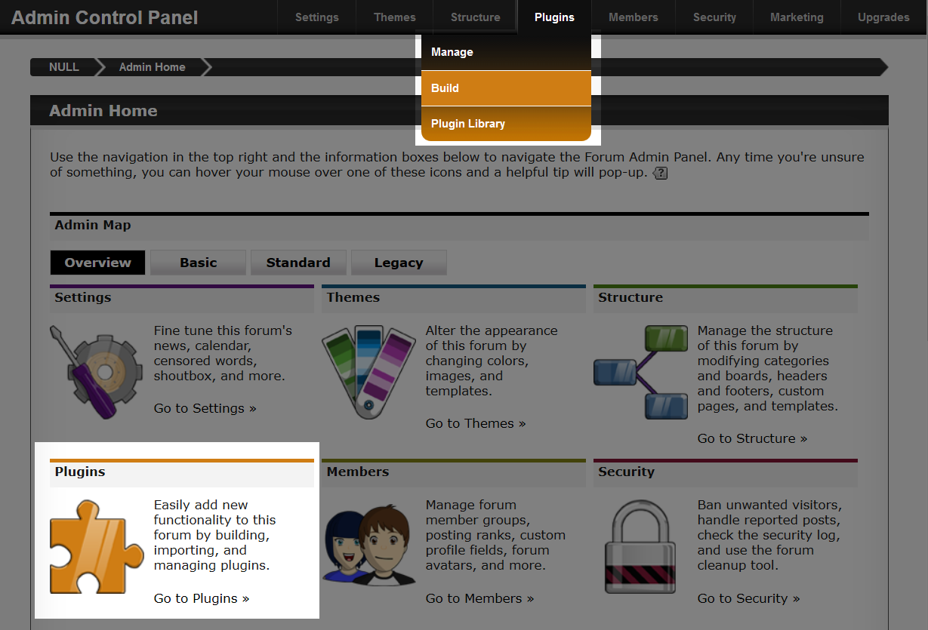
From the home page of the Admin Control Panel, you can see two sections highlighted in the image above. In the navigation at the top we have a drop down menu called "Plugins", we can choose between three options.
- Manage
This is where we will manage plugins that have been installed and created.
- Build
This is where we will manage plugins that are buildable, and where we will start when creating a new plugin.
- Plugin Library
This is where we can install / download plugins created by other authors.
The bottom highlighted section in the image provides us with the same options, just with a different way of presenting it.
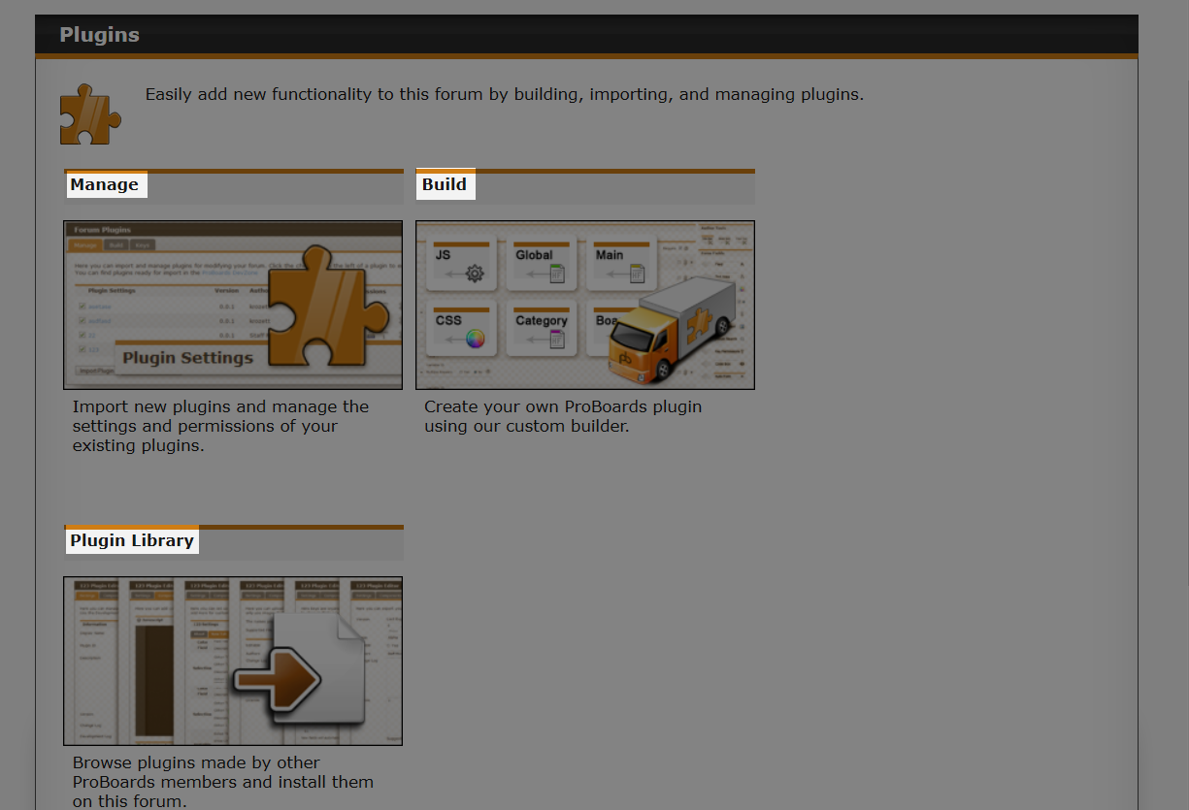
We want to create a new plugin, so let’s click the "Build" option, either from the navigation menu, or from the plugin page. This will take us to another page that allows us to view plugins we can edit, various statistics, quick access to the "Manage" and "Keys" tabs, and most importantly, an option to create a new plugin.
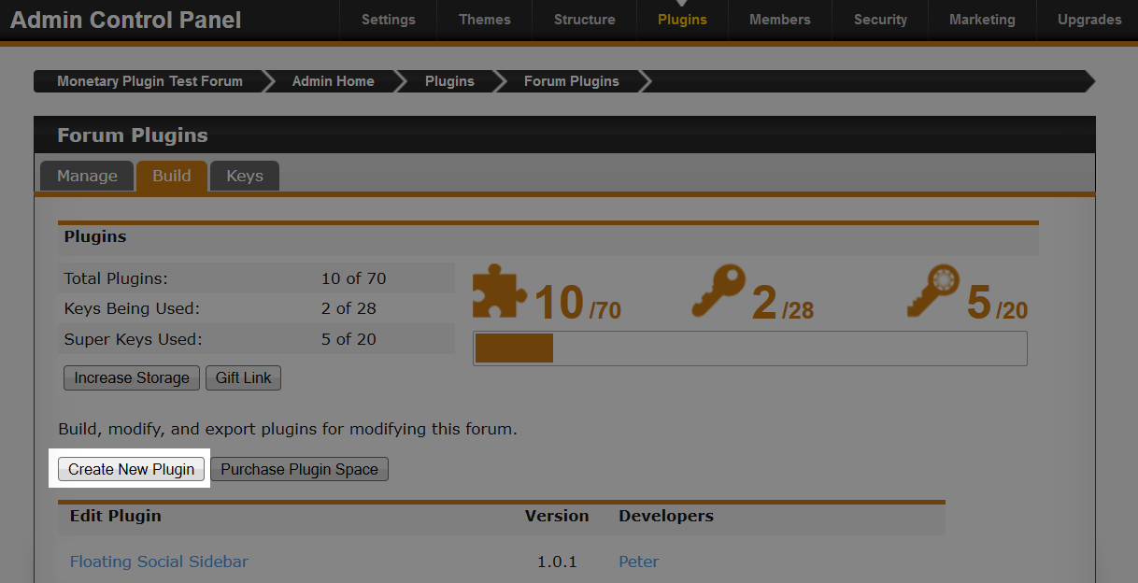
In the image above you can see a button called "Create New Plugin", click on it.
Once clicked, the "Create New Plugin" dialog appears that contains some fields and a couple of buttons.
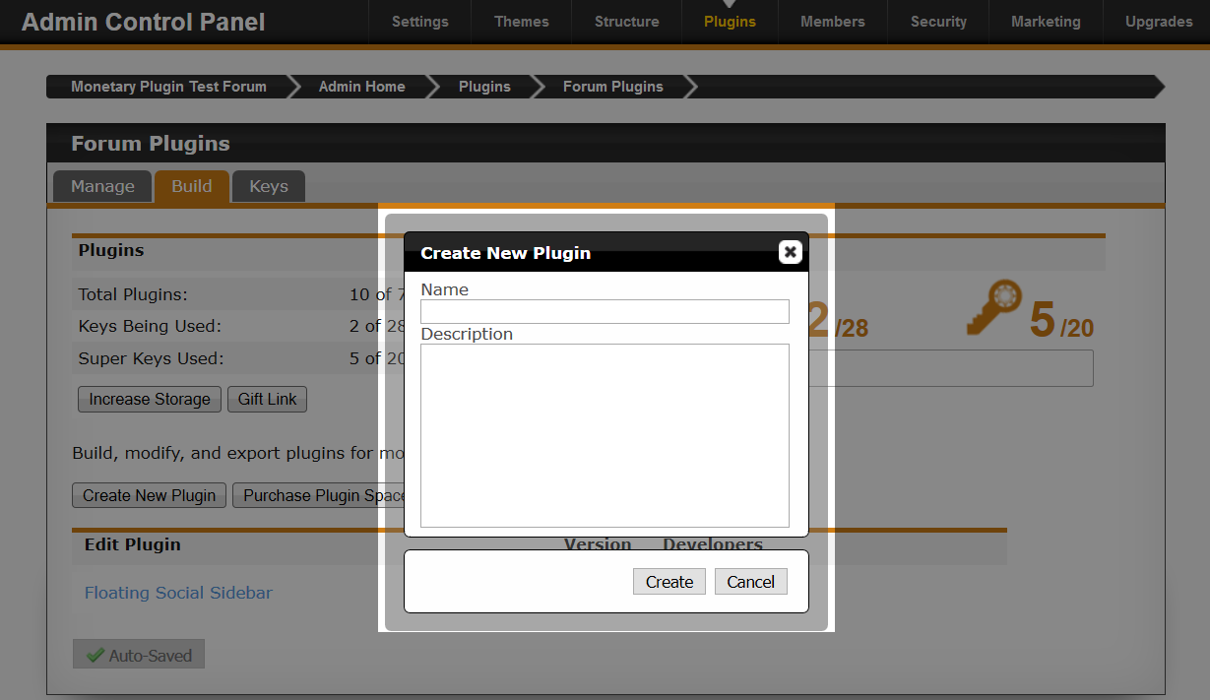
The first field, "Name" is for the name of your plugin that gets displayed to the user. The first 30 characters of this value is also used as the plugin ID.
Try and give your plugin a name that identifies what it does. For example; "Add Images to Posts" vs "Add Images".

The second field, "Description" is where you would explain what your plugin does, maybe include a feature list, and any special instructions on how to install or use it.
The name and description fields can be changed anytime. Once you are happy with what you have entered, click the "Create" button.

Plugin Editor
After clicking the "Create" button, you will come to a page that has quite a few fields. Most things on the page are self explanatory, but we will cover everything.
We will work our way through each tab that is seen, but at the end, try and have a little play by yourself. Click things, see what they do. Don’t worry about making mistakes, it’s your plugin, you can easily delete it and create a new one if needed.
Some tabs in the editor do not auto save when something has changed. Keep aware of this when we jump into components and UI later.

Settings
The settings tab is where you mange your plugin. You can change various things on this tab, from plugin name, to permissions. So let’s take a closer look at each option available.
In this first image we will look at the "Display Name", "Plugin ID", "Description", "Version", and "Stage".
The "Settings" tab will auto save for you when it detects a change.

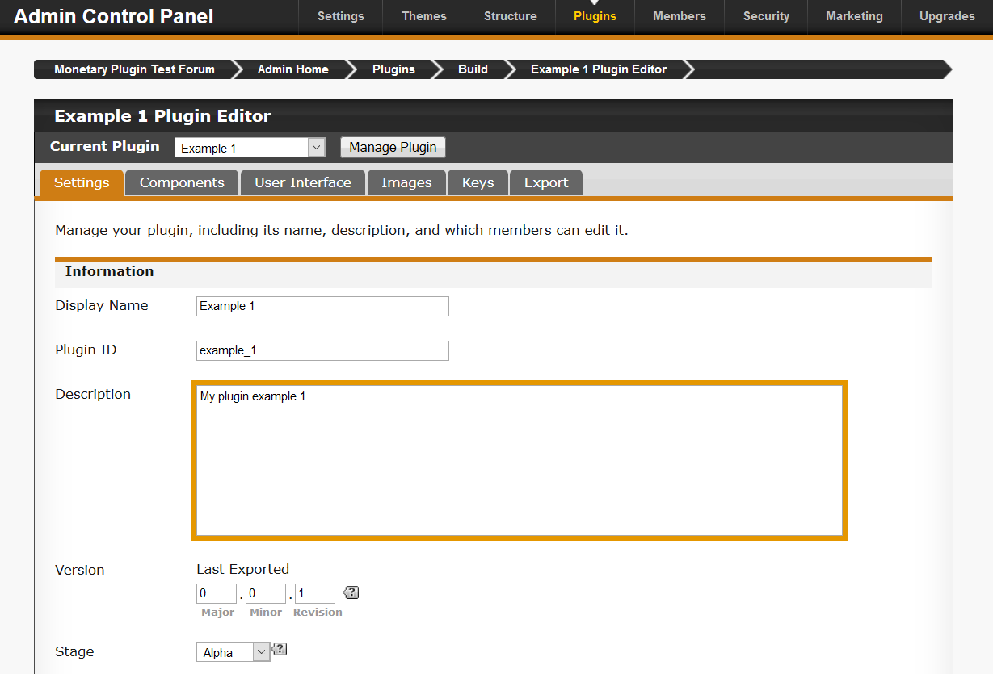
The first field, "Display Name" is the name of your plugin that users will see.

The "Plugin ID" field is a very important field when it comes to plugins. The value here will be used later on when we want to reference the plugin in JavaScript. It’s very important that this value is unique. If the value is not unique, then whatever plugin is last in the list to load will be the only one to work.

Maximum length of the plugin ID is 60 characters.

You will get no warning if you reuse a plugin ID.

Create a plugin ID that is unique to you. For example; "pd_rand_banner". "pd" is unique for me (my website "pixeldepth.net").

The "Description" field is for adding some details about your plugin. Make sure to include as much detail about your plugin as possible. If your plugin requires a specific plugin or library to be installed, then provide the link as well.

The "Version" field is helpful not just for you, but for users who want to see if they have the latest version of your plugin installed. This version number gets exported to the library. There is no real rule on how you set these numbers. However, there are versioning guidelines that you may want to follow. Otherwise, use something that you are comfortable with, but remember to increase your version before you export, otherwise if you left it at 0.0.1, how will users know which version is the latest?

For more information about software versioning, have a look at this link:

https://en.wikipedia.org/wiki/Software_versioning

For this example plugin, I will start versioning at 1.0.0.

The "Stage" option allows us to indicate to users what stage the plugin is in.

- Alpha – Plugin is ready to be tested
This stage of the cycle is generally where features are incomplete, may be very buggy and unstable (e.g., key data loss).
- Beta – Plugin is feature complete but may contain bugs
This stage of the cycle should be feature complete, but may contain bugs.
- Release – Plugin is finished
At this stage, the plugin should be available, and all known bugs are fixed.

You can submit a plugin to the library at any stage, but be careful submitting plugins early on in the development cycle. Nobody wants plugins that do not work.

When releasing a plugin, it’s useful to include a support link so that users who are experiencing problems, or have found a bug, can report them to you. This is where the "Help Link" field becomes useful. By default, ProBoards auto fills it with a link to the Plugins board on their Support forum.

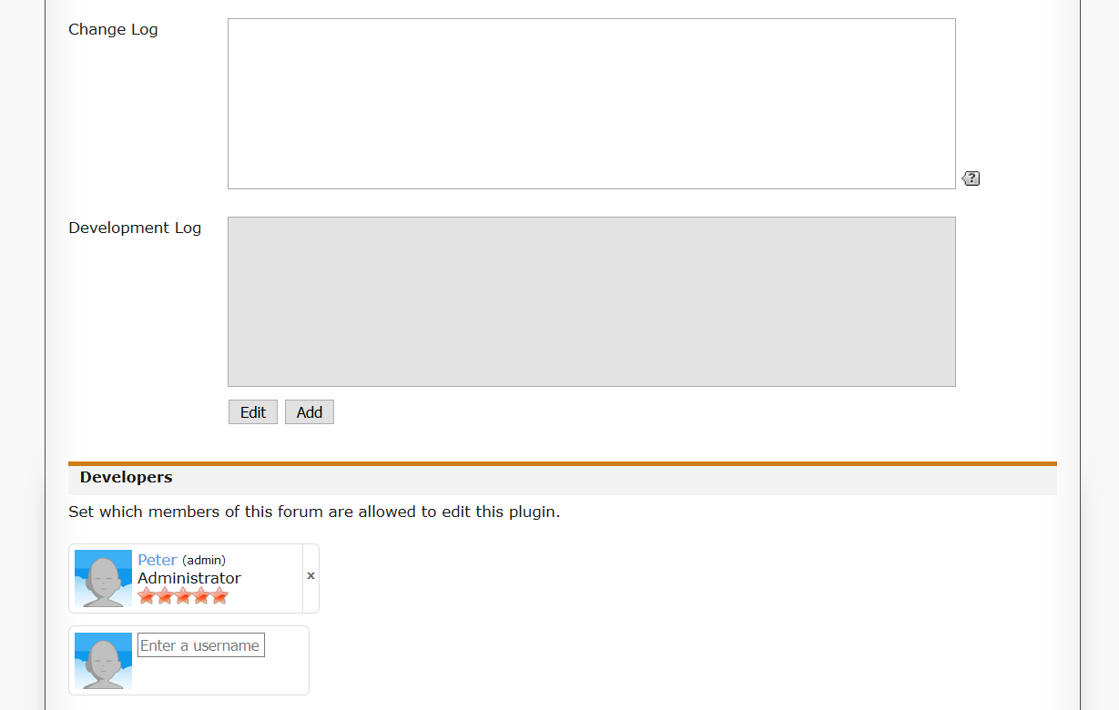
"Change Log" is another field to try and keep updated before exporting your plugin. It serves as a way to provide details to users on what has been changed and added between versions, and this gets viewed from the Library page (as seen in the image below).

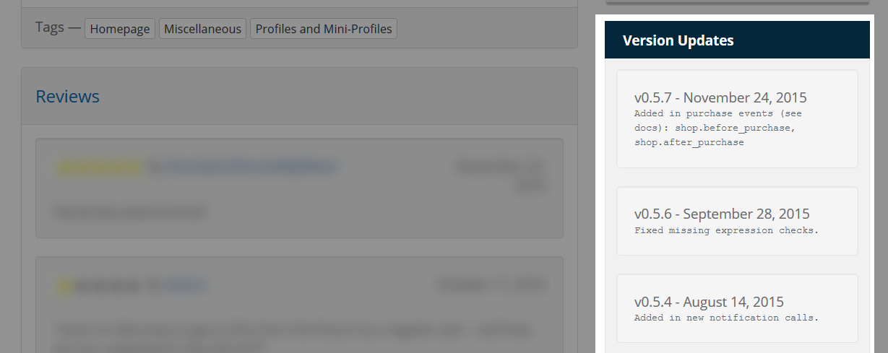

The "Development Log" is basically a place for you, the developer of the plugin, to enter a log. This is something I don’t really use myself, and by default it will be autofilled with your change log at some point during export.

Finally, we have some permissions. This is useful if you want to work with someone else on the plugin; you can search their forum name and add them as a co-developer.

Consider alternative methods when working with other people, as it can lead to each other overwriting code when saving.

For my example plugin, here is what I have set some of the fields to if you wish to copy:

- Display Name: "Example 1"
- Plugin ID: "example_plugin"
- Description: "My example plugin that will do nothing"
- Version: "1.0.0"
- Stage: "Release"

Components

Components are a very important part of your plugin. Without them, your plugin isn’t really going to do anything.

A plugin requires at least one component, or your plugin will not be active on the forum.

By default, our example plugin is enabled. This means that we could easily add a component such as the "Global Header & Footer" component, add some content, save it, and that content will show up on the forum to the user. But as it stands, even though the plugin is enabled, it will not be active on the forum (e.g., home page). Access to your plugin from JavaScript will not be possible.

The following sections will explain each component.

Each component that you add can easily be removed if needed.

JavaScript

This will become our most used component in later chapters. This is where all our JavaScript will be placed. Let’s click on the "JS" component on the right under "Plugin Assistant".
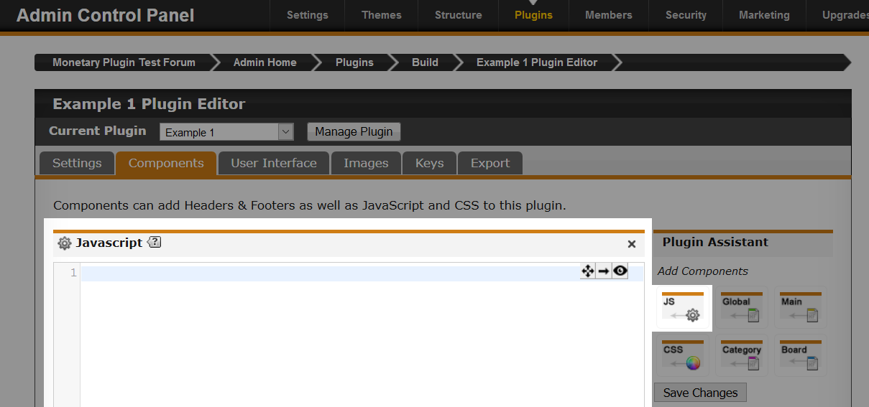
We now have our first component. On its own, it will do nothing. In later chapters, we will add some JavaScript that will do something.

ProBoards provides us with a very basic editor. While this is OK for small scripts, I would suggest writing code in your favourite editor / IDE, and then paste it into the component.

ProBoards allows us to have two JavaScript components. Currently you can store 65,535 bytes per component. If you go over this limit, then it will be truncated. Unless you are writing very big plugins, you will not need to worry about this. Generally one component is enough for most plugins.

You do not need <script> tags in your JavaScript components, as the code entered will be placed into a JavaScript file that ProBoards hosts.

CSS

The CSS component allows you to enter CSS rules to style the forum and your plugin. For example, we can easily make the background colour of the forum red.

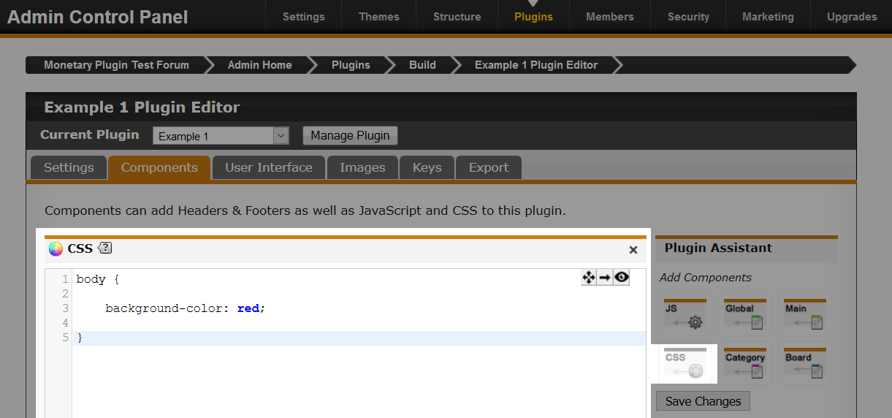

You do not need <style> tags in your CSS component, as the code entered will be placed into a CSS file that ProBoards hosts.

Give it a try. Enter the following CSS into the component and save, then load up your forum home page. You should see that it’s nice and red.

body {

background-color: red;

}

Global Header & Footer

The Header & Footer Component allows you to add content before and after the main content of the page respectively.

This component accepts HTML, CSS, and JavaScript. CSS and JavaScript will require their opening and closing tags.

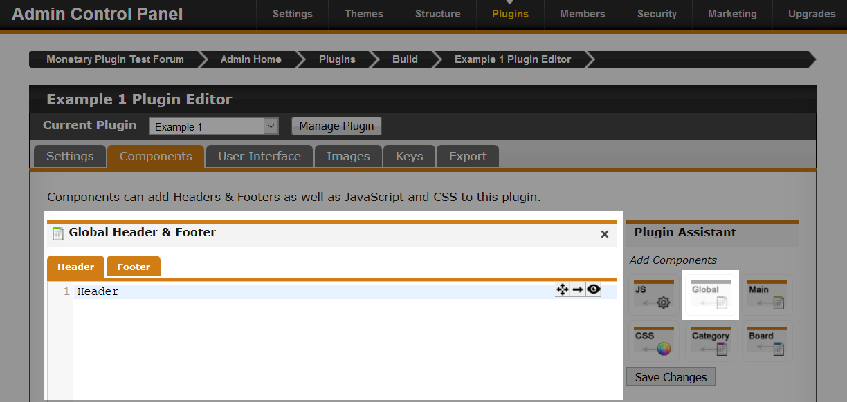
This component is very useful if you need to display something on the forum that shows on every page.

Main Header & Footer

The Main Header & Footer component works indentical to the Global Header & Footer component. The only difference is that the content in this component will only show on the main page of your forum. For example, you have a banner or welcome message that needs to be on the main page only.

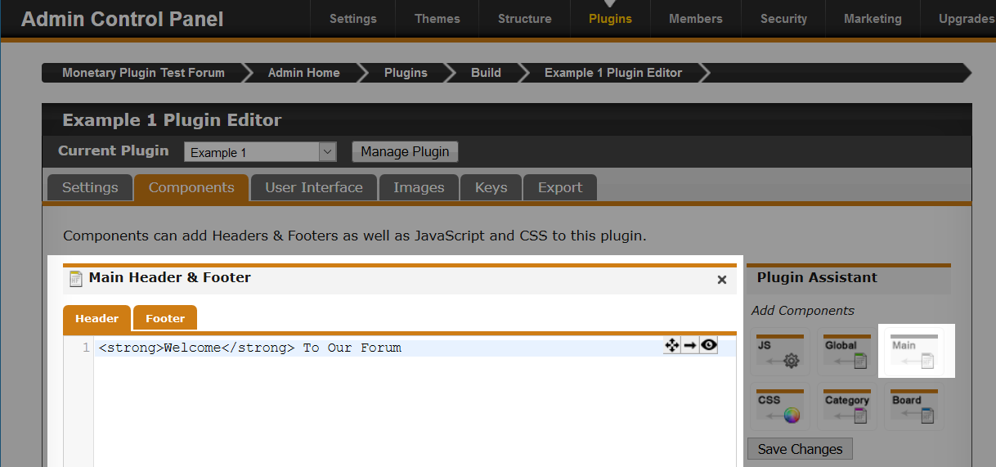
A simple welcome message will show up to everyone on the main page of the forum.

Category Header & Footer

The Category Header & Footer component allows you to create content that shows in selected categories that you pick. You can add as many as you like and apply different header and footer content to multiple categories.

This component can be a little tricky to understand at first, as it doesn't really tell you how to select your categories.

The first step is to create a name and add a description.

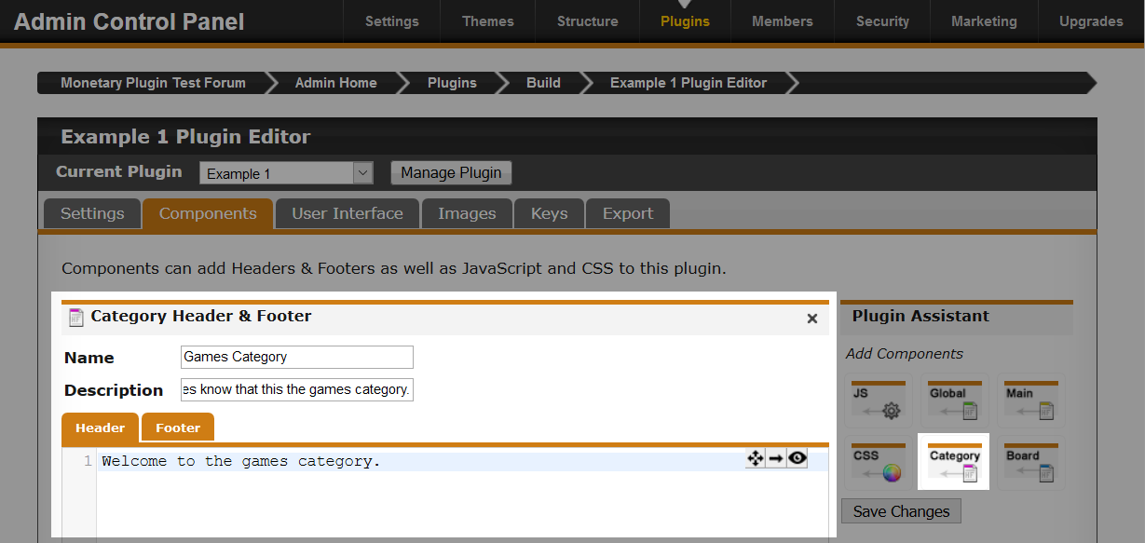
So we now have a header setup that we can apply to any category we like. But how?

Make sure to save your changes.

This component works much differently, we will need to visit the "Manage" page so we can select our categories.

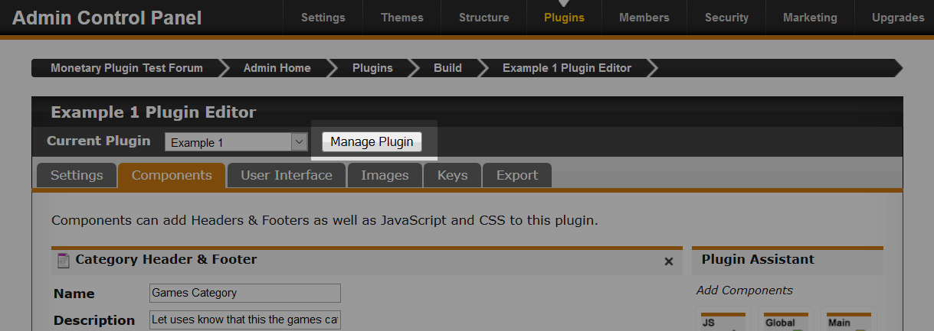
Above the tabs, you will see a button called "Manage Plugin". This allows us to select a plugin to manage from the drop-down to the left of it. In this case, though, our plugin will be already selected. So all we need to do is click the "Manage Plugin" button.

You should now be on the "About" page of your plugin.

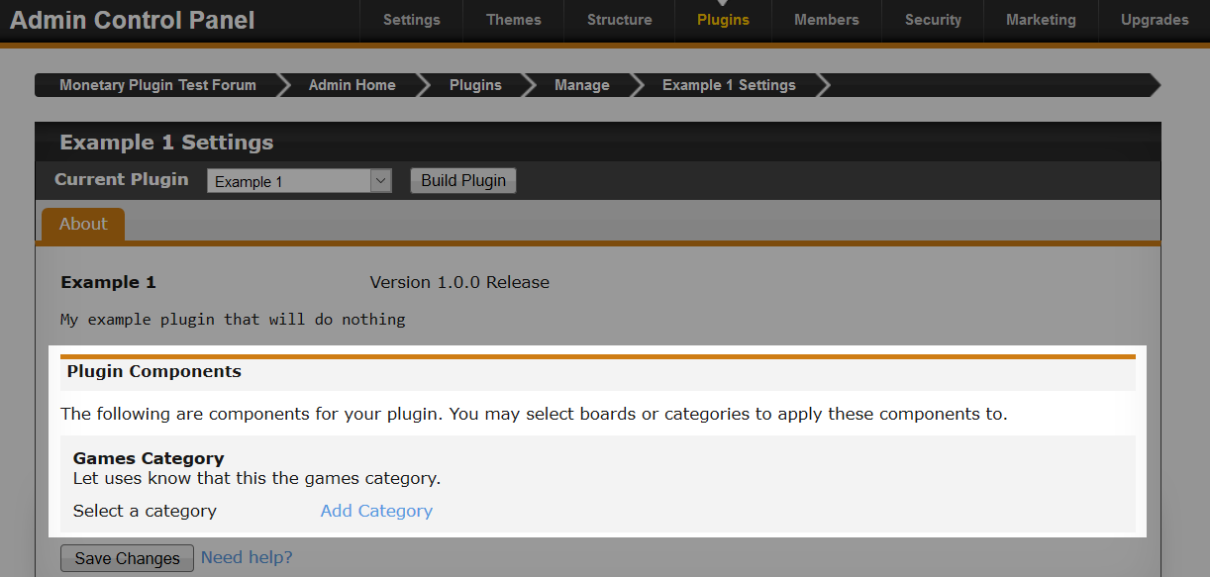
In the image above, you will see a section called "Plugin Components". Here you can select which categories the header and footer will be applied.

You can add different headers and footers for the same category.

Board Header & Footer

The Board Header & Footer component works exactly like the Category component, only for boards.

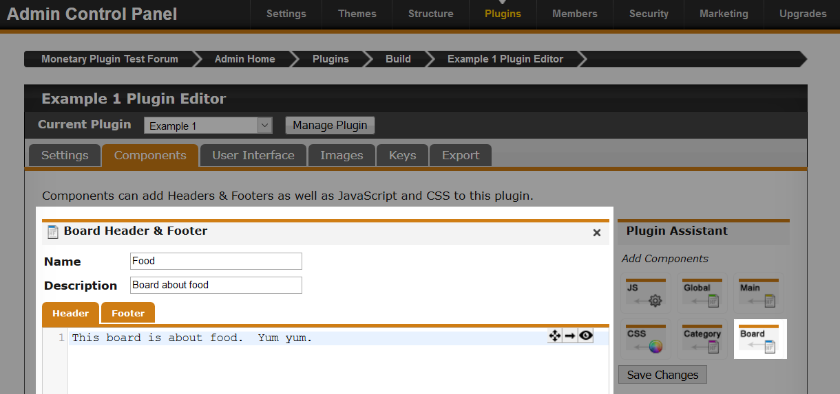
Follow exactly the same instructions for the Category Header & Footer component, only this time you will be selecting boards instead of categories.

User Interface

The user interface tab contains all the UI components that you can add to your plugin. Later, there will be a chapter dedicated to all components on this tab.

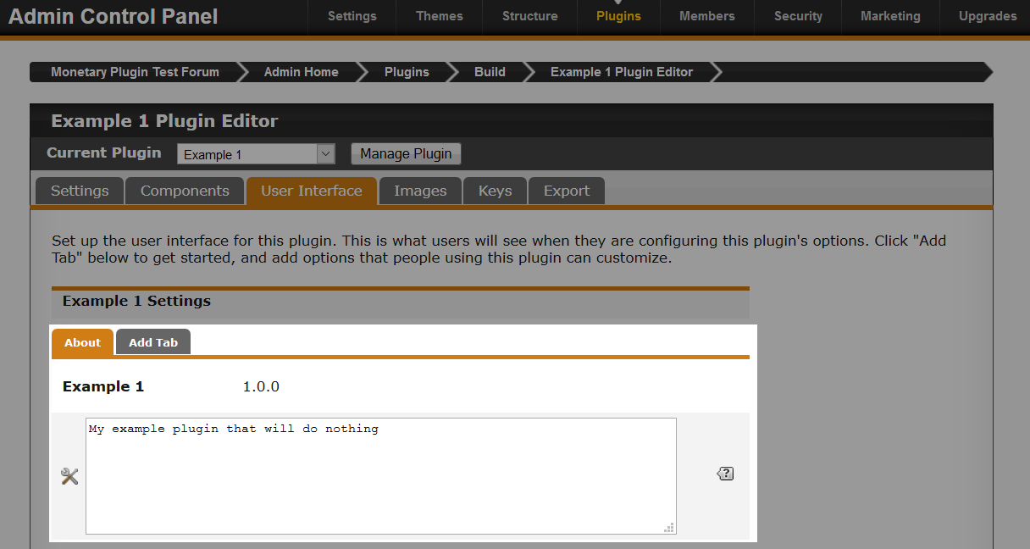
The "About" tab shows you the version. It also allows you to modify the description of your plugin. For now, ignore "Add Tab".

Images

The "Images" tab is fantastic if your plugin has custom images (e.g., icons). ProBoards allows you to upload 50 images per plugin, so you don’t need to worry about finding a host for the images.

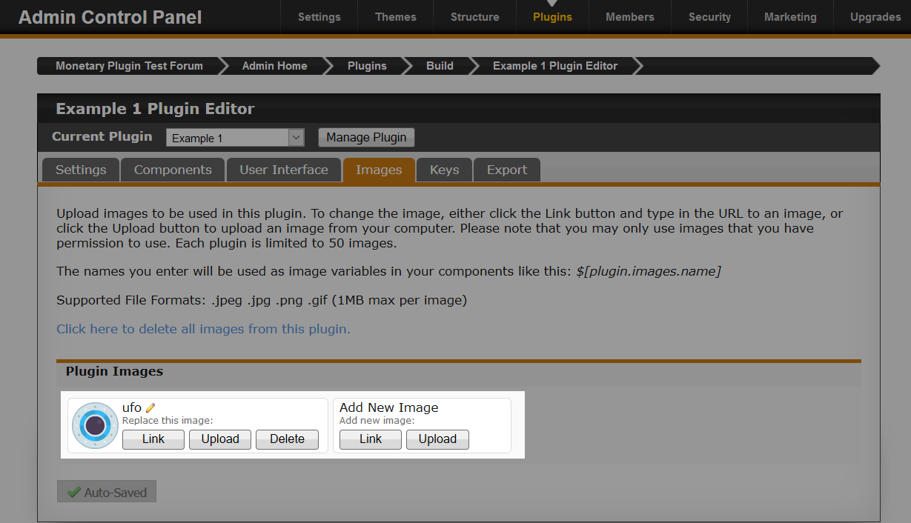
Once you add an image, you can edit the name. This will become more useful to us much later when we want to use images via JavaScript, using unique names (e.g., "img34572" vs "ufo") might be a good choice.

But if you have a lot of images, a better idea would be to group your images into one (e.g., Sprite Sheet / Texture Atlas). Doing so, you can have more than 50, as long as the file size doesn’t go over the limit.

Keys

Next, we will briefly go over what keys are. However, we will explore them in far more depth in chapter 3.

Keys allow the plugin to store a limited amount of data which is persistent. This means we can store some value in a key for as long as we wish until we want to clear it, or the admin decides to clear all saved data. The data stored in the key is saved to the ProBoards database.

There are seven possible types of keys we can create. Which one you use depends on your plugin.

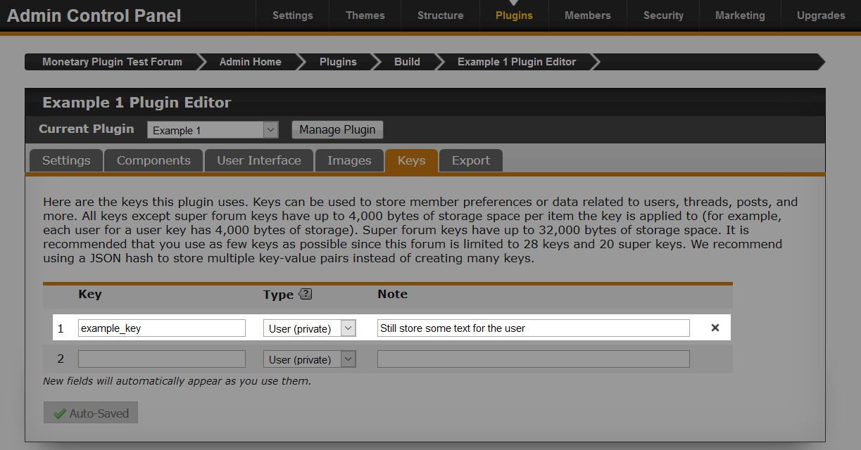
It’s very easy to create a key, and you can have more than one key for your plugin.

The first field is a unique name for your plugin. Follow the same rule as you did for the plugin ID. What you enter in this field will be used later on in JavaScript so that we can get and set the data of the key.

The max length of the key ID is 50 characters.

The "Type drop-down" really depends on your plugin. We will cover the different types in chapter 3. For now, I have picked a private user key.

Finally, we can add a note about the key. This will be more helpful if you are using multiple keys.

Export

Exporting your plugin is usually the last step. However, you can export your plugin to the ProBoards’ Library or to your computer at any time. The "Export" tab gives you these two options to select from.

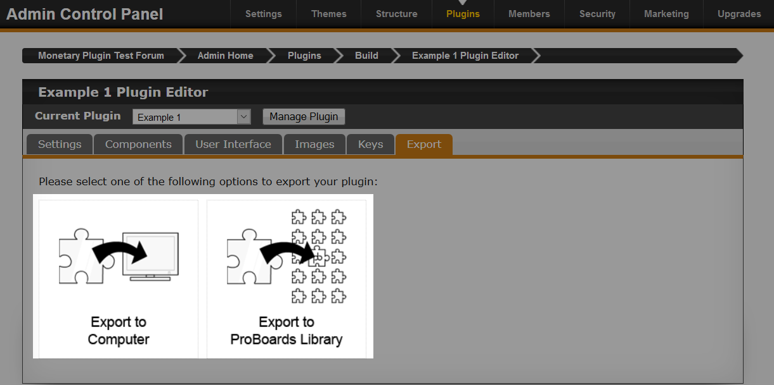
Exporting to the computer will allow you to download your plugin. This can be handy, if for example, you would like your friends test your plugin early on in the development cycle so they can provide valuable feedback.

Exporting to the ProBoards Library will allow you to share your plugin with the community for them to install or download.

For the moment we will click on "Export to Computer" and see the options.

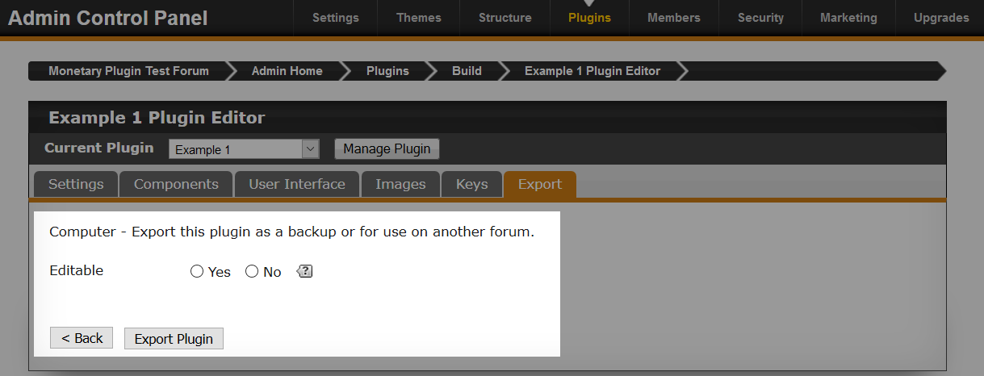
As you can see, we are presented with one option: do we want to export the plugin as "Editable" or not?

If you are developing the plugin with someone else, then the obvious choice is to allow the plugin to be editable. This means that they can install it onto their forum and access everything in the plugin editor.

The other option is to prevent anyone from editing it. This is good if you want to prevent people from making modifications to the plugin (e.g., UI components), or even the source.

This option is available for downloading and exporting to the library.

Once you click the "Export Plugin" button, your browser will either prompt you, or automatically download the file

Now let’s have a look at exporting to the Library.

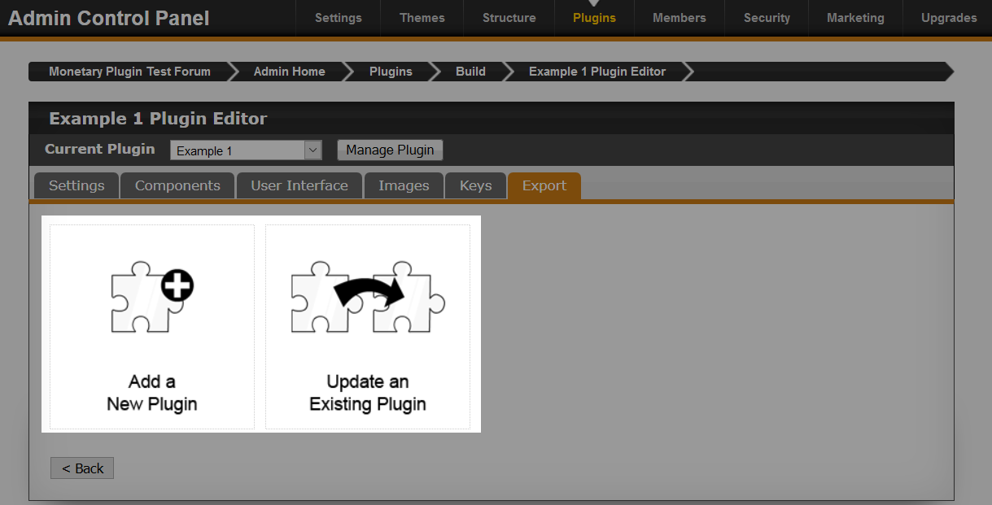
Here we see two options. Both options are very similar, the only difference with the second option is that we can select an existing plugin that we own, which will get updated.

- Add a New Plugin
Use this option if your plugin is completely new, or you want to release the plugin as a new version separate from the previous one.
- Update an Existing Plugin
If your plugin already exists in the library, then you can update it using this option. This is useful if you have fixed a bug, or added a new feature.

Since our plugin is new and doesn’t exist in the library, we will click "Add a New Plugin" and take a look at the first couple of sections.

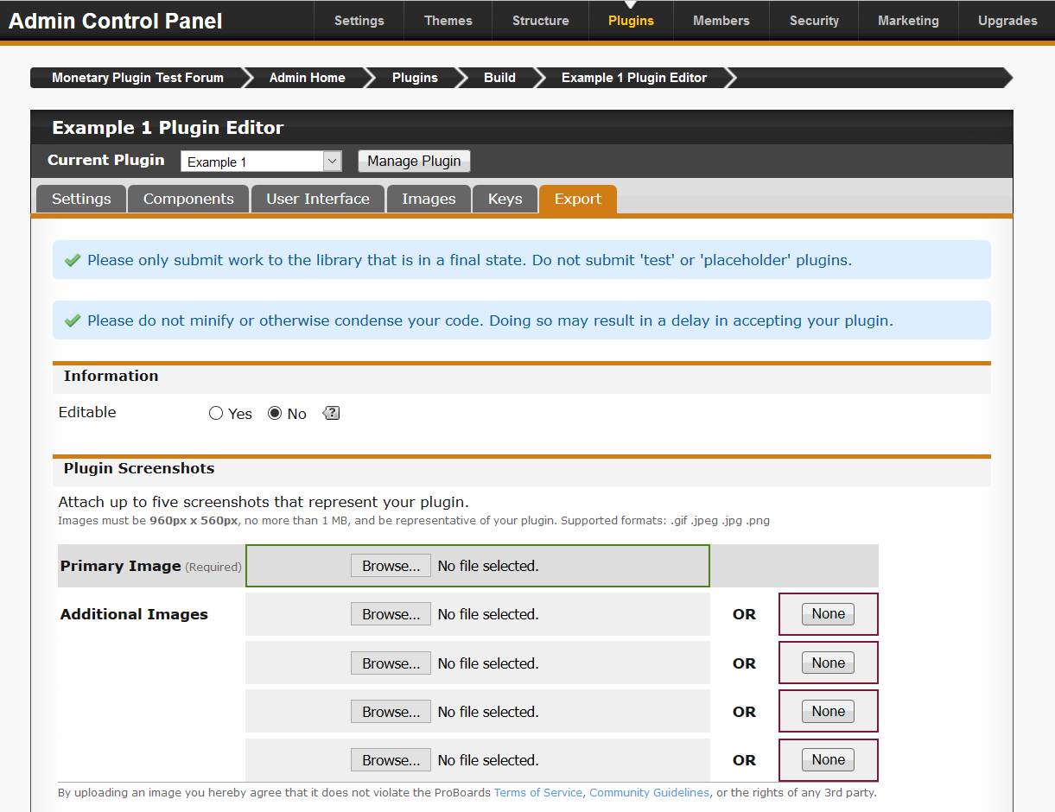
ProBoards does a good job explaining everything here, so most of it is self explanatory, but let’s go through it.

At the top, ProBoards gives us some information about submitting a plugin in its final state. You can submit a plugin that is in alpha or beta, but please refrain from submitting a test plugin or a plugin that needs tested, like ours.

There is also a mention about minifying your code. Some plugins do minify their code if it’s rather large and they are trying to squeeze some space out of it to fit more in. Just note that your plugin may take longer to be processed.

We then see we have the editable option again. Select if you want others to be able to edit your plugin or not.

Next we can add some preview images for the Library. This is really useful for users who are looking through the library. Showing a preview image of a feature of your plugin can be really helpful to the user. The primary image should be something that catches the eye, but shows what your plugin is.

Using an image that doesn’t reflect what your plugin is may get your plugin rejected.
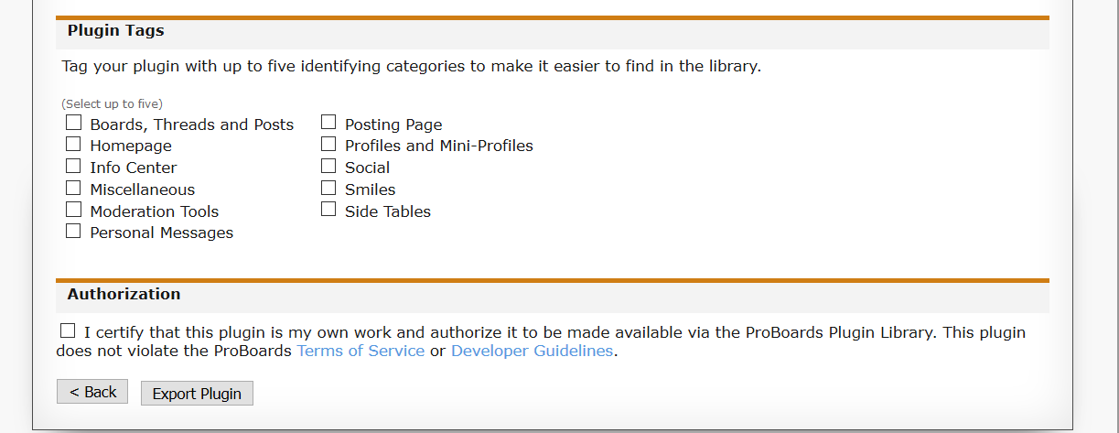
Selecting tags for your plugin will help users find it in the Library. Don’t just tick any of them, tick the ones that identify your plugin. For example, a plugin that modifies the info center on the home page shouldn’t have "Smilies" ticked unless it is also doing something relating to smilies.

Finally, tick the checkbox if you agree to the Terms of Service and Developer Guidelines, and then click "Export Plugin" to submit it to the Library. However, for this example, we do not want to submit a test plugin. So we will ignore this for now.

Once your plugin is submitted, you will be given a link to its possible placement location in the ProBoards’ Library. Then it’s just a matter of waiting until it has been approved or rejected. You will receive an email letting you know either way.

JavaScript Plugin Basics

To be able to do anything with your plugin, you need to understand how to reference it from JavaScript. Below we will look at some JavaScript and then break it down, as we will be seeing this with every component example throughout the next chapter.

var plugin = pb.plugin.get("example_plugin");

if(plugin){
var settings = plugin.settings;

// Component code will go here

} else {
console.error("Plugin not found");
}

Pretty short and simple code, and not a lot is going on. But let's break it down line by line, as there is one line that is important to understand.

var plugin = pb.plugin.get("example_plugin");

The line above fetches a reference to our plugin object and stores it in our variable plugin so we can use it later.

pb is ProBoards global namespace for the API. It contains many utility classes and methods that you will use quite often when making plugins.

pb.plugin is a class that has a method to help us with fetching a plugin object, and also contains a few methods relating to keys that we will look at in chapter 3.

pb.plugin.get is a method that when passed with the plugin ID, it will return a reference to the plugin object. This plugin object that is returned allows us to access all of the settings, images, and the version of the plugin.

It's important that the string (in my case the plugin ID is "example_plugin") which gets passed to the get method is your plugin ID. If the ID is incorrect, then you will receive a null value back. You can test this yourself by passing an incorrect ID and seeing what gets logged out to the console.

Most modern browser have a developer console where you can test some code, log to the console, and much more. F12 is the most common shortcut for this; however you can usually find it in the menu of your browser.

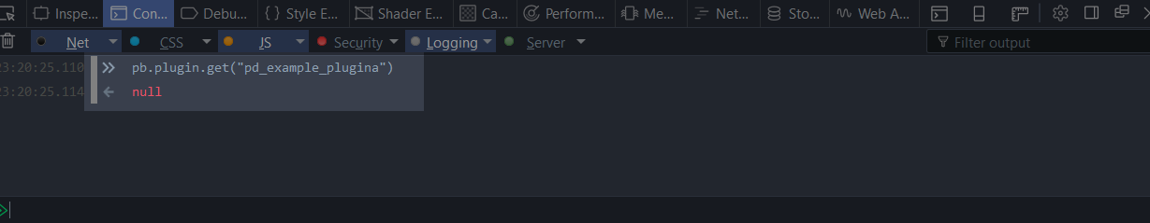
As you can see, null is returned as there is no object for our plugin. See the difference below when we correct this.

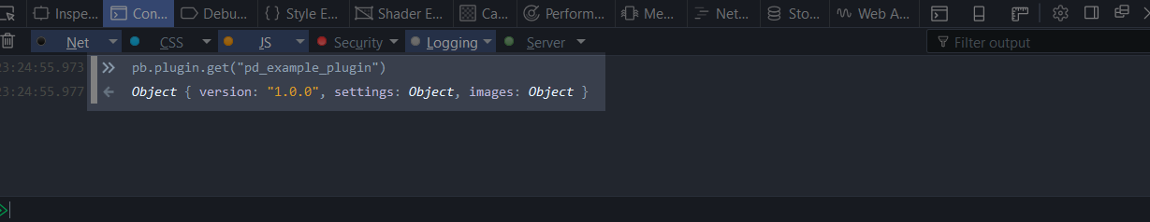
Looking a the console output, you will see the plugin object with all of the properties.

if(plugin){
var settings = plugin.settings;

Because there is a chance of null being returned back, we do a check to make sure the variable plugin is all good so we can continue.

We then store a reference to our plugin settings in the settings variable for later use. The settings variable is where we get access to all our UI Components that would exist. Currently, if we were to log out the settings variable, it would be an empty Object because we have not setup any UI Components in the plugin editor.

We can test and see what exists in our settings object by logging it out after we declare the variable.

var settings = plugin.settings;

console.log(settings); // Empty object currently.

This section has now covered the very basics of getting a reference to your plugin object, and storing a reference to the settings object. We will be using this code for each component example in the next chapter.

Chapter 2: UI Components

In this chapter we will be going over all the UI Components in the plugin editor. We will be looking at how to setup the component and how to reference that component from JavaScript.

ProBoards provides us with a number of components that we can use in the plugin editor. A component is what the user will see when they are configuring your plugin. For example, a text field component could allow the user to edit the title of some text in your plugin or on the forum.

Adding components to your plugin is really easy, and some components are very basic and they don’t need much of an explanation. We will not be doing anything with the data from the component apart from logging it out to the console to see the values.

UI Tab

To be able to add any of the UI Components to your plugin, you need at least one UI Tab. A tab can be seen as a way to group up related components. For example, you may have a tab for customising your plugin, you may have another for general settings; and another for permissions.

So let's head back to the admin control panel and edit our plugin in the plugin editor. We need to head over to the "User Interface" first.

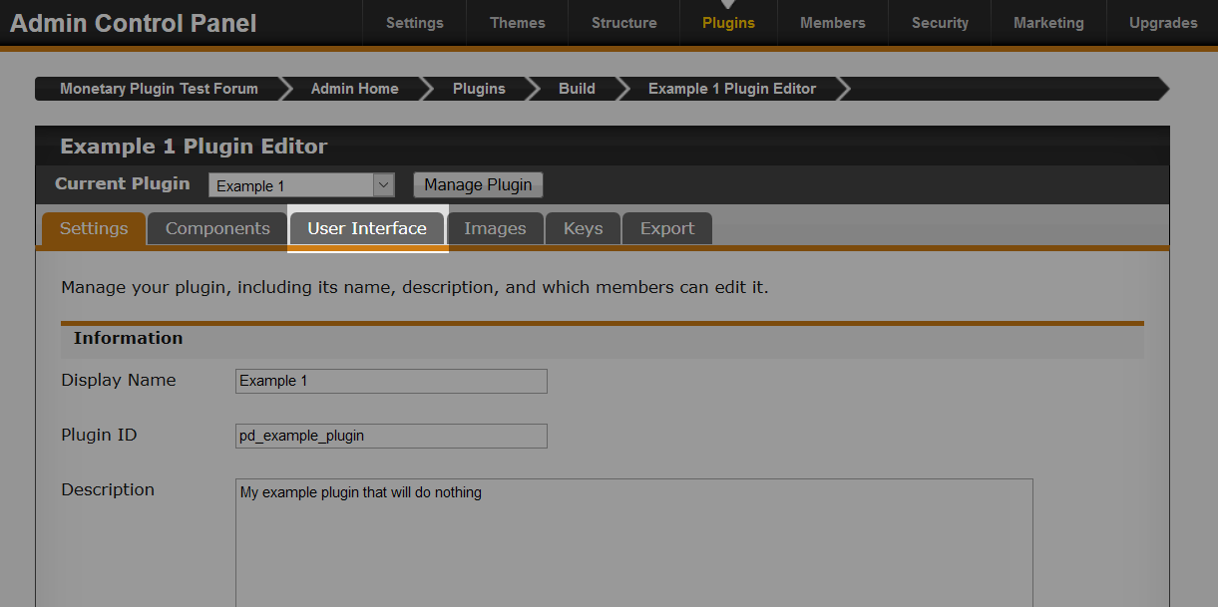
Click on the "User Interface" tab.
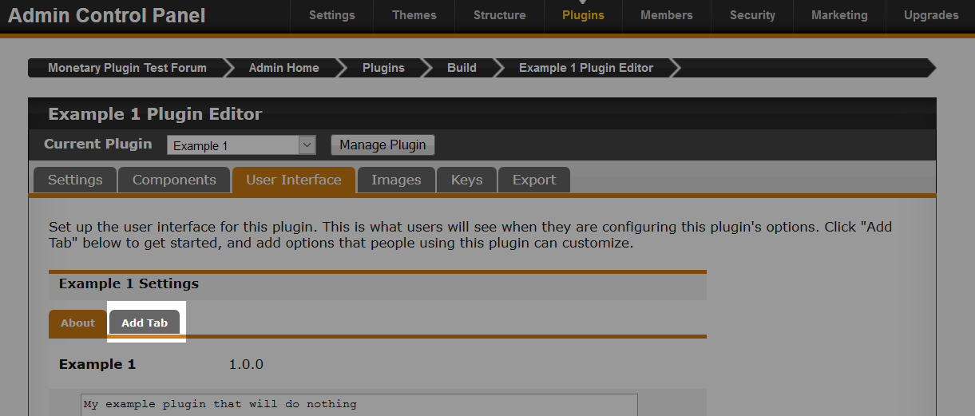

Now we need to add a new tab before we can add any components, so click on "Add Tab".

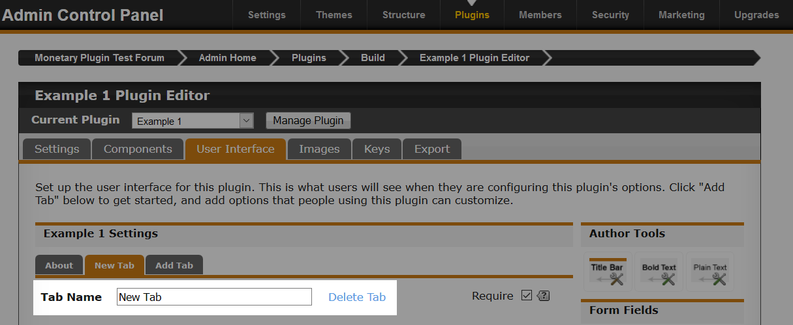
So we now have a new tab, and we can rename the tab to whatever we like. Give your tab a name. We also get the option to delete it if we aren't happy. However, be careful, as this would also delete all the components if you had any on that tab.

If you are creating multiple tabs, consider thinking about your order before you make them. Currently you can not reorder tabs once they are created.

Author Tools

There are three components in the Author Tools section that we can use to add further instructions to the user, or to separate components with a title.
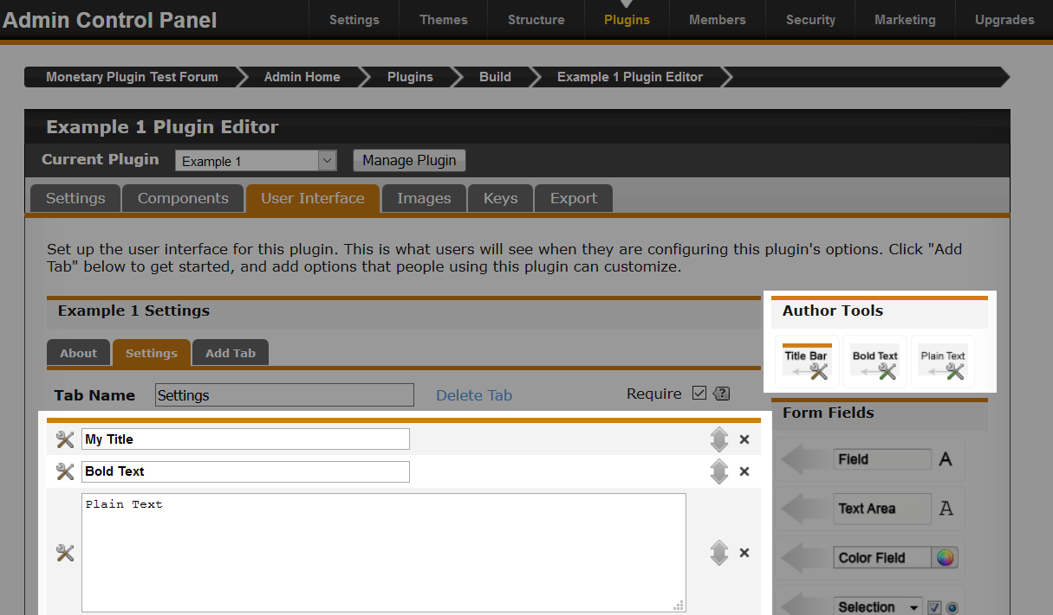
If you look at the image above, you will see that there are three new components that have been added. We can move them up and down to change their position, and we can also delete them.

But what if you want to preview what the plugin would look like to the user? We can easily do that. There is a handy button at the bottom of the page that allows us to preview the plugin. We can also setup default values for components, which we will discuss later.
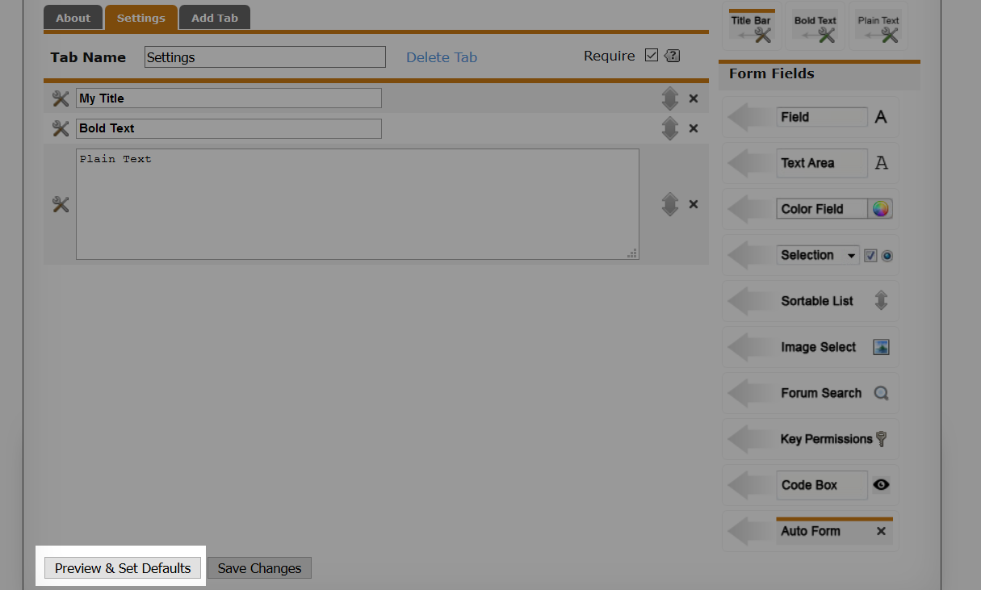
Click on the button "Preview & Set Defaults" to have a look at what your plugin currently looks like.

After playing around with the Author Tools components, remove them.

Field

The "Field" component allows us to add a text field to our plugin. This can be really useful when you want to allow the user to customise a part of your plugin (e.g., setting the text of a title bar). Let's add the Field component to our plugin and look at the options available for it.

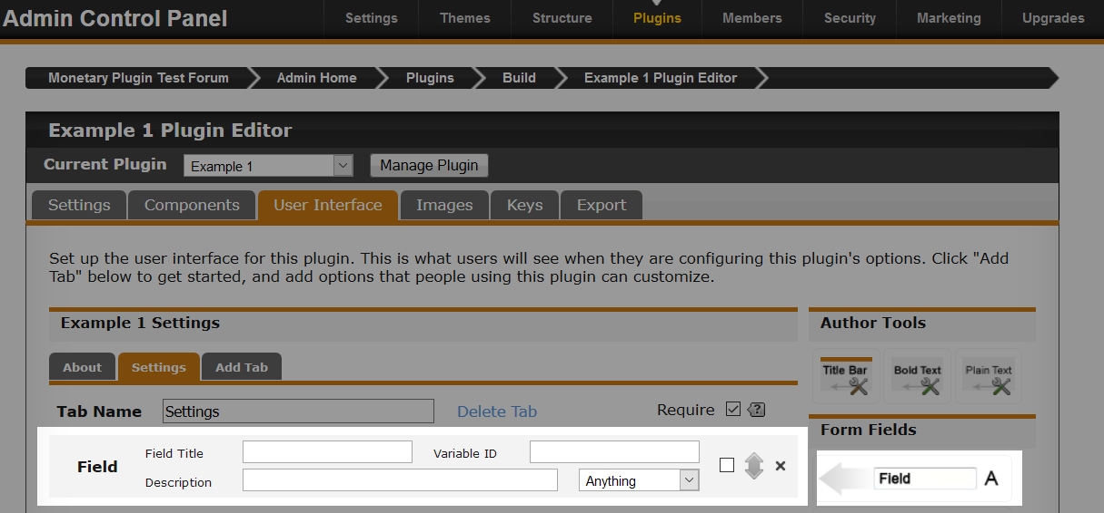
- Field Title
The title of the field that will be seen by the user.

- Description
A tip for the user. This is helpful when you need to include some information that may help the user who could become confused as to what the field is for.

- Variable ID
This is an important one and must be unique. Components cannot share ID's, so create something that relates to what the field is for. For example, "apple1" is not a good ID, but "title_text" is much better. Think of this value as an actual variable that you would create in JavaScript but with less limitation on what characters can be used.

When you start typing in the field title input, ProBoards will automatically start creating a variable ID for you based on your title. You can change this if you like.

You will see we have a select dropdown with various options. This dropdown allows you to add basic validation to the component. If you look through the list of options, you can see what is available.

- Anything
Anything can be entered into the text field by the user.
- Numbers Only
Only numbers can be entered into the field by the user, this includes decimals and hyphen for negative numbers.
- Alpha-numeric Only
This is useful if you want to allow only numbers and letters. Decimals will not work with this option selected.
- Email Address
Only email addresses can be entered.
- URL
Only a URL address can be entered. Useful if you want to use external images that the user has.

Have a play around with choosing different options and previewing your plugin to test the field out. You will notice if you enter an invalid value, you will get a warning above the field letting you know.

Here is what my field looks like.

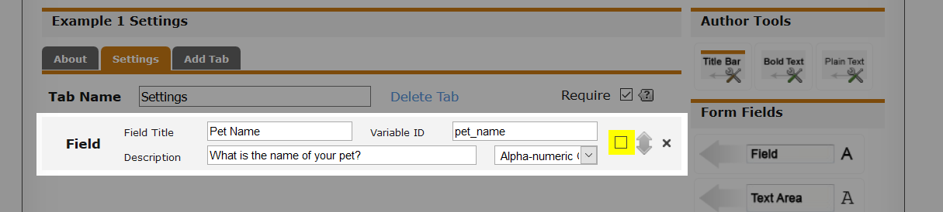
I want to get the pet name from the user. So it makes sense to set the title to "Pet Name", and the variable ID to "pet_name" so I know from JavaScript that the value in this field is for the pet name. I also added a description for the user. Finally, I am only interested in letters and numbers.

You may have noticed a checkbox that has been highlighted in the image above. This checkbox is an option for you to set. Basically if you enable this, the plugin cannot be enabled automatically when it is installed by the user until they have filled out the field. Then they will get the option to enable the plugin. This is really useful if you require some components to be filled out before enabling the plugin.

You can add more that one field component. Just remember that each one will need a unique variable ID.

Once you have finished creating your field, save your plugin. Now we can head over to the manage side of it where we can test it. At the top there is a button called "Manage Plugin". Click on that and you will be taken to your plugin page which is what the user would see.

You will then see your new tab that contains your field.

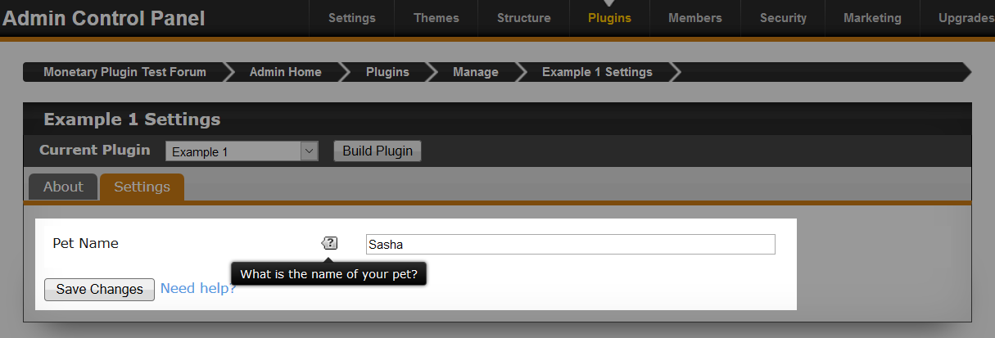
This is mine, and this is what the user will see who uses the plugin. They can enter a pet name and save it. You can also see the tip popup that displays my description of this field. I am going to save changes, so that we have a value we can output later in the JavaScript.

We now have a field component, and the user can save something in it. Next we need to look at writing the JavaScript. So head back over to the plugin editor, but this time we want to go to the components tab and add a "JavaScript" component.

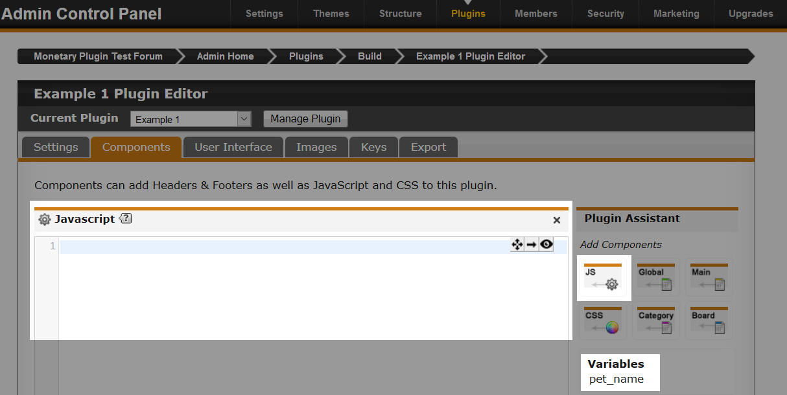
If you look to the bottom right of the image above, you can see that ProBoards shows us the variables available to us. We will be ignoring that, as we will be doing everything by hand.

We need to write some JavaScript to be able to see what the user entered in the field.

var plugin = pb.plugin.get("example_plugin");

if(plugin){
var settings = plugin.settings;

console.log(settings.pet_name);
} else {
console.error("Plugin not found");
}

If you read the last section of chapter 1 called "JavaScript Plugin Basics", then most of the code you see above is familiar. The only difference is that we now have this line.

console.log(settings.pet_name);

pet_name is our variable ID that we created. If you named yours something else, then you would need to change pet_name to your field variable ID.

We log out the value of this setting to the console to see what the user entered. Go to the home page of your forum and look in the console.

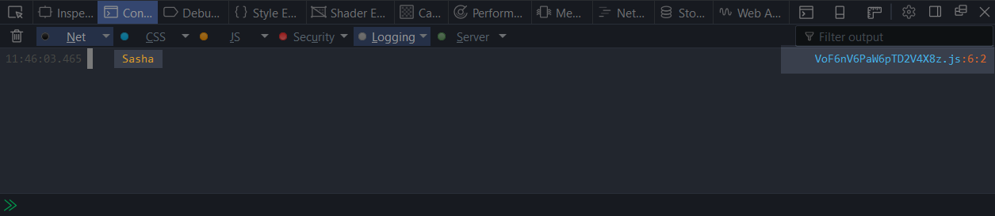
You can see that "Sasha" is logged to the console, this is the value I entered in the field.

You will also see to the right that there is something else highlighted. This is the JavaScript file that ProBoards creates for us when we use JavaScript components. This can be useful if you want to look at other peoples plugins that are installed on a forum.

That covers using the Field component and how to retrieve the value. What you do with this value is your choice. It could be used for a setting (e.g., width of something), or whatever you like.

Have a play around with it a little more, add some additional fields and log those out to the console. Don't forget you can preview your plugin components and test them. You can even store a default value for the field which we will look into much later.

Try and create two fields that allow anything to be entered into one field, and only numbers to be entered into the other.

Text Area

The "Text Area" component looks pretty much the same as the field component, the only difference is that you have no validation options.

Let's add a "Text Area" component.

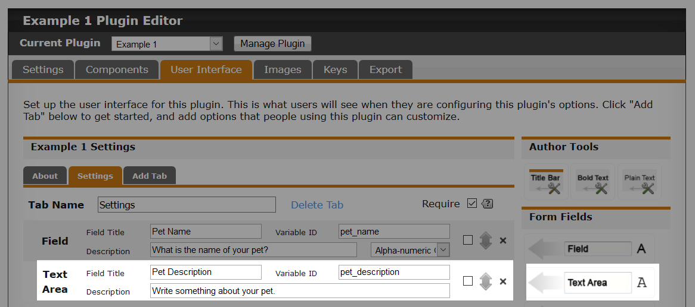
I've added a text area component which gets added after the field component. My text area is going to allow the user to enter a description about their pet. I've set the title, description, and variable ID. As you can see, it's really simple adding these basic components, as they work very similar to each other. They all need a title, description, and variable ID. The the only difference is the options the component provides to us.

We have a text area component and a preview of it. Enter some text to try it out. Make sure to save. Now head over and manage your plugin so you can enter a description into the text area.

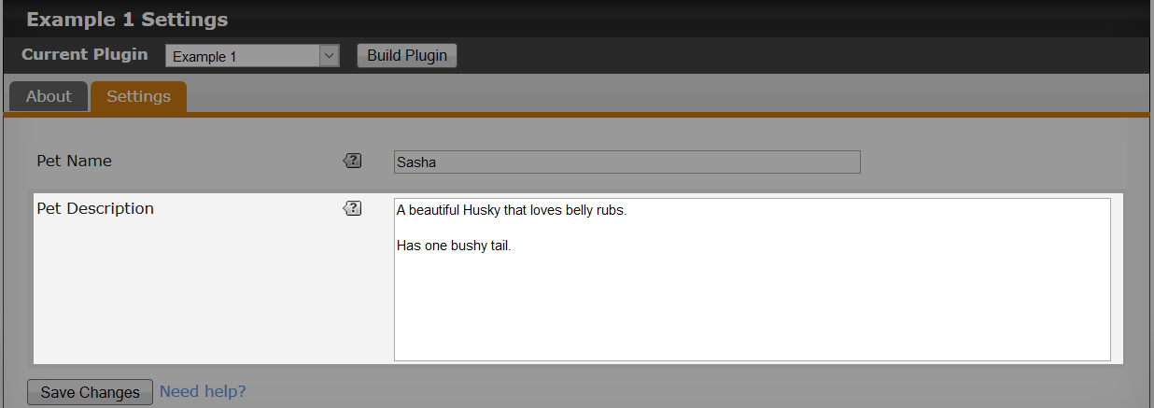
Make sure to save your changes, and then we can look at the JavaScript below.

var plugin = pb.plugin.get("example_plugin");

if(plugin){
var settings = plugin.settings;

console.log(settings.pet_name);
console.log(settings.pet_description);
} else {
console.error("Plugin not found");
}

So the only additional line we added, was to log out the pet description. By now you should be able to tell that any component in your plugin is a setting, and is accessed the same way for each component.

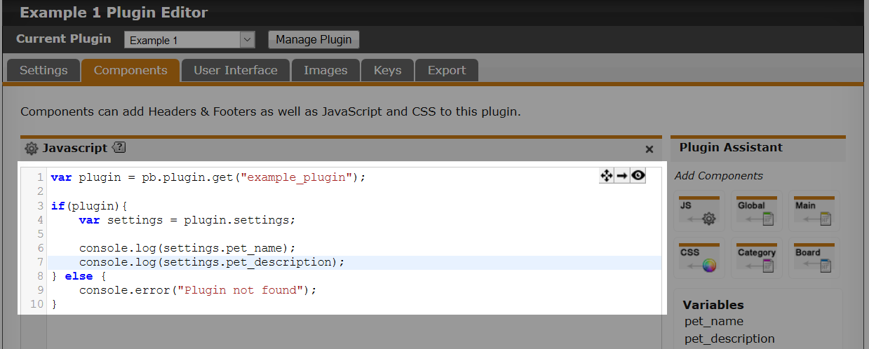
Add this to the JavaScript component (as seen above), then load up the home page of your forum to see what is logged to the console.

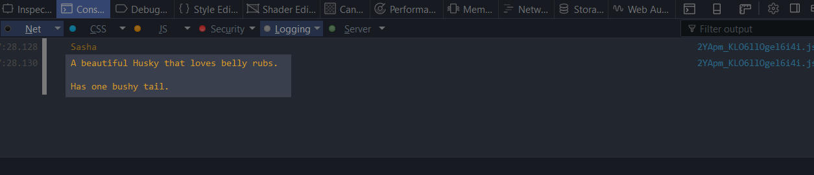
As you can see in the image above, the value of the text area component is logged out.

That is now two settings you have available to you. It's now starting to become a useful plugin. We could easily turn this in a plugin about a pet. But it needs more, so let's continue on and add a few more UI Components to make it even more interesting.

Color Field

The "Color Field" allows the user to select a colour from a colour selector. This makes it really easy for the user to find the right colour, and if they know the hex value, they can enter it manually.

Let's add a color field component under our description component.

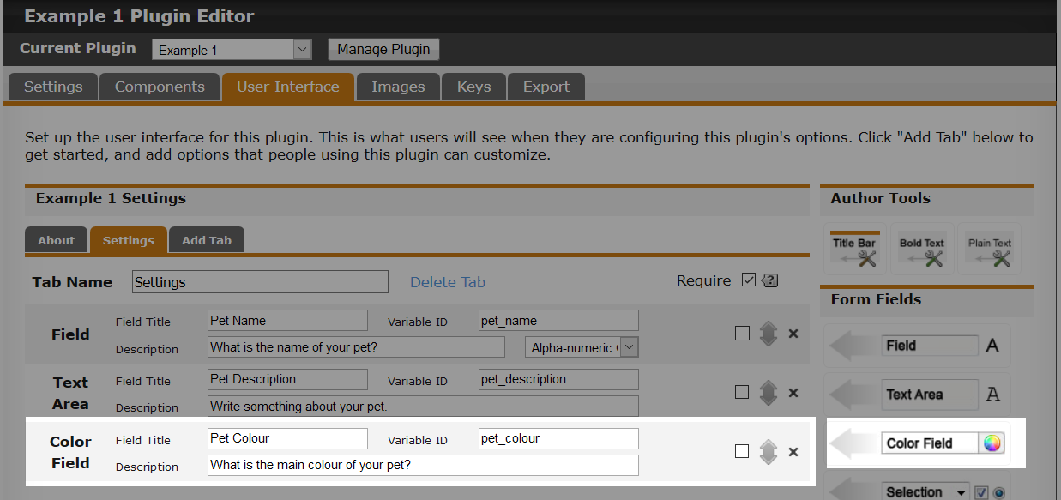
My component will be asking the user for the main colour of their pet. Now pets can be multiple colours, so this is where the description becomes useful. The user will probably be wondering why they can only select one colour, but then they will realise it's for the main colour.

Save your plugin, and go set a colour from the manage plugin page.

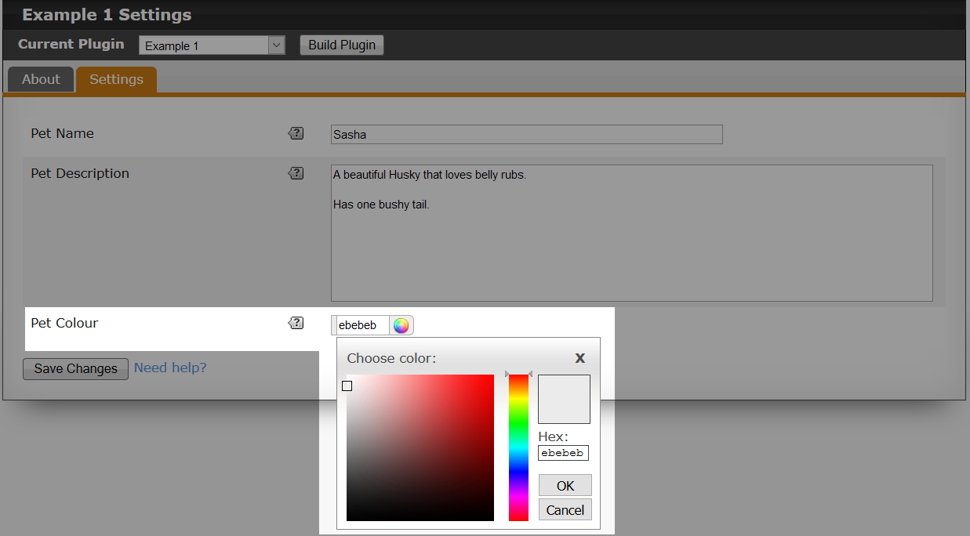
Just like that, we now have a simple way for the user to select a colour for their pet. This shows you just how powerful the plugin editor is. It gets much better as we move through the components.

Let's now take a look at what has changed with the JavaScript.

var plugin = pb.plugin.get("example_plugin");

if(plugin){
var settings = plugin.settings;

console.log(settings.pet_name);
console.log(settings.pet_description);
console.log(settings.pet_colour);
} else {
console.error("Plugin not found");
}

You can see the new line that was added in bold. We now can get the pet colour the user selected. We will log that out to the console and take a look.

Don’t forget to update your JavaScript component with the newest JavaScript code if you are following along.

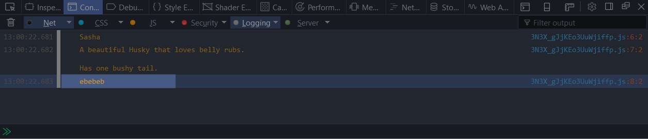
Notice we now have the colour being outputted to the console along with the pet name and pet description.

ProBoards doesn’t prefix the colour value with the "#" symbol. This is something you will need to do for the colour value to be valid (e.g., "#ebebeb").

Selection

The "Selection" component is really useful when you want to give the user options to select from. This could be a single option, or multiple. Let's add the selection component and take a look at the options available for it.
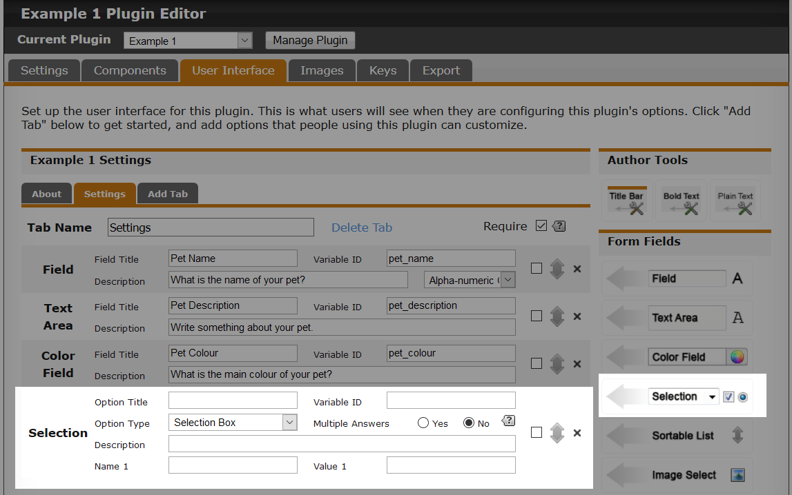
Looking at this component might seem confusing, as there are a lot more options. Lets break it down step by step.

- Option Title
The title that will be displayed to the user.

- Variable ID
The unique value that we will be using in JavaScript to access the value of this component.
- Option Type
The option type is for what element you want to use for the selection. This can be a selection box, checkboxes, or radio buttons. Radio buttons can not be multiple choice.
- Multiple Answers
Enabled this option for the selection box or checkboxes allows the user to select more then one option.
- Description
Just like previous components, you can add a description to provide additional information or tips to the user.
You will see two fields called "Name 1" and "Value 1". These are added by default when you add the selection component. When you start typing the name for your first option, you will see another pair of fields appear underneath called "Name 2" and "Value 2". This allows you to add as many options as you like.

- Name
The name field is for the name of the option that will show to the user.
- Value
The value field is the value of the option which we can look at in JavaScript to determine which options the user has selected.
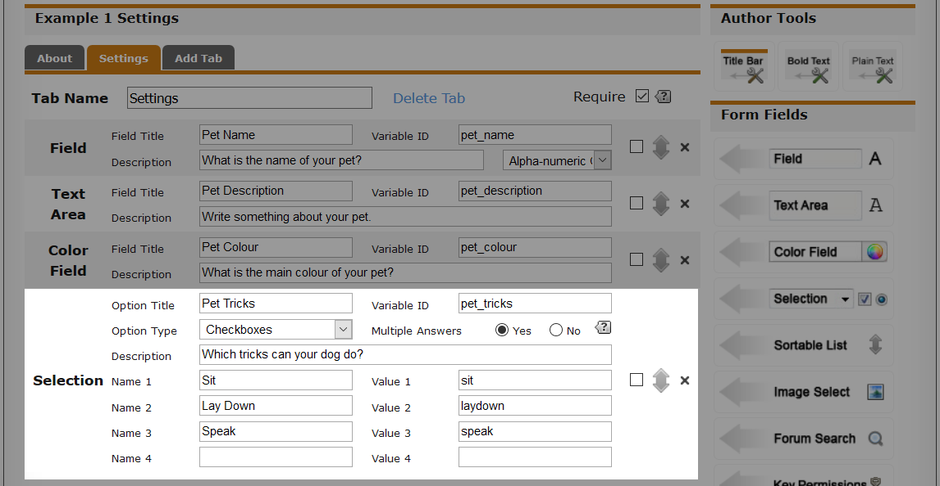
My selection will be asking the user which tricks the dog can do. I have three options to choose from, and it's multiple choice. Let's save and see what it looks like for the user.

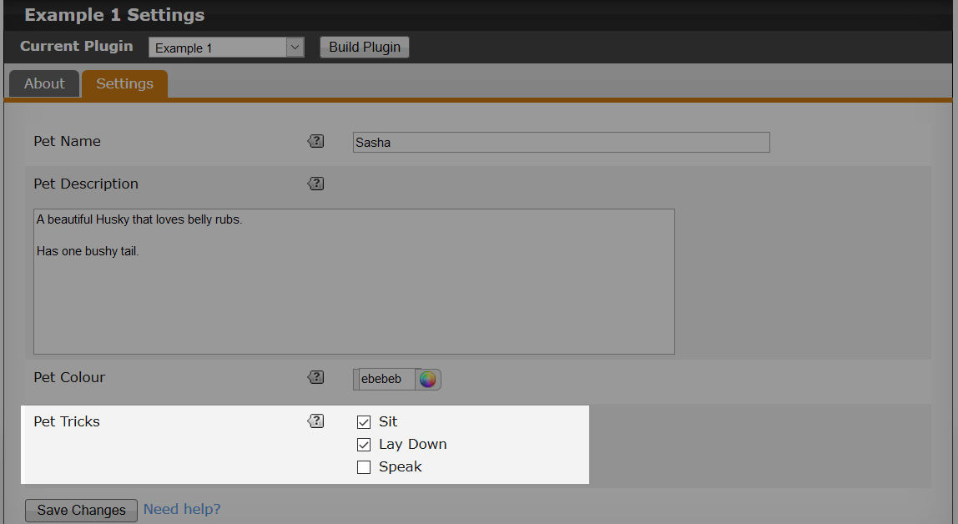
Now we have an option to select which tricks the dog can do. Save, and then we can look at how we can retrieve which options were selected from JavaScript.

var plugin = pb.plugin.get("example_plugin");

if(plugin){
var settings = plugin.settings;

console.log("Pet Name: " + settings.pet_name);
console.log("Pet Description: " + settings.pet_description);
console.log("Pet Color: #" + settings.pet_colour);

for(var i = 0, l = settings.pet_tricks.length; i < l; ++ i){
console.log("Pet Trick: " + settings.pet_tricks[i]);
}
} else {
console.error("Plugin not found");
}

The code has changed a little since the last section. We have included with each log a label so we can see more clearly in the console what each value is for.

for(var i = 0, l = settings.pet_tricks.length; i < l; ++ i){
console.log("Pet Trick: " + settings.pet_tricks[i]);
}

settings.pet_tricks is an Array that could have options selected by the user, so we must loop over to retrieve each selected option. We do this, and also log to the console each trick the user selected.

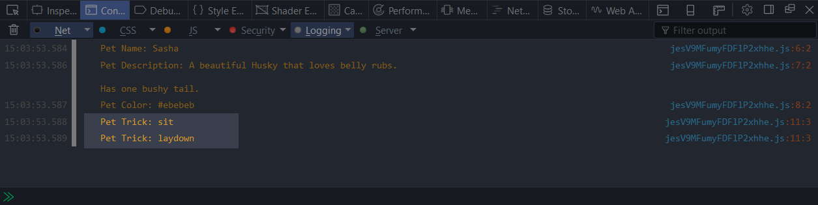
As you can see in the console, we now have the two values of the options that was selected.

Sortable List

The "Sortable List" component is one that isn't often used. But it's certainly an interesting one, as it allows you to use it in a couple of ways.

Add a sortable list component to your plugin, and then we will go over all the options.

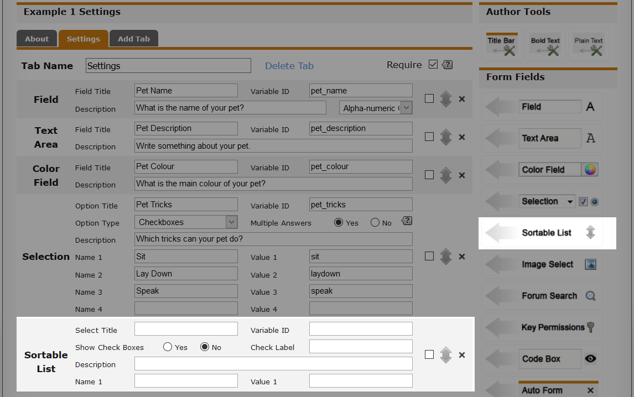
- Select Title
This is the title for the sortable list that will show to the user.
- Variable ID
The unique value that we will be using in JavaScript to access the value of this component.
- Show Check Boxes
Along with having a sortable list, you include a checkbox next to each item.
- Check Label
The label for the checkboxes if the "Show Check Boxes" option is enabled.
- Description
A description to provide additional information or tips to the user.
You then have the same fields that you saw with the Selection component, called "Name 1" and "Value 1".

Don’t forget you can preview your plugin and test the components to see what they do.

Once you are happy, save your plugin.

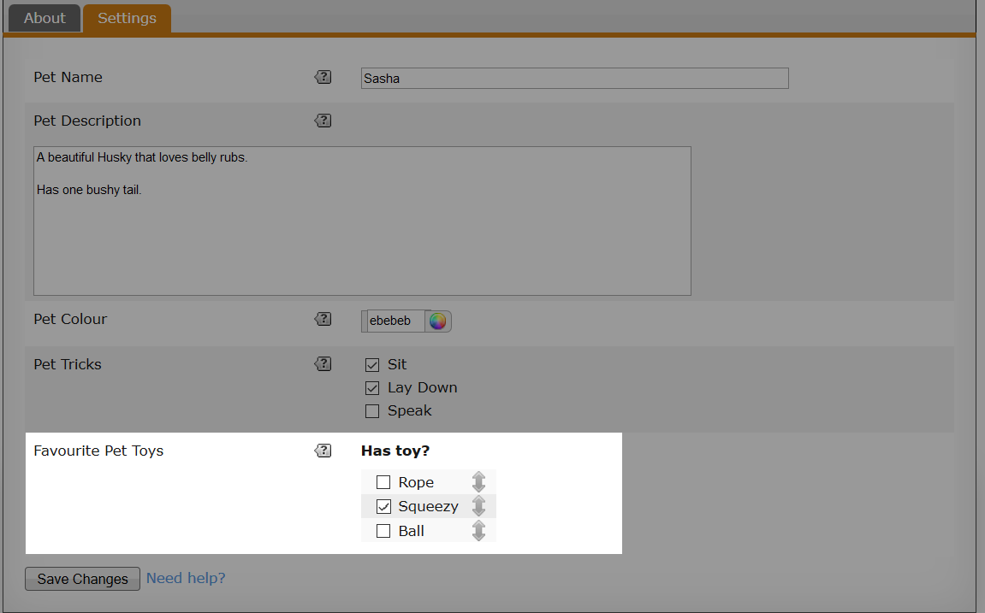
In my plugin, I want to know what the pet's favourite toys are, and also if they still have the toy. So the user would order the toys from best to worst (top being best in my case), and then also tick which toy the pet still has.

Now we have some options saved, we then need to look at how we can grab them from JavaScript.

If you are not sure what type a component will be, then you can log it out to the console and see.

console.log(settings.favourite_pet_toys); // Array

var plugin = pb.plugin.get("example_plugin");

if(plugin){
var settings = plugin.settings;

console.log("Pet Name: " + settings.pet_name);
console.log("Pet Description: " + settings.pet_description);
console.log("Pet Color: #" + settings.pet_colour);

for(var i = 0, l = settings.pet_tricks.length; i < l; ++ i){
console.log("Pet Trick: " + settings.pet_tricks[i]);
}

// Favourite toys

for(var i = 0, l = settings.favourite_pet_toys.length; i < l; ++ i){
var owns = (settings.favourite_pet_toys[i].checked)? " [Owns]" : "";

console.log(settings.favourite_pet_toys[i].value + owns);
}
} else {
console.error("Plugin not found");
}

Adding the JavaScript to our component and then refreshing the front page of our forum should now show the order of our list, and if any items are still owned.

for(var i = 0, l = settings.favourite_pet_toys.length; i < l; ++ i){
var owns = (settings.favourite_pet_toys[i].checked)? " [Owns]" : "";

console.log(settings.favourite_pet_toys[i].value + owns);
}

Lets walk through the code.

settings.favourite_pet_toys

This is our variable ID that we use in the plugin editor for list component. What we get from this property is an Array. This Array can be empty, or be an Array of Objects.

var owns = (settings.favourite_pet_toys[i].checked)? " [Owns]" : "";

My list has checkboxes enabled, so I am checking if each Object in the Array has a property of checked and that it's set to true.
console.log(settings.favourite_pet_toys[i].value + owns);

The other property of the object is value. This is the value that you entered into the plugin editor for your options.
An important thing to remember is that the component can return an Array of Objects.

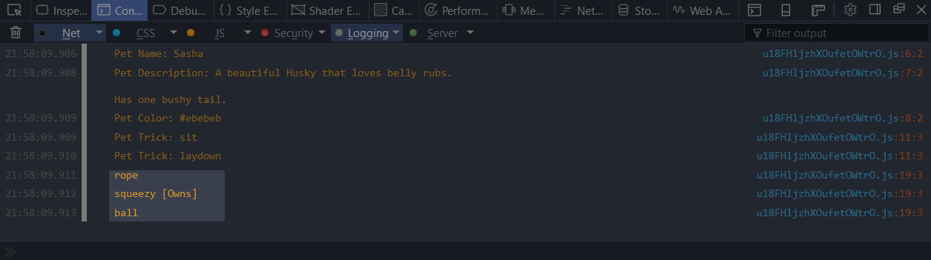
Looking in the console, we can see the order the list is in, and also which options were checked.

Have a play with the component. See what you can come up with.

Image Select

The "Image Select" component allows you to add a selection of images from which the user can choose. These images are those you add to the plugin on the image tab (see chapter 1).

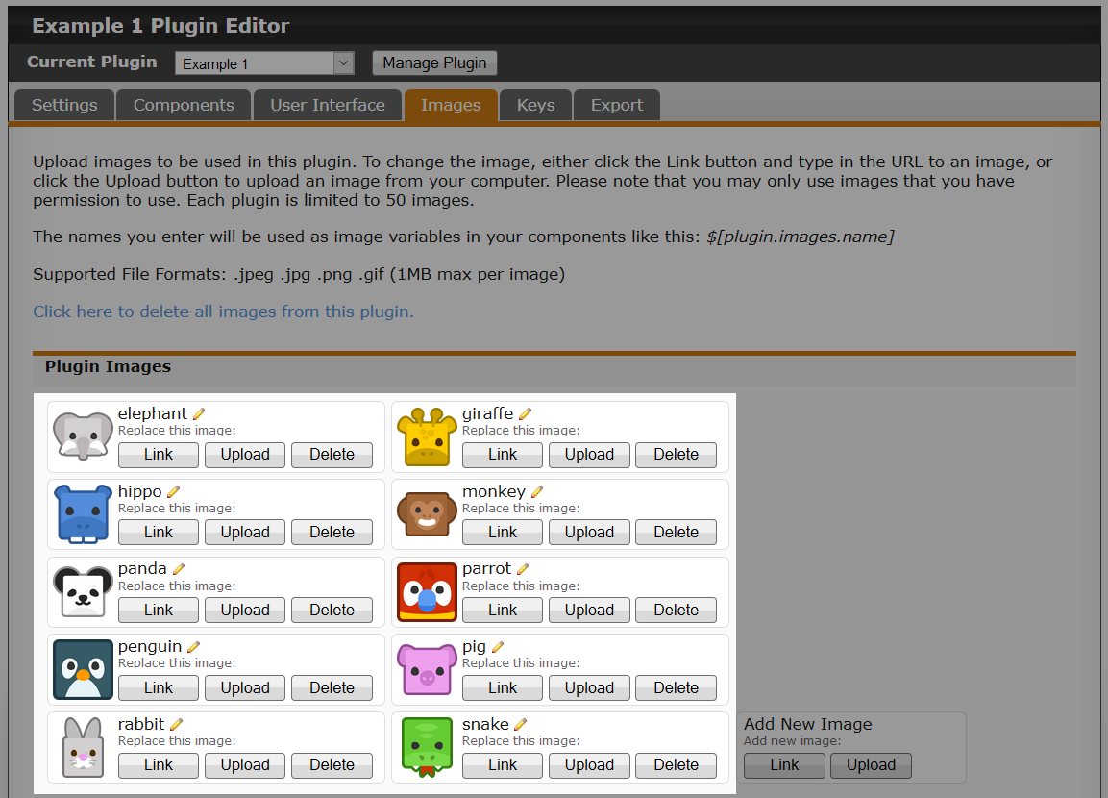
I've added some animal pictures to my plugin. Without any images, the component would be useless. So add some to your plugin if you are following along.

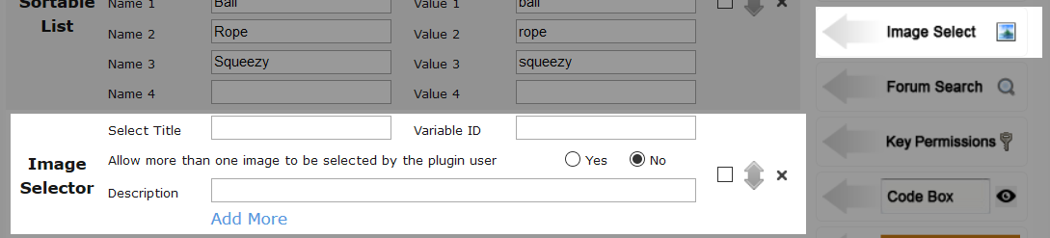
Let's go through the options available.

- Select Title
This will be the title shown to the user for this option.
- Variable ID
The unique value that we will be using in JavaScript to access the value of this component.
- Description
A description to provide additional information or tips to the user.
These are the basic options that you are familiar with now, but there are two more items to cover.

You will see an option called "Allow more than one image to be selected by the plugin user". This can be set to Yes or No. Setting this option to Yes will allow the user to select multiple images from the list that we will provide shortly. Setting the option to No allows the user to select only one image from the list you provide.

Below the description field, you will see a link called "Add More". Let's click on that to see what happens.

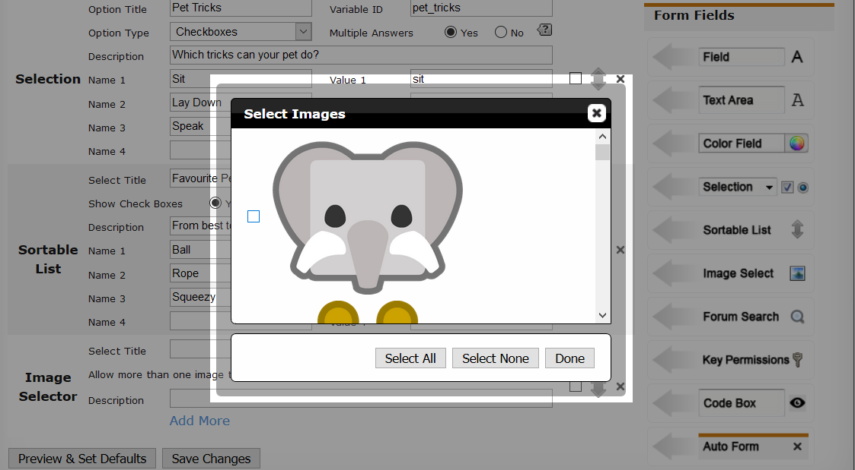
You will see a dialog popup showing you all of the images that you added to your plugin. Along with each image is a checkbox and some buttons at the bottom of the dialog. This is where you select which images the user can select.

Let's select a couple of images, and then click "Done" and take a look at what has changed with the component.

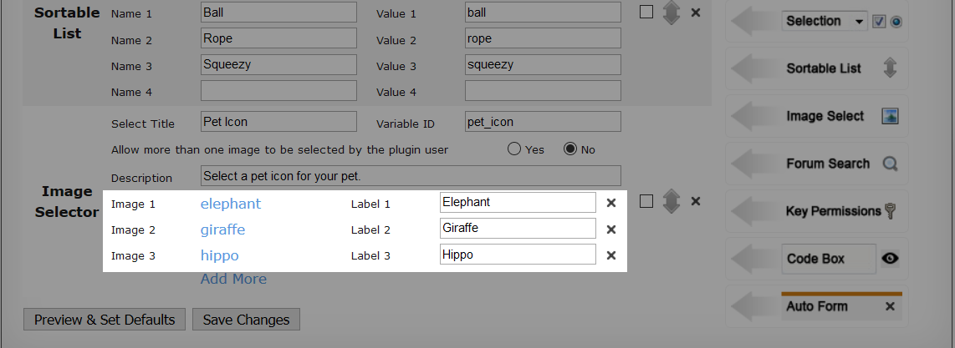
I selected three images. These now show up with the component. You can also label your images to make it clearer to the user what the image is. You can also click the image link to see what the image looks like. We can also add more if we like, and even remove them.

Save your changes, and let's see what this looks like from a user's point of view.
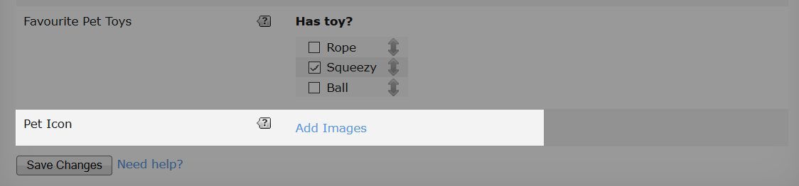
We now have an option to add images. When clicking on the "Add Images" link, we will get a dialog popup with all the images that we selected earlier. So my plugin will show three pet images, and I didn't allow multiple to be selected.
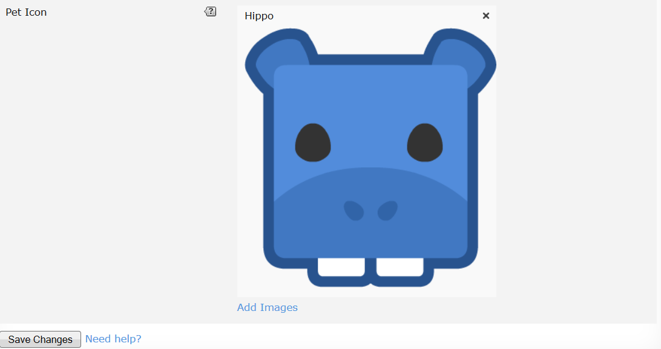
As you can see in the image above, I have selected an image which is the Hippo, as indicated by the label as well.

Let's now take a look at how we can use the component from JavaScript.

var plugin = pb.plugin.get("example_plugin");

if(plugin){
var settings = plugin.settings;
var images = plugin.images;

console.log("Pet Name: " + settings.pet_name);
console.log("Pet Description: " + settings.pet_description);
console.log("Pet Color: #" + settings.pet_colour);

for(var i = 0, l = settings.pet_tricks.length; i < l; ++ i){
console.log("Pet Trick: " + settings.pet_tricks[i]);
}

// Favourite toys

for(var i = 0, l = settings.favourite_pet_toys.length; i < l; ++ i){
var owns = (settings.favourite_pet_toys[i].checked)? " [Owns]" : "";

console.log(settings.favourite_pet_toys[i].value + owns);
}

// Only one image allowed to be selected

console.log(images[settings.pet_icon[0]]);
} else {
console.error("Plugin not found");
}

There are a couple of new lines added which are bolded.

var images = plugin.images;

We can add images to our plugin, but we need a way to retrieve them. ProBoards creates an object for us so that we can fetch any of our images at any time. The images property is an Object where the key is the name of your image in your plugin, and the value is the URL.

console.dir(images); // See inside the images object

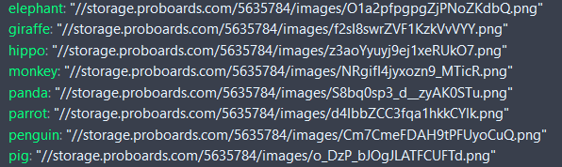
Logging the images object shows us what keys and values we have. The key being the image name and the value being the URL to the image.
For example; if we wanted the "pig" image, we can do this:

console.log(images.pig);

Or

console.log(images["pig"]); // Same as above

Let's look at how we can get the selected value.

console.log(images[settings.pet_icon[0]]);

We have our images Object, but we need to fetch the selected image URL by passing the key. The key will be whatever image was selected.

settings.pet_icon

pet_icon is our variable ID, this will be an Array. There are three possible outcomes.

- Empty Array
If the user has not selected an image, then the Array will be empty.
- One Element in the Array
If only one image is allowed to be selected by the user, then the Array will never be greater that a length of one, so we can directly get the first element without looping.
- Multiple Elements in the Array
If you allow for multiple images to be selected, then the Array needs to be looped over.
In my case, I only allow for one image to be selected, so I can fetch the first element of the Array, as I know it will always be the image selected by the user.

I selected the Hippo, so pet_icon[0] will be a String of "hippo" which is a key in our images Object (see image above).

If we allow mutliple images to be selected, we would then need a loop like so:

for(var i = 0, l = settings.pet_icon.length; i < l; ++ i){
console.log(images[settings.pet_icon[i]]) // URL
}

Remember you don’t need a loop if only one image can be selected, as element 0 will always contain the image selected by the user. A loop will still work, but is not needed in this case.

Forum Search

The "Forum Search" component is extremely useful. It allows us to give the user the ability to search for things that may be awkward to input manually. For example; if we use a "Member" search type, the user can find users and add them to the component which we can then use in JavaScript. This could be useful if you wanted to apply something to the selected members only.

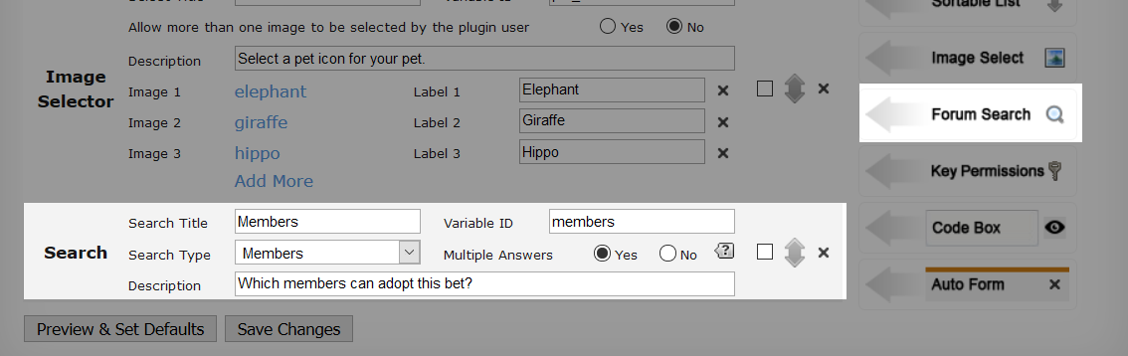
Add the "Forum Search" component to your plugin. I went with a member search, however, there are six different types we can use. Which one you use really depends on what your plugin will be doing.

- Search Title
This is the title that will be displayed to the user.
- Variable ID
The unique value that we will be using in JavaScript to access the value of this component.
- Search Type
There are six types that we can choose from.
Members, Boards, Categories, Themes, Groups, and Custom Pages.
- Multiple Answers
If this option is set to Yes, then the user will be able to select multiple instead of one. This can be useful if you want the plugin to work for specific members that the user chooses.
- Description
A description to provide additional information or tips to the user.

Save your plugin, and go take a look at it from the users point of view.


You can see we have a new area that has a link called "Add Members". Click the link and try out the search.

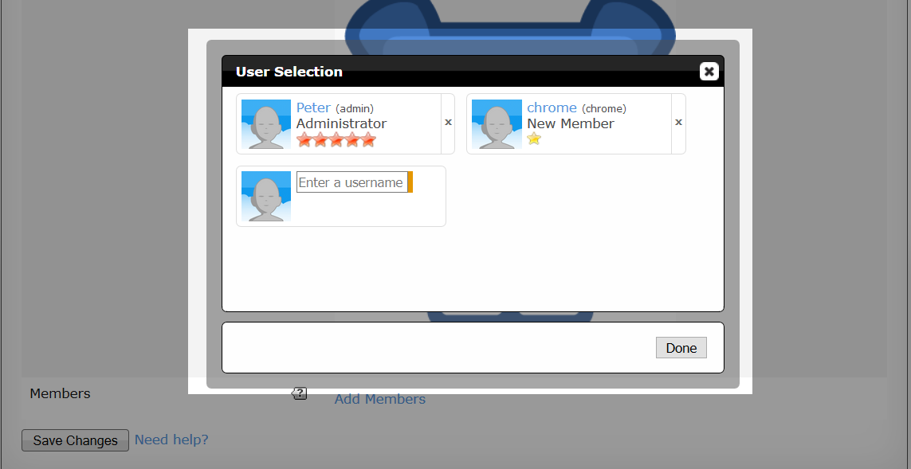
Clicking on the link will show a dialog that allows us to search. Because I chose a member type search, I am able to search for users. This in return, shows me the mini profile for the user searched. I can then add as many users as I like. And I also have the option to remove any. Once I am happy, I can click "Done".

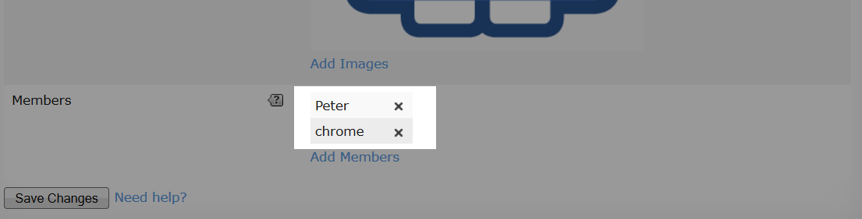
You then see the searched items you selected in the plugin. We can now save and take a look at how we can fetch these from JavaScript.

var plugin = pb.plugin.get("example_plugin");

if(plugin){
var settings = plugin.settings;
var images = plugin.images;

console.log("Pet Name: " + settings.pet_name);
console.log("Pet Description: " + settings.pet_description);
console.log("Pet Color: #" + settings.pet_colour);

for(var i = 0, l = settings.pet_tricks.length; i < l; ++ i){
console.log("Pet Trick: " + settings.pet_tricks[i]);
}

// Favourite toys

for(var i = 0, l = settings.favourite_pet_toys.length; i < l; ++ i){
var owns = (settings.favourite_pet_toys[i].checked)? " [Owns]" : "";

console.log(settings.favourite_pet_toys[i].value + owns);
}

// Only one image allowed to be selected

console.log(images[settings.pet_icon[0]]);

for(var m = 0, l = settings.members.length; m < l; ++ m){
console.log(settings.members[m]);
}
} else {
console.error("Plugin not found");
}

Not much has been added, just a few lines of new code so we can see which users were selected by the user. We are looping over the members Array and logging the value to the console.

settings.members

members is a property of the settings Object, it is the variable ID we set for the search component. The value of this property will always be an Array.

The Array returned back to us will contain the user ID as a String. Let's take a look at the elements in the Array and view them more closely.

console.dir(settings.members);

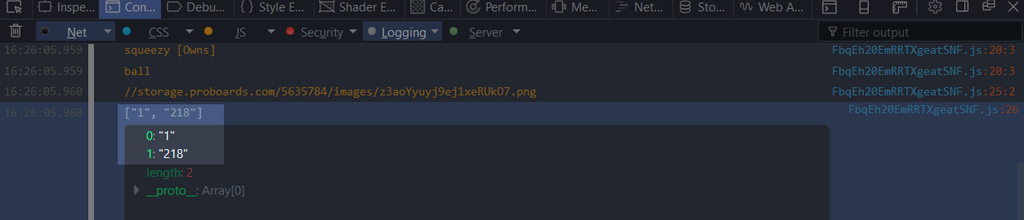
As you can see, each element of the Array is a String that represents the user ID that was selected. ProBoards doesn't output these values as an Integer.

Key Permissions

The "Key Permissions" component allows the user to modify the read and write permissions of the key, as well as some other useful options.

When your plugin has a key, it’s important that this component is included and the default values are setup as you want them. Failing to do this will result in your plugin throwing up a dialog error to the user about not having writing permission.

Our plugin currently does not have a key, but that doesn’t stop us from still using the component to look at the options. In chapter 3, we will look at this a little more closely.

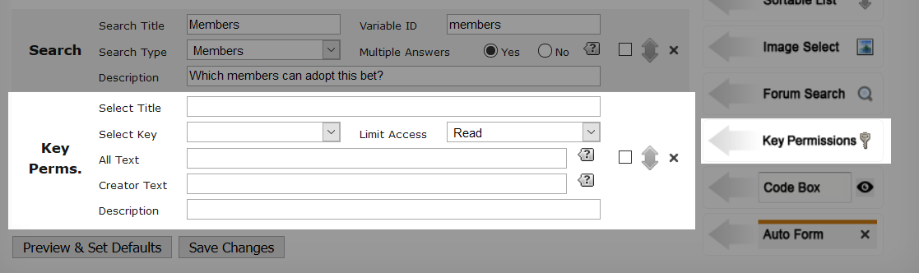
- Select Title
This is the title that will be displayed to the user.
- Select Key
If we had a key, then it would display and be selected by default. If we had multiple keys for our plugin, then we could select the key and apply the permissions to that specific key.
- Limit Access
Keys can be written to, and read from. What we can do here is limit what permissions the user can change. For example, if we wanted to limit what permissions they can set for reading, we would set it to "Read" only. Generally plugin authors will set this to "Read + Write" so the user gets full access. Have a play with the different options and preview the plugin to see the difference.
- All Text
This is the text that will show for each permission type (Read and Write) for the drop down for the member groups. Change it, then preview the plugin to see the difference.
- Creator Text
Because we don’t have a key for our plugin, you won’t see what this effects. What it does is change the text for the checkbox for allowing users to read and write to their own key. If you like, add a temporary key and preview the plugin to see what this is for. Remove the key after you are done if you are following along.
- Description
A description to provide additional information or tips to the user.
The component may be confusing at first, but have a play with it. Generally the default options are good enough, the only thing that needs to be considered is the default read and write permissions.

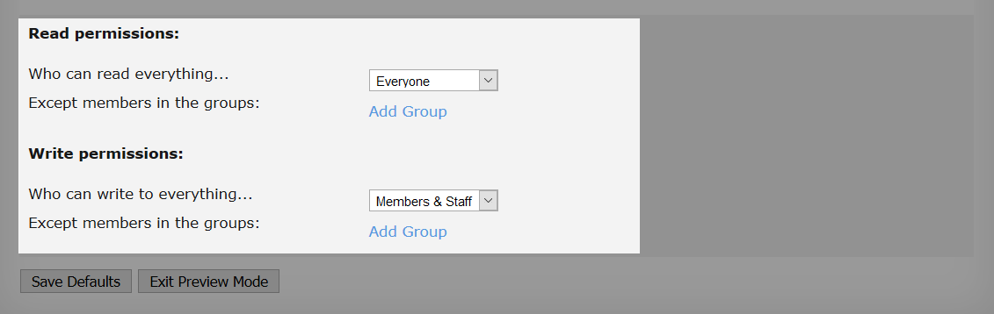
Preview your plugin to see these options.

The options selected in the image are the general defaults I pick if my plugin has a key. Obviously it really depends on your plugin.

My plugin wants to allow "Everyone" (which includes guests) to read from the key. This is useful if you have something that can be seen in a post, or maybe a mini profile, as these are parts of the forum that everyone can usually see.

For the write permissions, I only allow "Members & Staff".

As said before, what permissions you use depends on the key and what your plugin does. For example, A notes plugin would be private to the user. So this would be a private key. Another example, A todo list plugin allows members to see each others list but not modify it. So the read permission would either be "Everyone" or "Members & Staff", and the write permission would be "Staff". Users can read and write to their own key at all times, so this would work nicely.

The best thing to do is to experiment. Once you are comfortable using keys, then this component will become much less confusing. And most of the time you won't need to do much with it apart from setting up a few default values.

For now, remove the component as we won't be doing anything with it.

Code Box

The "Code Box" allows the user to enter anything they like which we can use in our plugin. This can be HTML, CSS, JavaScript, or just plain old text.

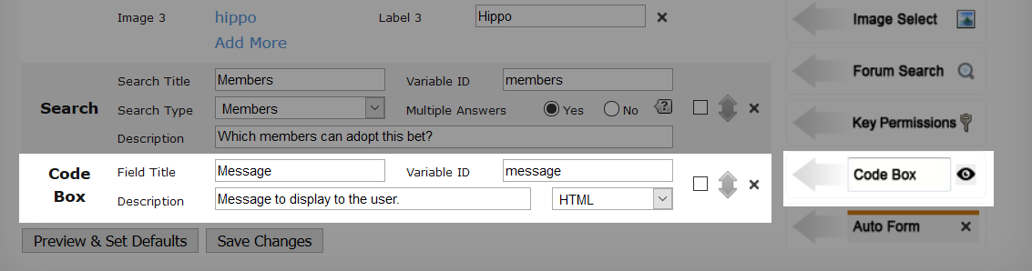
Add a "Code Box" component to to your plugin.

- Field Title
This is the title that will be displayed to the user.
- Variable ID
The unique value that we will be using in JavaScript to access the value of this component.
- Description
A description to provide additional information or tips to the user.
You will then see a drop down that has three options. The option selected doesn't really mean a whole lot. The reason for this, is that plain text is still the output. The only small change that the user may see is syntax highlighting in the code box.

var plugin = pb.plugin.get("example_plugin");

if(plugin){
var settings = plugin.settings;
var images = plugin.images;

console.log("Pet Name: " + settings.pet_name);
console.log("Pet Description: " + settings.pet_description);
console.log("Pet Color: #" + settings.pet_colour);

for(var i = 0, l = settings.pet_tricks.length; i < l; ++ i){
console.log("Pet Trick: " + settings.pet_tricks[i]);
}

// Favourite toys

for(var i = 0, l = settings.favourite_pet_toys.length; i < l; ++ i){
var owns = (settings.favourite_pet_toys[i].checked)? " [Owns]" : "";

console.log(settings.favourite_pet_toys[i].value + owns);
}

// Only one image allowed to be selected

console.log(images[settings.pet_icon[0]]);

for(var m = 0, l = settings.members.length; m < l; ++ m){
console.log("Member ID: " + settings.members[m]);
}

console.log(settings.message);
} else {
console.error("Plugin not found");
}

Only one extra line add which logs out the megssage to the console.

console.log(settings.message);

message is the variable ID for the component which holds the value the user enters in the code box.

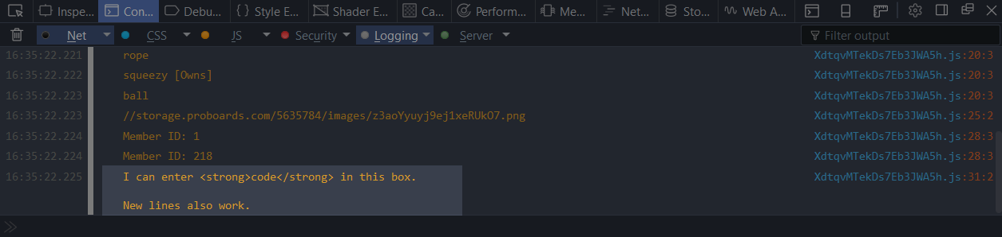
The value of message:

I can enter <strong>code</strong> in this box.\n\nNew lines also work.

Notice that the console parses new lines. However if you were to use the value as HTML, you will need to convert new lines to break tags. This is easy to do as ProBoards provides us with a method to handle that.

Auto Form

The "Auto form" allows you to create a group of components that can be repeated by the user as many times as they like. For example, if you wanted to award different user groups with a different item, then you could have an auto form with a group search, and a text field (e.g., URL to award image). When the user fills the auto form out, a new set of these components will appear so they can fill out another if they choose.

Add a auto form to to your plugin.

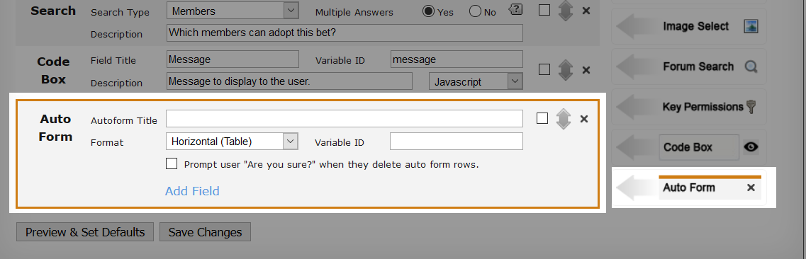
- Autoform Title
This is the title that will be displayed to the user.
- Format
This is how you want the auto form blocks to appear to the user. You have two options available. Which one you use isn't really that important, as it's more of a visual look. Play around with both options to see which you prefer.

- Variable ID
The unique value that we will be using in JavaScript to access the value of this component.
- Prompt User
If enabled, when a user deletes an auto form entry, they will be prompted if they are sure they want to delete the entry. This can be useful if an auto form is likely to have a lot of entries.
At the bottom of the auto form, you will see a link called "Add Field". When clicked on, a dialog will appear that has a list of all the UI components that are allowed to be in the auto form. These components work exactly the same as explained in this chapter, the only difference is the way we access them from JavaScript.
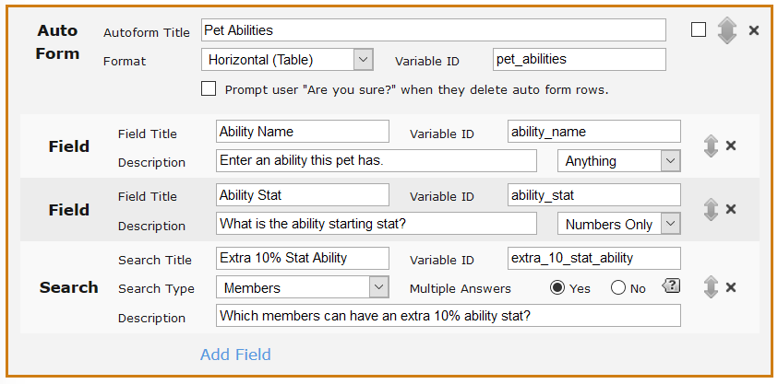
In my auto form example, I want to allow the user to be able to add pet abilities, and also pick which users can get an extra 10% increase.

Don’t forget to preview your plugin to see how the components work. What you see when previewing is exactly what the user will see.

Let’s see what this would look like from a user’s perspective.

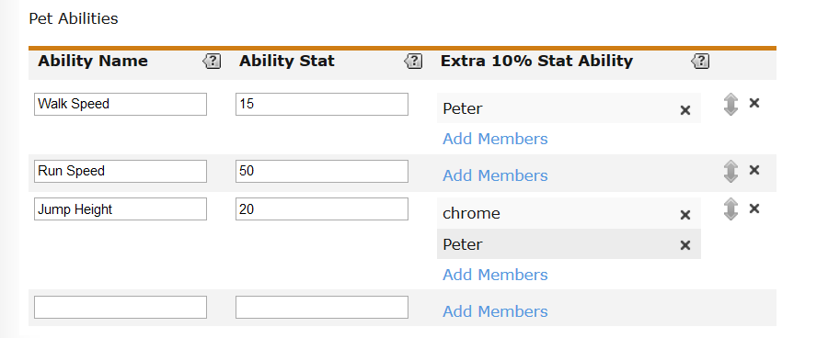
Looking a the image above, you should now be able to see how powerful the auto form component is.

In my example, I added three stats. I also have the option to choose which users can get an increase for that stat. You will see for "Walk Speed" I added myself, so I will get an extra 10% walk speed. "Jump Height" also gives me an extra 10%, but also the user "chrome" will get a 10% extra jump height.

ProBoards will automatically add a new auto form entry that will be blank. This blank entry will always show but is never included in the output.

Now let’s take a look at the JavaScript and then break it down.

var plugin = pb.plugin.get("example_plugin");

if(plugin){
var settings = plugin.settings;
var images = plugin.images;

console.log("Pet Name: " + settings.pet_name);
console.log("Pet Description: " + settings.pet_description);
console.log("Pet Color: #" + settings.pet_colour);

for(var i = 0, l = settings.pet_tricks.length; i < l; ++ i){
console.log("Pet Trick: " + settings.pet_tricks[i]);
}

// Favourite toys

for(var i = 0, l = settings.favourite_pet_toys.length; i < l; ++ i){
var owns = (settings.favourite_pet_toys[i].checked)? " [Owns]" : "";

console.log(settings.favourite_pet_toys[i].value + owns);
}

// Only one image allowed to be selected

console.log(images[settings.pet_icon[0]]);

for(var m = 0, l = settings.members.length; m < l; ++ m){
console.log("Member ID: " + settings.members[m]);
}

console.log(settings.message);

// Auto form

var pet_abilities = settings.pet_abilities;

for(var a = 0, l = pet_abilities.length; a < l; ++ a){
var ability_name = pet_abilities[a].ability_name;
var ability_stat = pet_abilities[a].ability_stat;
var extra_stat_for_members = pet_abilities[a].extra_10_stat_ability;

var output = "";

output += ability_name + " = " + ability_stat;

if(extra_stat_for_members.length){
output += "; Following member IDs get an extra 10%:";

for(var m = 0, ml = extra_stat_for_members.length; m < ml; ++ m){
output += " " + extra_stat_for_members[m];
}
}

console.log(output);
}
} else {
console.error("Plugin not found");
}

So a new block of code has been added that handles logging out everything from the auto form that the user filled in. Looking at the code in bold, there is only one difference compared to how we accessed the components before. The difference is, the components we access in the auto form are accessed inside a loop which is looping over each entry the user created.

For my auto form, I created three entries. All these entries are stored in an array. Once you start looping through them, you can access the components the same way as you did in the code above that block. Let's break the block down a little more to make it a little clearer.

var pet_abilities = settings.pet_abilities;

Here we store a reference to our auto form component. pet_abilities is the auto form component that is in your plugin. It's the variable ID you set for it.

The value of this variable will always be an Array. An auto form is an Array of entries that contain components in each entry. And to be able to access any of these components, we need to loop through the entries.

So what is an entry?

An entry is an Object, this Object contains all the UI components for this entry.

console.dir(pet_abilities);

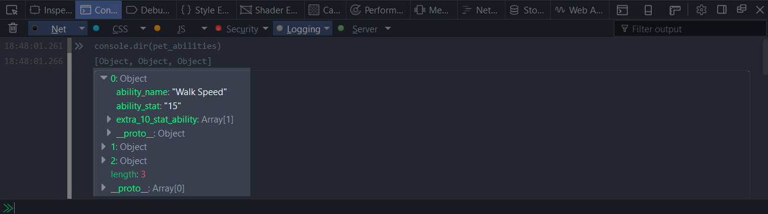
Logging out the variable, we can see it's an Array with three elements (three stats created by the user). Each element is an Object. You can also see that the first element has been expanded so you can see the components inside the Object.

To be able to access any component value in the Object, we need to loop over the elements.

We can access elements without looping, but the problem with that is we will not know how many entries might exist in the Array.

pet_abilities[0].ability_name

The example above shows how we can access the ability_name component from the first element in the Array without looping over all the entries.

That's it for auto forms. The thing to remember is that the reference to your auto form is an Array that needs to be looped through. Each element in the Array is an Object that contains the UI components for that auto form entry.

Don’t forget to use the browser console. You can easily log out the auto form reference to see what is contained within. Each element is an Object that can also be expanded to see what the UI component variable ID is.

Have a play around with adding different components in your auto form and try to access the values in the console.

Default Values

Something we haven't discussed yet that you may have seen when previewing your plugin components, is the ability to set default values for them.

In the plugin editor, you will see a button at the bottom called "Preview & Set Defaults".

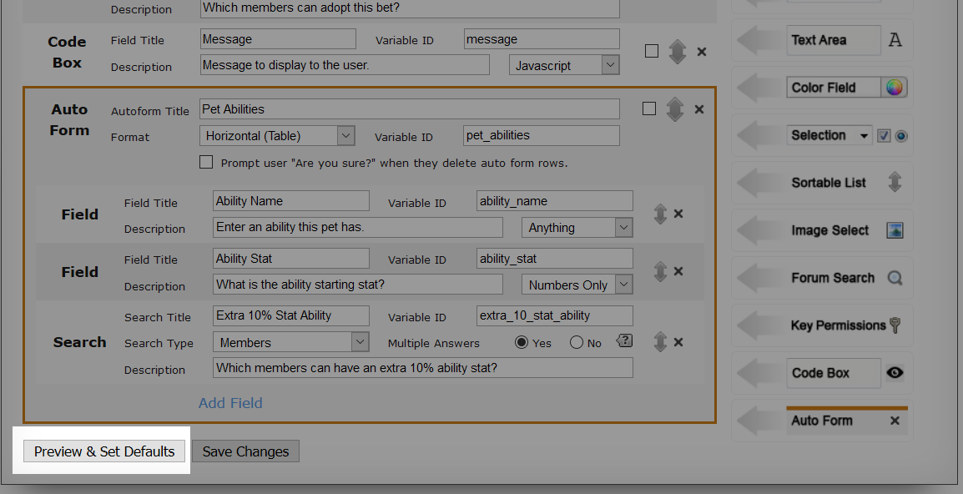
Clicking on that button will preview your plugin. This is exactly what the user will see when editing your plugin. On this preview page, we can set defaults for any component, including auto forms. Once you have set the values, just click on the "Save Defaults" button.
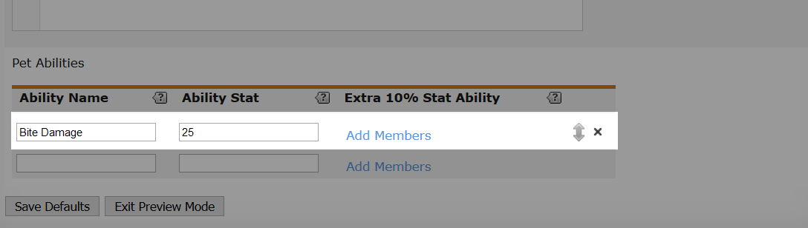
So now, my plugin will have a default stat "Bite Damage" that will show up in the plugin for the user. This default value will only show if the user has not edited the plugin already.

Chapter 3: Keys

In this chapter we will be covering everything to do with keys. We will cover all of the methods you can use and the events, which will also include JavaScript code to show how we can use each key method and event.

Prior to ProBoards version 5, we had to store data in profile fields. We were extremely limited on how much we could store, and once a mod was removed, it left behind long strings of data in the fields which appeared across the forum.

Keys allows us to store a limited amount of data that is persistent,. This means that once we set it, it will contain that data for as long as we or the user clears it. This data is available to us on the page, although depending on what type of key you use, the data may only be available on specific pages.

We will create a new example plugin for this chapter. The ID for this plugin will be "example_plugin_keys" and it will have one JavaScript component.

Key Setting Guideline

Before we jump in, we need to cover an important guideline about setting keys.

Setting a key must be done from a user action.
What does this mean? Simply put; for your plugin to be able to set a key (e.g., updating the data in the key), it must be set from something that the user does on the page.
Example: Not allowed; Setting your key on page load.
Example: Allowed; User clicked on an element (e.g. a button).

Key Sizes

Something to know about keys, is how much data can you really store. ProBoards says the following:

"All keys except super forum keys have up to 4,000 bytes of storage space per item the key is applied to (for example, each user for a user key has 4,000 bytes of storage). Super forum keys have up to 32,000 bytes of storage space."

So the limit of keys according to ProBoards, is in "bytes". This is incorrect currently, and I would go as far as to say, this is a bug or maybe incorrect wording (more likely the latter). The reason I say this, is because when you save to a key, a check is done client side by ProBoards on the length of the key value, not how many bytes the key value is.

So while the limit is a character limit set client side, the actual byte limit is higher than what ProBoards states depending on the byte size of the characters.

Characters that are 4 bytes (UTF-8) are considered 2 characters.

Key Type | Stated Size | Real Size | Max Characters (< 4 Bytes)
Conversation | 4,000 bytes | 12,000 bytes | 4,000
Forum (Super) | 32,000 bytes | 96,000 bytes | 32,000
Message | 4,000 bytes | 12,000 bytes | 4,000
Post | 4,000 bytes | 12,000 bytes | 4,000
Thread | 4,000 bytes | 12,000 bytes | 4,000
User (Private) | 4,000 bytes | 12,000 bytes | 4,000
User (Super) | 4,000 bytes | 12,000 bytes | 4,000

Key Types

There are 7 key types. Which one you use really depends on what you want to accomplish with your plugin. To make the decision easier for you, I have constructed a list of all the key types below, and included an example use case for each key. This should hopfully give you a better idea which key to pick for your plugin.

- Conversation
A conversation key can be used on pages where a conversation between users takes place, or in the message list as long as the message title appears on the page. This key is identical to the Thread key, but for the conversation thread instead.
Example plugin:
A plugin that allows the conversation creator to set a colour for the title of the conversation. The user would be able to set a colour which gets stored in the key, and in the message list for all users who are in that conversation will see the title colour.
- Forum (Super)
This key is the only key that is available on every single page of the forum, and allows for more data to be saved then all the other key types.
Example plugin:
A plugin where users are only allowed to place one secret bid for an item set by staff. This bid would get pushed to the forum key, and eventually, the system will close to bids automatically. Whoever made the highest bid is announced as the winner of the item.
- Message
A message key is exactly the same as a post key but for conversations. You can store data for each message in the conversation. The key data will be available on all pages where the message appears.
Example plugin:
A plugin that allows the users in the conversation to edit their own messages within a certain time period. This could be a small edit to the message, or adding additional information to the existing message.
- Post
A post key allows you to store data for each post in a thread. The data will be available on all pages where the post appears.
Example plugin:
Allow users to add a reaction to the first post of the thread only.
- Thread
A thread key allows you to store data for the thread. Any page that this thread appears on, including the title, will allow you to access the key data.
Example plugin:
Allow users to like a thread.
- User (Private)
A private user key is a key that is private for that user. The data for this key will be available only to the user, no other user can view or edit this key.
Example plugin:
A plugin to allow the user to store private notes for themself.
- User (Super)
This key is probably the most used key of all of the keys available. The data stored in this key is available on all pages that the user appears on (e.g., mini profiles).
Example plugin:
A plugin that allows users to virtually slap each other with a wet stinky fish. Each time you are slapped, a counter is incremented and shown in your mini profile for all to see.

JavaScript Key Basics

Before we look at the key API methods, it would be good to explain something that will appear in nearly all of the sections below. In this way, I won’t need to repeat the explanation each time you see the code below.

Getting a reference to a key requires you to use the ProBoards API, and that you know the unique key ID. Let’s look at how we can get a reference to a key, however this key does not really exist, but will give you an idea of what JavaScript is needed.

var my_key = pb.plugin.key("my_plugin_key_id");

The key method takes an argument, that being a String. This needs to be the key ID that you created for your plugin. We will get an Object returned back which will allow you to call any of the key API methods. The variable my_key will now hold a reference to all those methods for the key.

If a key ID is incorrect or the key doesn’t exist, you will still get back an Object with all the key methods. You will only get a JavaScript error when you attempt to use one of the methods in the Object that was returned.

Let’s take a look and see.

console.dir(pb.plugin.key("my_plugin_key_id"));

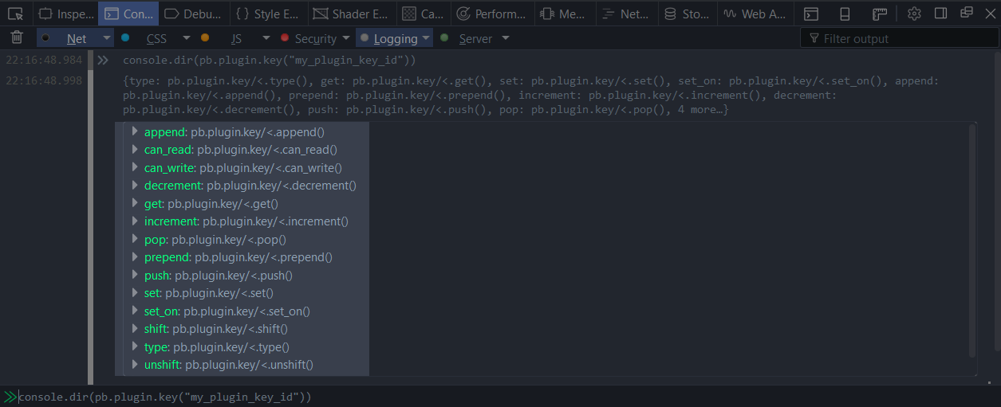
Looking at the image above, you can see all of the methods that we have available to us.

Now there may be a good reason to check the existence of a key. There is no public documented API to do this, so we have to handle it ourself. This is actually easy to do.

if(proboards.plugin._keys["my_plugin_key_id"]){
console.log("Key exists");
} else {
console.log("Key doesn't exist");
}

Every key on the forum will have an entry in the _keys Object.

This could be helpful if you want to read data from another key that is related, but is in another plugin that you didn’t create.

Key API

In the following sections we will be going over all the API methods you can use with keys It will explain what each method does, and how we use it.

For all the sections below that explain the key methods, we will be using a key type of "User (super)".

Get

Before we can look at using any of the other key methods in this chapter, we need to understand how to use the get method first.

The get method allows us to get the data that is stored in the key.

var my_key = pb.plugin.key("example_super_user");
console.log(my_key.get());

We store a reference to the key Object in my_key, and then we called get to return the data in the key. If the key has not been set, then it will return undefined, otherwise it will return the data in the key.

The get method also allows us to pass in a parameter. This parameter is an object ID. In our case it will be the user ID. If the key for the user exists on the page we are viewing, then we can fetch that users key data by passing the ID.

console.log(my_key.get(1));

In the example above, I want to fetch the key data for the user ID 1. If that user appears on the page (e.g., mini profile), then we will be able to see what data is stored in the key.

The parameter value you pass is based on what type of key you are using. In this example, it will be a user ID as the key type is "user". If for example your key was a post type, then the ID you pass would be the ID of the post you want to fetch the key data for.

ProBoards uses JSON.parse() on the key data, so you do not need to handle converting the value back into an Array or Object.

Set
The set method is probably one of the most important key methods you can learn along with the get method. This method simply allows you to set the data for a key.

Add a new key to your plugin called "example_super_user", and choose "User (super)" as the key type.

var my_key = pb.plugin.key("example_super_user");

my_key.set({

value: "Hello World"

});

my_key holds a reference to the Object that holds all the key methods you can use. In this case we want to use the set method.

my_key.set({

value: "Hello World"

});

The set method requires an Object to be passed. This Object can contain various key value pairs, but we will only talk about two of them for now. Later in this chapter we will cover the other possible keys we can use.

- value
This will be the data which you want the key set to. This can be nearly anything you like (e.g. Array, String, Object), as ProBoards will handle converting it into a String before it is sent to the server via an AJAX call to be saved.
ProBoards uses JSON.stringify, and then does a character count on this data to make sure it isn't larger than the maxiumn size allowed for your type of key. In this case for a super user key, we can store 4,000 characters.

Because the key being used is a user key, if no user ID is passed in, then ProBoards will assume that you are saving the key for the user currently viewing the page. So in our case, if we run the code in the console, it will save it for ourself.

But what if you want to save the data for a different user? All we need to do is pass another key value pair, where the key will be object_id.

var my_key = pb.plugin.key("example_super_user");

my_key.set({

value: "Hello World",
object_id: 2

});

So now we have a new key called object_id with a value of 2. The value 2 is the user ID I want to set this key for. I could change this to any ID I like and it will set the key for that user.

object_id is a generic key name because it can be used for different things depending on the key type you are using. For example; if you use a post key, then the object_id value will be a post ID instead of a user ID.

If calls to the set method are called under 100ms of each other, then ProBoards will queue them up. Once 100ms passes, it will send them all as one AJAX call.

Have a play around in the console setting the key for different users and fetching the data.

Set On

The set_on method allows you to set a key when a specific action occurs. Currently these actions are form submit actions.

set_on takes three parameters:

- hook
This is the name of the action. There are only 4 hooks you can use, though only two of them are documented. These are passed in as a String.

  - thread_new
Use this hook when a new thread is created.
  - conversation_new
Use this hook when a new conversation is created.
  - post_new
Use this hook when a new post / message is created.
  - post_quick_reply
Use this hook when a quick reply (including in conversations) is created.
  - message_new
Use this hook when a new conversation is created.
- object_id
This is the ID of the object (e.g. thread ID, post ID, conversation ID, message ID, user ID). This is an optional parameter, and if you don't pass in an ID, then it will use the user ID of the user viewing the page depending on the key type.
- value
This is what you want to store in the key.

set_on will return false if there is no form that the hook can be created for. Otherwise it will return true.

There are a couple of other hooks that aren’t listed because they are not officially listed by ProBoards.

Now let's have a look at an example of using it with a hook. To be able to use the set_on method, we need to be on a page where the event will fire. On the forum, go to a board and click "New Thread". On this page we will enter our JavaScript into the console and then create a new thread and look at what is in the key.

var my_key = pb.plugin.key("example_super_user");

my_key.set_on("thread_new", pb.data("user").id, "New thread created");

Once we create the thread, we will be taken to the view thread page, where we can see if anything was saved into the key.

console.log(pb.plugin.key("example_super_user").get()); // "New thread created"

What happens when we call set_on, is ProBoards will either look for a hidden field or create one where it will set the value of that field to the value (stringified) you passed in.

Let's look at how we can use this without entering it into the console. This time we will capture the timestamp of when the user loads the thread page, but we will only save the data to the key if the post is created.

var my_key = pb.plugin.key("example_super_user");

if(pb.data("route").name == "thread"){
my_key.set_on("post_quick_reply", pb.data("user").id, + new Date());

var key_value = parseInt(my_key.get(), 10);

if(key_value){
console.log(new Date(key_value)); // Example output: "Date 2017-02-18T16:38:34.511Z"
}
}

So looking at the line in bold, we use the post_quick_reply event, as we are only interested in saving to the key if the user uses the quick reply. Because the quick reply event can be used for messages in conversations, we check the route name to make sure it is the thread page we are viewing.

You don't need to pass the object ID. ProBoards will handle it for you. But it's good practice, so I recommend getting in the habit.

So why use set_on over set? The difference is, set will issue an AJAX call and attempt to update the key as soon as it can depending on the rate that set is being called. set_on will only update the key when the action is completed. Meaning, ProBoards will only save to the key on the server (e.g when a thread is created server side).

Experiement with different pages that support the events mentioned.

Append

The append method allows you to append to the data in your key. There is a restriction on what types of data you can append. The data type of the key must be either a String or Number, otherwise ProBoards will display an error.

var my_key = pb.plugin.key("example_super_user");

my_key.append({

value: 1

});

console.log(my_key.get()); // 1

my_key.append({

value: "two"

});

console.log(my_key.get()); // "1two"

my_key.append({

value: 3

});

console.log(my_key.get()); // "1two3"

As you should be able to see when using the append method, we are using it in exactly the same way as the set method. The only difference is that the method being used is doing something different. In this case, appending to the data each time you call the method.

At the moment we are appending to our own key But we can also include an object id if we want to change another user's key.

my_key.append({

value: 3,
object_id: 2 // User ID 2

});

console.log(my_key.get()); // "3"

Decrement

The decrement method allows you to decrease the number being stored in the key. If the key data is not a number, then you will get an error dialog. So it’s important to set a number first before you call this method.

var my_key = pb.plugin.key("example_super_user");

my_key.set({

value: 10

});

console.log(my_key.get()); // 10

Now our key data is a number which is set to 10.

my_key.decrement();

console.log(my_key.get()); // 9

Calling decrement with no options will decrease the number in the key by 1. If we like, we could make it decrease by more each time.

my_key.decrement({

value: 2 // Decrease by 2 each time

});

console.log(my_key.get()); // 7

decrement will not stop at 0. It will keep decreasing the number. So if you don’t want a negative number, you will need to put a check in place.

Let’s talk about a small problem we have with this method. This method requires that the default data in the key is a number, so we must set before we can decrement. Let’s look at how we can solve this properly.

var my_key = pb.plugin.key("example_super_user");

if(my_key.get()){
my_key.decrement();
} else {
my_key.set({

value: 10

});
}

console.log(my_key.get());

What we have done is checked to see if the data in the key exists. get will return either the data in the key, or undefined, if the data is undefined. Then we set the key to a number of 10. Next time this piece of code runs, it will decrement each time.

You may be thinking that the if condition will fail if the number reaches 0, as 0 is a false value. ProBoards returns the number back as a String, so in this case if it hits 0 it will actually be "0". So this will become a true condition.

Increment

increment works exactly the same as decrement, only it increases the number.

var my_key = pb.plugin.key("example_super_user");

my_key.set({

value: 0

});

console.log(my_key.get()); // 0

First we need to set a default starting number.

my_key.increment();

console.log(my_key.get()); // 1
Calling increment with no options will increase the number in the key by 1. If we like, we could make it increase by more each time.

my_key.increment ({

value: 5 // Increase by 5 each time

});

console.log(my_key.get()); // 6

Pop

pop will remove the last item or a number of items that you can specify from the end of the Array. Those items that are popped off are returned back to you as a String if one item is popped, or an Array if multiple items are popped, and key data is updated with the items removed.

Before we can try popping any items, we need to make sure that the data type is an Array, otherwise ProBoards will display an error letting us know.

var my_key = pb.plugin.key("example_super_user");

my_key.set({

value: ["apples", "pears", "oranges"]

});

console.dir(my_key.get()); // ["apples", "pears", "oranges"]

We set the data in the key as an Array with 3 elements.

var popped_item = my_key.pop();

console.log(popped_item); // "oranges"

Using the pop method with no options, we will get one item popped off from the end of the Array that is stored in our key. This item is returned back to us as a String. In this cases the last element being "oranges".

Let’s add some more items to the Array in the key and try popping of multiple items this time.

my_key.set({

value: ["one", "two", "three", "four", "five", "six"]

});

console.dir(my_key.get()); // ["one", "two", "three", "four", "five", "six"]

var popped_items = my_key.pop({

num_items: 3

});

console.dir(popped_items); // ["six", "five", "four"]

In this case, we want to pop off three items, so we pass an Object to the pop method that contains a key called num_items. The value of num_items is an Integer for how many items we want to pop off and be returned back.

You will notice that the order of the items returned back is reversed, as it is the order in which they were last in the Array.

Prepend

The prepend method allows you to insert at the front of the data in your key. There is a restriction on what types of data you can prepend to. The data type of the key must be either a String or Number, otherwise ProBoards will display an error. If the key data is undefined, then ProBoards will set the data to the first value you pass in.

var my_key = pb.plugin.key("example_super_user");

my_key.prepend({

value: 1

});

console.log(my_key.get()); // 1

my_key.prepend({

value: "two"

});

console.log(my_key.get()); // "two1"

my_key.prepend({

value: 3

});

console.log(my_key.get()); // "3two1"

Don't forget that we can use these methods for other users instead of our own key by adding the object_id key and setting the value as the user ID.

my_key.prepend({

value: 3,
object_id: 2 // User ID 2

});

console.log(my_key.get()); // "3"

Push

The push method will push a value, or multiple values to the end of the Array. You will need to make sure that the data type in the key is an Array. Otherwise, you will get an error unless the key data is undefined. If it is undefined, then ProBoards will create a new Array with the items you are pushing.

var my_key = pb.plugin.key("example_super_user");

my_key.push({

value: "A"

});

console.dir(my_key.get()); // ["A"]

When we pass an Object to the push method, this Object contains a key called value with the String value of "A". Because our key data is undefined, ProBoards will create an Array with 1 element containing the String "A".

A better way to make sure that the data type is an Array is to check it before updating the key. If it is not an Array type, then we can make it one.

var my_key = pb.plugin.key("example_super_user");

if(!Array.isArray(my_key.get())){
my_key.set({

value: ["A"]

});
} else {
my_key.push({

value: "A"

});
}

The "if" condition checks to see if the data in the key is an Array. If it isn't, we set the data to an Array with 1 element, otherwise we use the push method.

We can also push multiple items at once.

var my_key = pb.plugin.key("example_super_user");

my_key.push({

values: ["B", "C", "D"]

});

console.dir(my_key.get()); // ["A", "B", "C", "D"]

Instead of using value, we use values. This must be an Array with all of your items you want to push to the end of your key data.

As with all of the methods, you can pass an object_id if you want to set the key for something specific (e.g. a user).

Shift

The shift method works much like the pop method, only instead of removing items from the end of the Array, it removes them from the front. For this method to work, the data type in the key must be an Array, or you will get an error.

Let’s setup some basic code first to make sure that we have an Array with some elements.

var my_key = pb.plugin.key("example_super_user");

if(!Array.isArray(my_key.get())){
my_key.set({

value: ["One", "Two", "Three", "Four", "Five", "Six"]

});

console.dir(my_key.get()); // ["One", "Two", "Three", "Four", "Five", "Six"]
}

Now we have an Array, we can remove elements from the front.

my_key.shift(); // "One"

Using the method without any options will remove the first item in the Array that is in our key and return it back to us.

var items = my_key.shift({

num_items: 2

});

console.dir(items); // ["Two", "Three"]
console.dir(my_key.get()); // ["Four", "Five", "Six"]

This time we pass in an options Object. We can remove more them 1 item from the front of the Array by using an option key called num_items, and the value being how many items we want to remove. These items are returned back to us, but removed from the key.

Unshift

The unshift method works similar to the push method, only it will add the items to the front of the Array, whereas the push method will add the items to the end of the Array. You will need to make sure that the data type in the key is an Array. Otherwise, you will get an error unless the key data is undefined. If it is undefined, then ProBoards will create a new Array with the items you are unshifting.

var my_key = pb.plugin.key("example_super_user");

my_key.unshift({

value: "A"

});

console.dir(my_key.get()); // ["A"]

When we pass an Object to the unshift method, this Object contains a key called value with the String value of "A". Because our key data is undefined, ProBoards will create an Array with 1 element containing the String "A".

A better way to make sure that the data type is an Array is to check it before updating the key. If the it is not an Array type, then we can make it one.

var my_key = pb.plugin.key("example_super_user");

if(!Array.isArray(my_key.get())){
my_key.set({

value: ["A"]

});
} else {
my_key.unshift({

value: "A"

});
}

The "if" condition checks to see if the data in the key is an Array. If it isn't, we set the data to an Array with one element. Otherwise, we use the unshift method.

We can also unshift multiple items at once.

var my_key = pb.plugin.key("example_super_user");

my_key.unshift({

values: ["B", "C", "D"]

});

console.dir(my_key.get()); // ["A", "B", "C", "D"]

Instead of using value, we use values. This must be an Array with all of your items you want to unshift to the front of your key data.

Can Read

The can_read method allows you to check if a key can be read by the user viewing the page. Either true or false will be returned back. If the key doesn’t exist, then undefined will be returned instead.

var my_key = pb.plugin.key("example_super_user");

if(my_key.can_read()){
console.log("Can read key");
} else {
console.log("Can't read key");
}

By default it will use a user object ID, of the user viewing the page. You can pass in the object ID (e.g. post ID) you want to check.

var post_id = 123;

if(my_key.can_read(post_id)){
console.log("Can read post key");
} else {
console.log("Can't read post key");
}

This method can be useful, for example, if the key doesn’t allow guests to read. Then you could display a message to tell them they will need to login.

Can Write

The can_write method is similar to the can_read method, but checking if the user viewing the page can write to the key.

var my_key = pb.plugin.key("example_super_user");

if(my_key.can_write()){
console.log("Can write to key");
} else {
console.log("Can't write to key");
}

By default it will use a user object ID, of the user viewing the page. You can pass in the object ID (e.g. post ID) you want to check.

var post_id = 123;

if(my_key.can_write(post_id)){
console.log("Can write to post key");
} else {
console.log("Can't write to post key");
}

Type

The type method can be used to find out what type of key the plugin is using. This method will return back an Integer.

var my_key = pb.plugin.key("example_super_user");

console.log(my_key.type()); // 2 (Super User key)

By itself, it really isn't of much use unless you know all of the different Integers for the key types. ProBoards has another method we can use to fetch all of the different key types. We can then tell which type of key the plugin is using.

console.dir(pb.plugin.key_types()); // {USER: 1, SUPER_USER: 2, THREAD: 3, POST: 4, CONVERSATION: 5, MESSAGE: 6, SUPER_FORUM: 7}

pb.plugin.key_types() will return an Object that contains key value pairs. The key gives us a better idea what type of key the plugin is using. In the case of the example playing, we are using a "SUPER_USER" key type, as that is Integer 2.

var my_key = pb.plugin.key("example_super_user");
var plugin_key_type = my_key.type(); // 2 (Super User)
var key_types = pb.plugin.key_types();

for(var key in key_types){
if(key_types.hasOwnProperty(key) && key_types[key] == plugin_key_type){
console.log(key); // SUPER_USER
break;
}
}

Callbacks

ProBoards supports three call backs when using any of the key methods.

Error Callback
A function to call if the request fails.

Example:

var my_key = pb.plugin.key("example_super_user");

my_key.set({

error: function(status){
console.log(status.message);
}

});

Notice a value was not passed. This is so we can force the error callback to happen. The error callback will provide us with a status Object containing the error message and code.

Complete Callback
A function to call once the request finishes. This will fire regardless if there is an error or not.
Example:
var my_key = pb.plugin.key("example_super_user");

my_key.set({

complete: function(){
console.log("Request complete");
}

});

Success Callback
A function to call if the request succeeds.
Example:
var my_key = pb.plugin.key("example_super_user");

my_key.set({

success: function(){
console.log("Success");
}

});

Chapter 4: Pet Picker

In this chapter we are going to use what we have learned from the previous chapters to create a complete plugin.

The plugin we will be creating will allow the users to select a pet from a dialog, and that pet will show up in their mini profiles for others to see. We will also add an option in the dialog to allow the users to set a name for their pet.

We will be covering building the UI, creating a key, and writing all the JavaScript for the plugin.

Creating The Plugin UI

There won't be a lot of UI for this plugin, as all the images will be pre-entered. We do need to allow some text customisation. Maybe they don't want it to be a "Pet", so we will add in a field to allow switching out the text that will appear in the dialog to the user.

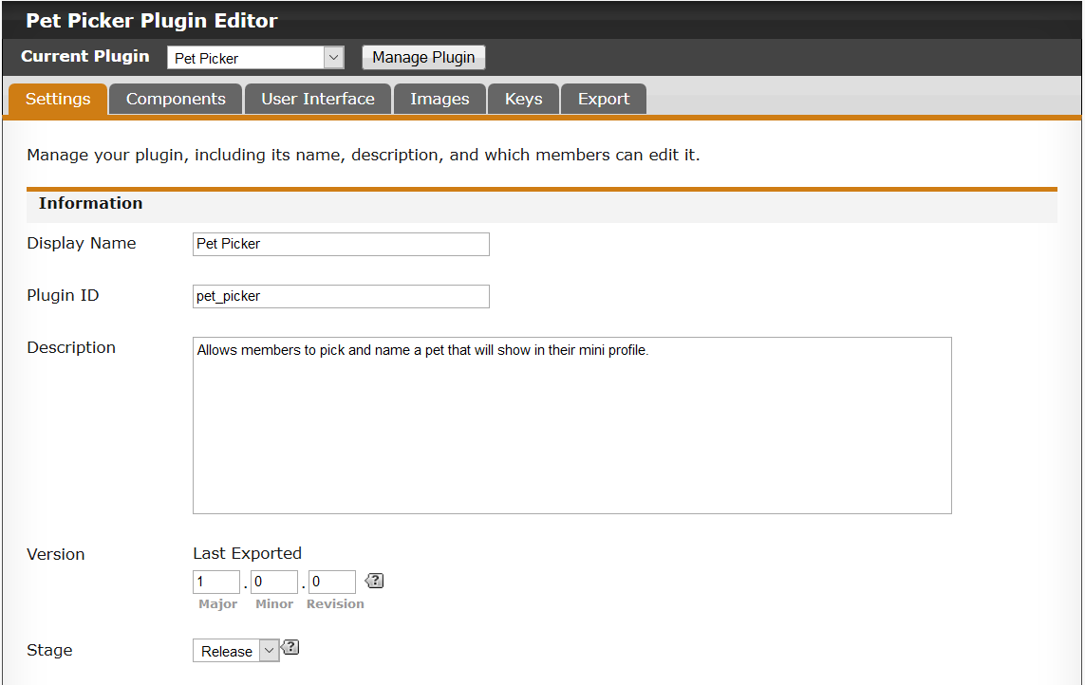
Here is a look at the plugin settings I will be using.

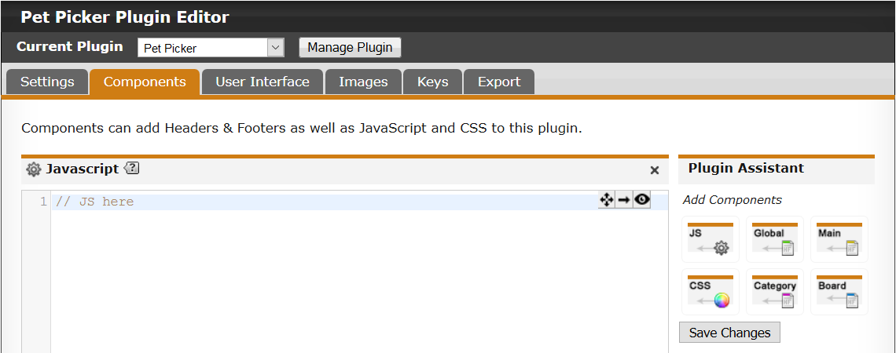

We need a JavaScript component for the plugin.

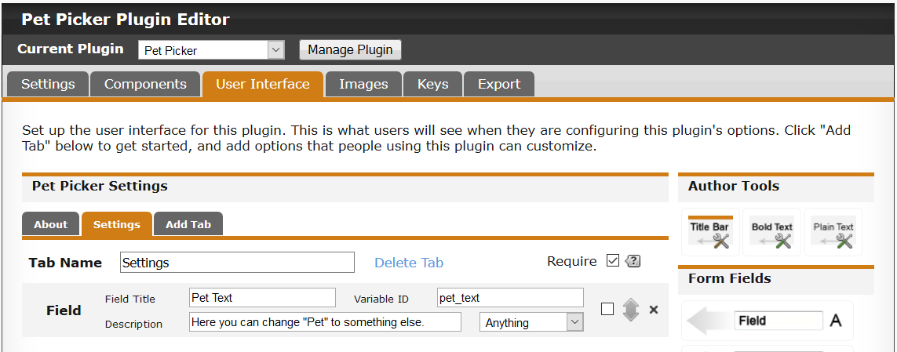
Next we need to add a new tab. I called it "Settings". On this tab I add a text field so that the user will be able to change "Pet" to something else if they wish.

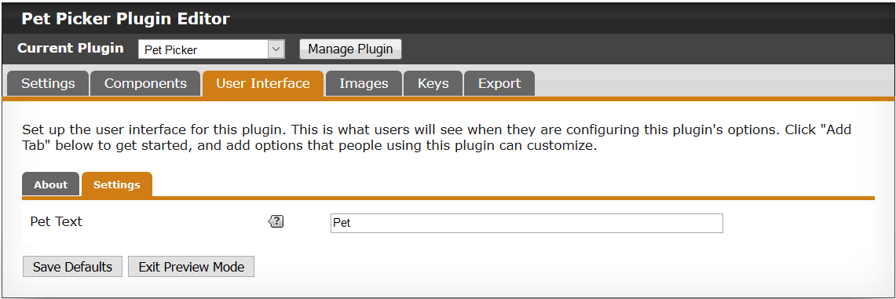
I also setup what the default text of the field will be. We don't have to do this. We could do it in JavaScript. But I think it's a nicer touch, as the user will see the default on their end.

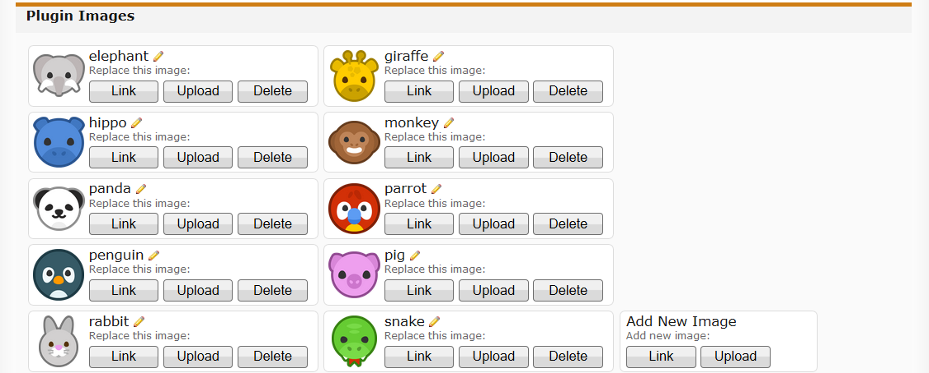
On the images tab, I've uploaded the images that the users can select from.

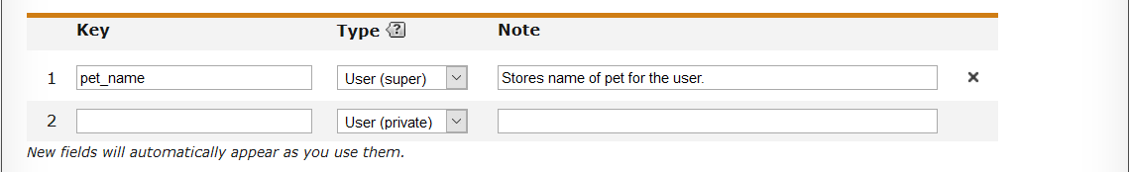
We also need a key for this plugin. We want to allow users to enter a name for their pet that will show up when hovering the mouse over the image, as well as saving their selection. We will use a Super User key here because we want to allow everyone else to read from the key. But only the user and staff can write to the key. We will need to go back to the User Interface tab and setup our key permissions.

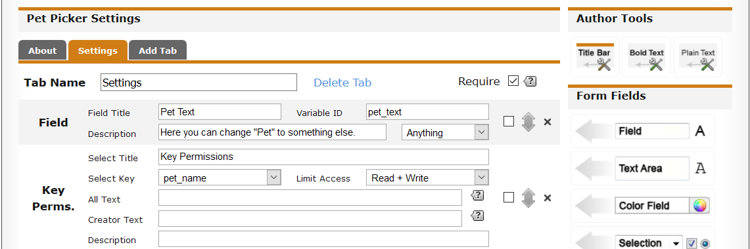
When adding the key permissions component, we need to make sure that we select the key. If you only have one key for your plugin, then this will be selected by default. I also selected "Read + Write", as I want to setup both the permissions for this key.

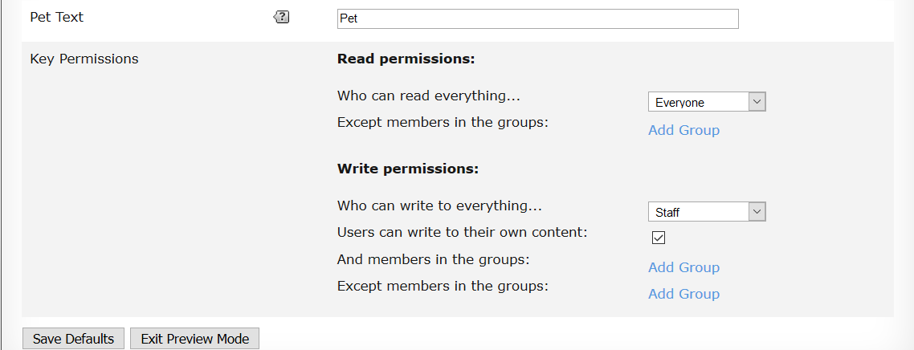
To be able to setup the key permissions, you will need to preview your plugin so we can save some defaults.

Only the user and staff should be able to write to the key. Everyone else can read. We also need to make sure that the users can write to their key, so we enabled the check box under "Write permissions" called "Users can write to their own content". If we don't, then only staff can write to the key. The reason we allow staff to be able to write to the key, is if users enter an inappropriate name for their pet, we need to allow some moderation for this type of event.

Breaking It Down

We have a UI, a key, and some images. We now need to work on the JavaScript. Before we do, lets break down what needs to be done.

- Button on the profile page that users can click on.
To be able to allow users to select an image, we need an access point to those images. This point can be a button on the users profile page. They will navigate to their profile and a button near the "Edit Profile" will show if the user has permission.
- Dialog box for users to pick an image and also enter a pet name.
We need to be able to display the images and text field. A nice way to handle this is containing it all in a dialog that will popup when the button is clicked.

- Show pet for each user in their mini profile in threads and conversations.
We want to be able to allow users to show off which pet they selected, and also the name of the pet. To keep things nice and tidy, we will only display the name of the pet when the mouse cursor hovers over the images.

JavaScript Plugin Template

When I was new to creating plugins, I tried to come up with a simple template for myself that I could reuse. A few iterations of the template later and I had something that I could easily copy and paste for each plugin. This has changed now due to ES 6, but let's look at an older template I would have used.

({

images: {},
settings: {},

init: function(){
if(this.setup()){
$(this.ready.bind(this));
}
},

setup: function(){
var plugin = pb.plugin.get("pet_picker");

if(plugin){
this.settings = plugin.settings;
this.images = plugin.images;

return true;
}

return false;
},

ready: function(){
console.log("Ready");
}

}).init();

If you don't have a solid understanding of JavaScript, then you may not fully understand what the above code does.

Consider adopting a common JavaScript style, take a read of the section in chapter 6 called "ProBoards JavaScript Style".

Generally you do not need access to your plugin from outside, so you will see that the Object does not get stored in a variable. We invoke the init method which gets the ball rolling.

images: {},
settings: {},

These two properties will get assigned in the setup method. These will hold a reference to the images and settings for our plugin. We could just store the whole plugin object as a property, but I like to have a reference for each.

init: function(){
if(this.setup()){
$(this.ready.bind(this));
}
},

The init method will handle the basic setup of our plugin. If the setup all goes OK, then we call the ready method which will run when the DOM is ready (using jQuery). The reason for the bind on the ready method, is that we will lose the context of the object (aka "this"). And "this" inside of the ready method will become window, which is of no use to us, as we want to access other methods and properties from within that method.

setup: function(){
var plugin = pb.plugin.get("pet_picker");

if(plugin){
this.settings = plugin.settings;
this.images = plugin.images;

return true;
}

return false;
},

Next we have the setup method. This method would handle anything to do with the setup of the plugin. In this case, there isn't a lot to do apart from getting the settings and images and setting up the references to them so they are available throughout the object. For bigger plugins, a lot more would happen here.

ready: function(){
console.log("Ready");
}

The final method in the template is the ready method. This method gets fired when the DOM is loaded. Most of what we will be doing will be when the DOM is ready, as we will need to look for places in the existing DOM where we can inject our new elements (e.g., button).

That covers one basic template example. There are many ways to write a plugin. There is no real right way to write one. It comes down to personal preference at the end of the day. I like to have everything self contained and split up into methods. This is the way we will be writing this plugin, however feel free to write it the way you want. The goal is to understand how to make a plugin, not force a specific style on you.

Fleshing Out

Before we get into really writing the JavaScript, lets try and flesh out the template a little more. We will add some empty methods to the template, and then we will come back to these and write the body later. This is a good way to get a general idea of what will be needed for the plugin.

add_button_to_profile: function(){
console.log("Add profile button");
},

add_pet_image_to_mini_profiles: function(){
console.log("Add pet to mini profiles");
},

update_user_pet: function(){
console.log("Update pet");
},

show_pet_dialog: function(){
console.log("Show pet dialog");
},

build_dialog_html: function(){
return "Pet dialog HTML here";
}

Five new methods are added. We may add more if needed, but for now these are the main ones that we need for the plugin.

Let’s look at the ready method, as we need to add some code that will look for a specific route so that certain methods can be called.

ready: function(){
if(pb.data("route").name == "user" || pb.data("route").name == "current_user"){
this.add_button_to_profile();
} else {
var route = (pb.data("route").name == "thread" || pb.data("route").name == "conversation" || pb.data("route").name == "all_recent_posts" || pb.data("route").name == "search_results");

if(route){
this.add_pet_image_to_mini_profiles();
}
}
},

We need to check if the page we are on is the profile. To do this we need to use the ProBoards API to get the route data and check the name of that route. In a later chapter we will cover the ProBoards API in more detail.

If you aren't sure what the name of the route is of the page you want to check for, then you can simply log it out.
console.log(pb.data("route").name);

If the route is "user" or "current_user", then we know that the user viewing the page is on the profile. There is a little more we need to do here, but let’s come back in a little while.

var route = (pb.data("route").name == "thread" || pb.data("route").name == "conversation" || pb.data("route").name == "all_recent_posts" || pb.data("route").name == "search_results");

ProBoards has a few different pages where the mini profile can be. The four (there are a couple of more, but the main four is all we want) we are interested in, are the thread page, the conversation page, the recent posts page, and the search results page. We need to check for all four. And if the condition matches, we can then add the pet to the mini profiles.

Profile Button

We need a profile button for users to be able to click on. When clicked on, it will show the dialog. We need to make sure that the button shows only for the right users, the owner of the profile and staff. We do have permissions setup to prevent other members writing to the a users key, so in theory we don’t need to check for who can see the button. But why have a button on a profile that will do nothing for other users?

Who Can See The Button

We need a button on the profile, but we have a problem. We only want the button to show for the owner of the profile and staff. Luckily we can find out if the user viewing the profile owns it in a few different ways. But we will be using ProBoards API to help us.

console.dir(pb.data("page").member);

If we enter this in the console and we are on a profile, we can get the user information for who owns that profile.

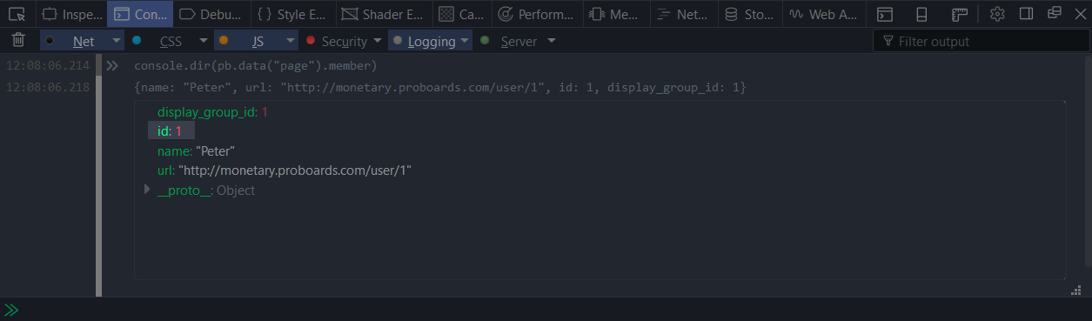
As you can see we have a few properties about the profile page. What we are interested in is the id property. We can use the ID from the profile page and compare it to the user ID of the user viewing the page.

So let’s improve our ready method and add an extra "if" condition.

ready: function(){
if(pb.data("route").name == "user" || pb.data("route").name == "current_user"){
var member_id = parseInt(pb.data("page").member.id, 10);
var user_id = parseInt(pb.data("user").id, 10);

if(member_id == user_id){
this.add_button_to_profile();
}
} else {
var route = (pb.data("route").name == "thread" || pb.data("route").name == "conversation" || pb.data("route").name == "all_recent_posts" || pb.data("route").name == "search_results");

if(route){
this.add_pet_image_to_mini_profiles();
}
}
},

You can see what was added in bold. We grab the member ID and user ID and simply compare them. If they match, then we know that the user viewing that profile is the owner of it.

We now need to allow staff members to access the button as well. We can use the ProBoards API to check if the user viewing the page is staff.

console.log(pb.data("user").is_staff);

Logging that out to the console will either output 1 or 0. If you are a staff member of the forum, then it will show as 1. Otherwise, it will be 0. This is basically a true and false value, so we can use this in our if condition as well.

If we run all our code so far, we will get "Add profile button" logged out to the console.

Creating A New Button

We know who can see the button. We now need to create the button and add it to the profile page. But where should we place it?

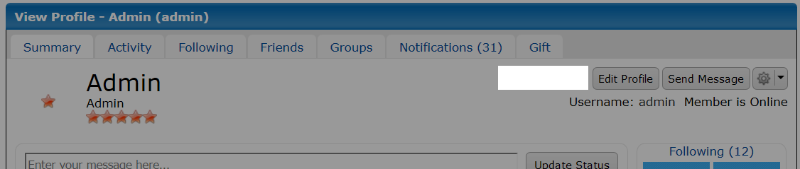
The most obvious spot would be next to the "Edit Profile" button. So let’s work on the add_button_to_profile method.

add_button_to_profile: function(){
var $button = $("<a class='button' id='pet-picker-button' href='#' role='button'>Edit " + this.settings.pet_text + "</a>");
var $conversation_button = $(".controls a.button[href^='/conversation/new/']");

if($conversation_button.length){
$button.on("click", this.show_pet_dialog.bind(this));
$button.insertAfter($conversation_button);
}
},

This method will now create a new button and insert it before the conversation button that is always visible on the profile page. Let’s break it down a little so we can see more closely what is going on in this method.

var $button = $("<a class='button' id='pet-picker-button' href='#' role='button'>Edit " + this.settings.pet_text + "</a>");

Here we use jQuery to handle creating an element for us, that being an anchor element. You will see that we are using the text from the plugin settings, the default being "Pet". But we allow the user to customise it to whatever they like.

Notice that I prefix anything that is wrapped with jQuery with "$". This makes it clearer to me that what is stored in the variable is jQuery wrapped.

var $conversation_button = $(".controls a.button[href^='/conversation/new/']");

Next we grab a reference to the conversation button. This button should always be on the page for users.

if($conversation_button.length){
$button.on("click", this.show_pet_dialog.bind(this));
$button.insertAfter($conversation_button);
}

We do a quick check to make sure we have the conversation button, and then we bind a "click" event to the button. When the button is clicked, it will call the method show_pet_dialog. We also have to bind the this context so we have access to anything within our main object. We then insert the new button after the conversation button which will actually appear before it due to the controls being floated right.

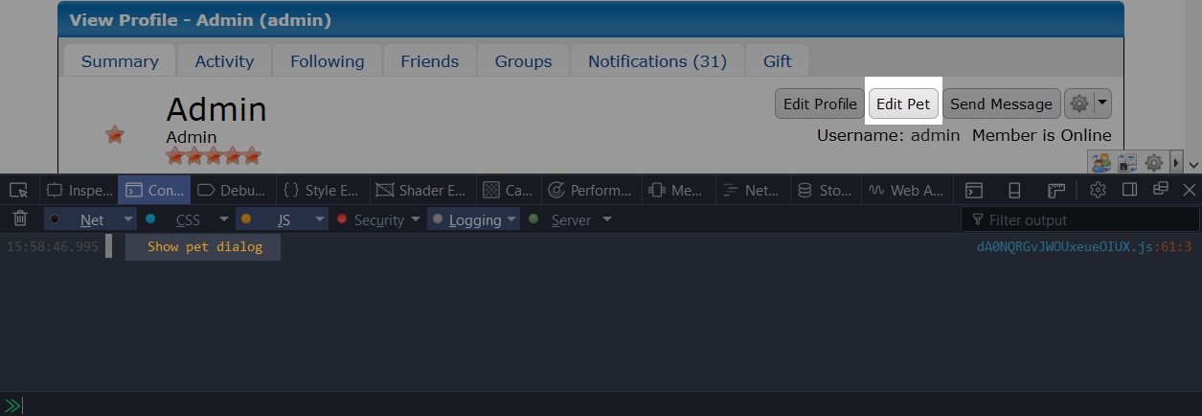
In the image above, we have a new button, and when clicked on we will get a message in the console letting us know.

Creating The Dialog

We have our button with an event attached. We now need to make a dialog that will appear when the user clicks on the button.

ProBoards API has a few methods to create dialogs. They are basically a wrapper around jQuery UI. The good thing with these dialogs is that the options you pass are the same for the ProBoards API and the jQuery UI Dialog API. If you need to do something more, then you can use the dialog API directly, as not all options are supported.

It's good to know what options, methods, and events are available to you:

https://api.jqueryui.com/1.8/dialog/

show_pet_dialog: function(){
pb.window.dialog("pet-picker-dialog", {

title: "Edit " + this.settings.pet_text,
html: this.build_dialog_html(),
modal: true,
resizable: false,
height: 400,
width: 500,

buttons: [

{

text: "Close",
click: function(){
$(this).dialog("close");
}

},

{

text: "Save",
click: this.update_user_pet

}

]

});

return false;
},

This is now our show_pet_dialog method. When the button is clicked, all this code in the method will run, which will show a dialog to the user. Let’s break it down a little.

pb.window.dialog("pet-picker-dialog", {

The ProBoards API method for the dialog requires two parameters. The first parameter is a unique ID for the dialog. The second parameter is the dialog options that you want to apply (see tip above).

title: "Edit " + this.settings.pet_text,

We set the title of our dialog here, we use the pet_text value that the user may have customised.

html: this.build_dialog_html(),

We need to set the HTML of the dialog, otherwise it will just be blank. We will create all the HTML in the build_dialog_html method. In that way, we know where all the HTML will be, and this will prevent our methods getting too big.

modal: true,
resizable: false,
height: 400, // Pixels
width: 500, // Pixels

Next we have some basic options. You can read about these at the jQuery site linked above. For now, we set the height to 400 and width to 500. We could tweak these later to improve the look of the dialog if we need to.

buttons: [

{

text: "Close",
click: function(){
$(this).dialog("close");
}

},

{

text: "Save",
click: this.update_user_pet

}

]

We need a couple of buttons for our dialog Without any, we can’t do much other than close the dialog. The "buttons" option needs to be an Array made up of Objects.

Our first button will handle closing the dialog. The dialog already has a way of closing ("X" top right corner). But for a nice touch, we include it.

The second button will handle saving the pet name and pet image selection to the key, so we set the "click" option to the method we will be using. In this case it’s update_user_pet.

You will notice at the end of the show_pet_dialog method, we return false. The reason for this is because the button the user clicks on is actually an anchor, so we need to prevent its default behaviour from happening. In this case, if we click the link without the return statement, we will get sent back to the top of the page. So we need to return false to prevent that.

If we give our plugin a test, you should have a dialog appear when clicking on the button.
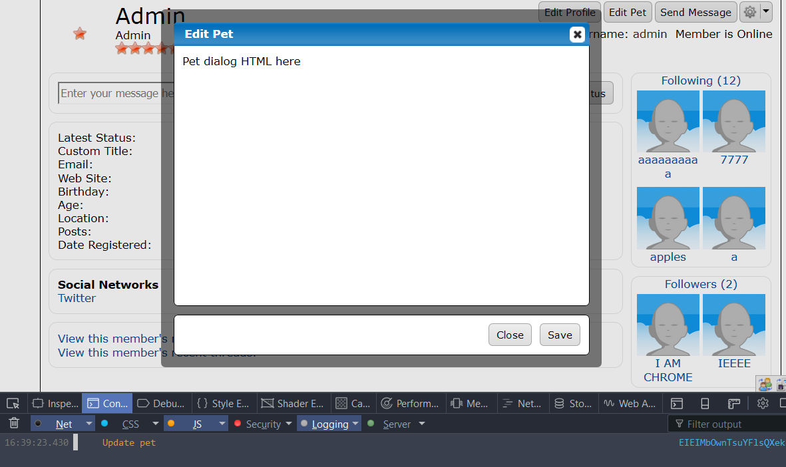
Clicking on the button will invoke the update_user_pet method, and you should get a console message.

Building The Dialog HTML & CSS

We now need to build the HTML for the dialog. This HTML will consist of a field for the pet’s name, and all the animal images in the plugin. We need to think carefully how we want to build the HTML, because we need to consider how we will handle the selection side of things. And also how we will set the current pet that the user has selected when they reopen the dialog.

- Input Text Field
This field will need an ID so we can set and get the value.
We will also likely need to set a max limit on the amount of characters the user can have for the pet name. We will do something simple here, and use the max length attribute. And when saving to the key, we will simply grab a max of 40 characters from this value.
- Image
Each image will be placed inside a span element.
Any span that is not selected will have the opacity decreased so it’s easier to see which item has been selected.
Any span that is selected will get a class added called "pet-picker-item-selected". This is so we can find this element when we need to save to the key.
Now that we have a general idea of what the HTML will consist of, let’s build it.

build_dialog_html: function(){
var html = "";

html += this.settings.pet_text + " Name: <input type='text' value='' maxlength='40' id='pet-picker-name' />";
html += "<div class='pet-picker-images'>";

for(var img in this.images){
if(this.images.hasOwnProperty(img)){
html += "<span class='pet-picker-item'><img class='pet-picker-image' src='" + this.images[img] + "' data-pet-picker-id='" + img + "' /></span>";
}
}

html += "</div>";

return html;
}

This method handles building the HTML for the dialog and returns the final string. We loop over all the images in the plugin and concatenate them to the html variable.

We need to do some styling to make the dialog contents look a little nicer. I would also like to show which item is selected when the user clicks on it, so let’s add a little code to the show_pet_dialog method.

show_pet_dialog: function(){
pb.window.dialog("pet-picker-dialog", {

title: "Edit " + this.settings.pet_text,
html: this.build_dialog_html(),
modal: true,
resizable: false,
height: 400,
width: 500,

buttons: [

{

text: "Close",
click: function(){
$(this).dialog("close");
}

},

{

text: "Save",
click: this.update_user_pet

}

]

});

$(".pet-picker-item").on("click", function(){
$(".pet-picker-item-selected").removeClass("pet-picker-item-selected");
$(this).addClass("pet-picker-item-selected");
});

return false;
},

The new code added are the lines in bold. We need to bind a "click" event to each span element in the dialog. When a span is clicked on, we remove the class "pet-picker-item-selected" from any span that may already be selected. Then we add the class to the current span being clicked on.

img.pet-picker-image {

width: 64px;
height: 64px;

}

span.pet-picker-item {

opacity: 0.4;
padding: 5px;
cursor: pointer;
display: inline-block;
margin: 3px;

}

span.pet-picker-item:hover {

box-shadow: 0 0 0 2px black;
border-radius: 4px;

}

div.pet-picker-images {

margin-top: 15px;

}

span.pet-picker-item-selected {

opacity: 1;
box-shadow: 0 0 0 2px black;
border-radius: 4px;

}

We will need to add a CSS component to the plugin and paste that in. Then we can take a look at the dialog to see what it looks like.

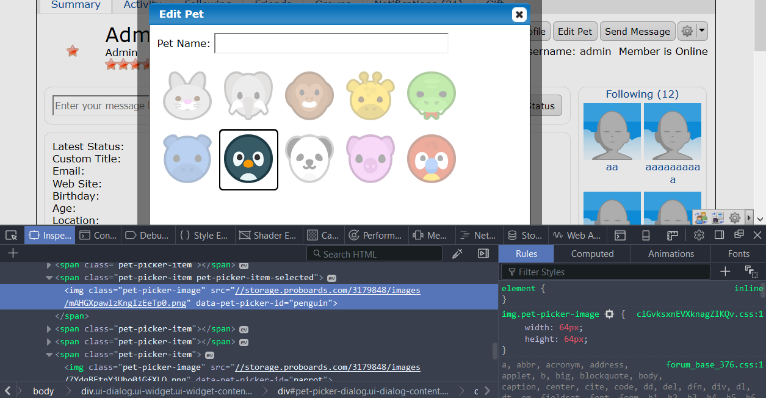
You will see in the console that the selected item has the data attribute. This will come in real handy later on when we need to fetch the image the user selected.

There is more room for improvement, but for this example I think it is good enough.

Saving Pet Name & Selection

We need to save the pet name and the selected item to the key. We need to modify the update_user_pet method which is invoked when the "Save" button is clicked on. We also need to handle some basic validation on both values that get stored in the key.

update_user_pet: function(){
var name = ($("#pet-picker-name").val() || "").replace(/[^\w\s]+/g, "").substring(0, 40);
var selected = ($(".pet-picker-item-selected img").attr("data-pet-picker-id") || "").replace(/[^\w]+/g, "");

if(selected.length){
var my_key = pb.plugin.key("pet_name");
var member_id = parseInt(pb.data("page").member.id, 10);

my_key.set({

object_id: member_id,
value: {

name: name,
selected: selected

}

});
}
},

The code above handles a few different things, so let’s break it down.

var name = ($("#pet-picker-name").val() || "").replace(/[^\w\s]+/g, "").substring(0, 40);

This line handles fetching the value from the text field for the pet name. We make sure that we at least have an empty String. Then we clean the name with a regular expression pattern, as we only want to allow A-Z, a-z, 0-9, _, and spaces. We also are only interested in the first 40 characters, so we grab a substring.

Learn about regular expressions here.

var selected = ($(".pet-picker-item-selected img").attr("data-pet-picker-id") || "").replace(/[^\w]+/g, "");

This line handles fetching the selected item key. We store the key of the image in the data attribute, we make sure to clean it up. It doesn’t matter too much about cleaning this value, as we will be using it later to fetch the correct pet image from the images Object.

Security is a big problem and something that should be taken seriously in your plugin. The lines above do some basic clean up to try to prevent unwanted characters when saving. However, the user could do a manual write to their key and inject malicious content. So it’s important to make sure the output is safe.

if(selected.length){

We only save to the key if the user has a selection. We aren’t too concerned if the user didn’t name their pet, so we don’t check for that.

var my_key = pb.plugin.key("pet_name");

We store a reference to the key object for the plugin. The key ID is called pet_name, this is what was setup in the plugin editor on the keys tab.

var member_id = parseInt(pb.data("page").member.id, 10);

We need to make sure we are saving to the owner of the profile, not the user viewing the profile. We do this because we want to allow staff to edit other users’ pet names.

my_key.set({

object_id: member_id,
value: {

name: name,
selected: selected

}

});

Finally we set the key. We pass an option Object as the parameter. This Object contains the object_id key, and the value is set to the member_id. For the value, we use an Object, as we want to save two bits of data. ProBoards will handle converting it to a String for us. In this way, when we come to fetch the data, we can easily access each property.

Entering a name and selecting a pet and then clicking "Save" will save that data to the key.

Setting The Dialog Defaults

We need to setup the default values for the dialog. We need to set the default value for the pet name field, and the default item selected. These default values need to come from the key, or they can be empty. The reason we want to do this is to show the name and selected item each time the user opens the dialog.

We will modify the build_dialog_html method and grab the key data so we can set the value of the input field, and also set which item is selected.

build_dialog_html: function(){
var my_key = pb.plugin.key("pet_name");
var member_id = parseInt(pb.data("page").member.id, 10);
var data = my_key.get(member_id);
var name = "";
var selected = "";

if(data){
name = (data.name)? data.name.toString().replace(/[^\w\s]+/g, "").substring(0, 40) : "";
selected = (data.selected)? data.selected.toString().replace(/[^\w]+/g, "") : "";
}

var html = "";

html += this.settings.pet_text + " Name: <input type='text' value='" + name + "' maxlength='40' id='pet-picker-name' />";
html += "<div class='pet-picker-images'>";

for(var img in this.images){
if(this.images.hasOwnProperty(img)){
var klass = (img == selected)? " pet-picker-item-selected" : "";

html += "<span class='pet-picker-item" + klass + "'><img class='pet-picker-image' src='" + this.images[img] + "' data-pet-picker-id='" + img + "' /></span>";
}
}

html += "</div>";

return html;
}

The parts of the code that are in bold are the new changes.

var my_key = pb.plugin.key("pet_name");

We need to get a reference to our key Object, so we save that in the variable my_key.

var member_id = parseInt(pb.data("page").member.id, 10);

This needs to be the profile owner, not the user viewing the page, so we store the member ID in a variable.

var data = my_key.get(member_id);

Here is where we get the data from the key. We pass the Object ID, that being the member ID, and we get a value back which is stored in data.

if(data){
name = (data.name)? data.name.toString().replace(/[^\w\s]+/g, "").substring(0, 40) : "";
selected = (data.selected)? data.selected.toString().replace(/[^\w]+/g, "") : "";
}

We do a basic check on the data variable, and then we do some additional checking to see if the data Object has the keys. We could do different checking on the data variable, but this is good enough for now.

html += this.settings.pet_text + " Name: <input type='text' value='" + name + "' maxlength='40' id='pet-picker-name' />";

name gets concatenated, so that if it does have a value, then it will show up in the field when we open the dialog.

var klass = (img == selected)? " pet-picker-item-selected" : "";

Here we are simply comparing the key img to the value stored in the selected variable. If they match, then we add a class to the span element so that when the dialog is opened, the saved selection is selected by default.

With the new code and changes, you should be able to go to any profile and edit a user’s pet.

Adding Pet To Mini Profiles

The final thing to do for the plugin, is to add the pet image to mini profiles so that users can see which pet each picked. Hovering over the image will show the name if one was entered.

Let’s break done some of the steps:

- Route
To be able to add anything to mini profiles, we need to make sure we are on pages that mini profiles appear. Luckily for us, we already have done this part, as we are checking specific routes that mini profiles appear on.
- Fetching
We need to be able to query all the mini profiles on the page.
ProBoards adds a class to each div that is considered a mini profile, so this will be very handy for us to use.
- Adding
We then need to consider where in the mini profile we are going to add the new element.
- Pagination
ProBoards has pagination, meaning, users can navigate between pages inside a thread. No big deal right? Wrong, as these pages are pulled in via AJAX.
ProBoards provides an event for us to use so that when the page has been changed, we can apply our changes.

Mini Profile Routes

To be able to add our own elements to the mini profile, we need to know where to look for them. All we need to do is log out the route name to the console for any page that has a mini profile on it, and then we use that in our code.

We already have this part of the code covered, but let’s take a look again.

var route = (pb.data("route").name == "thread" || pb.data("route").name == "conversation" || pb.data("route").name == "all_recent_posts" || pb.data("route").name == "search_results");

In the ready method, we have already covered four possible routes where mini profiles may show up.

If you aren't sure what the route name is for a page, simply enter this into the console.
console.log(pb.data("route").name);

Fetching Mini Profiles

We now need to fetch the mini profiles on the page so we can add in a new element. ProBoards adds a class to each mini profile wrapper called "mini-profile". This class should always exist unless a theme has removed it. If that is the case, that is the fault of the theme and not the plugin.

If you find that a theme has removed an important classe (e.g., "mini-profile"), then let the theme author know. It could have just been something they overlooked / removed by mistake. This helps everyone.

To fetch the mini profiles, we will use jQuery to query all elements that have a class called "mini-profile".

var $mini_profiles = $(".mini-profile");

Here we grab all the mini profiles on the page and store them in a variable.

Try to avoid prefixing selectors with the element (e.g. "div.mini-profile"), as theme authors may have used a different element. If that is the case, your plugin will not find any mini profiles.

Let’s look at the full add_pet_image_to_mini_profiles method.

add_pet_image_to_mini_profiles: function(){
var $mini_profiles = $(".mini-profile");

if(!$mini_profiles.length){
return;
}

var my_key = pb.plugin.key("pet_name");
var self = this;

$mini_profiles.each(function(){
var $mini_profile = $(this);
var $user_link = $mini_profile.find("a.user-link[href*='user/']");
var $info = $mini_profile.find(".info");

if($info.length == 1 && $user_link.length == 1){
var user_id_match = $user_link.attr("href").match(/\/user\/(\d+)\/?/i);

if(!user_id_match || !parseInt(user_id_match[1], 10)){
return;
}

var user_id = parseInt(user_id_match[1], 10);
var data = my_key.get(user_id);

if(data){
var name = (data.name)? data.name.toString().replace(/[^\w\s]+/g, "").substring(0, 40) : "";
var selected = (data.selected)? data.selected.toString().replace(/[^\w]+/g, "") : "";
var $elem = null;

if(selected && self.images[selected]){
$elem = $("<div><img class='pet-picker-image' src='" + self.images[selected] + "' /></div>");

if(name){
$elem.attr("title", name);
}
}

if($elem){
$info.append($elem);
}
}
}
});
},

Let’s break the code down.

if(!$mini_profiles.length){
return;
}

If we have no mini profiles, lets bail out now.

var my_key = pb.plugin.key("pet_name");

We setup a reference to the key Object, as we will be needing to fetch the data for each user that has a mini profile.

var self = this;

We need a reference to the main Object, as we will need to access the images property from within a function where the context gets lost.

$mini_profiles.each(function(){

We need to loop over all the mini profiles so we can add our changes to each one. We can’t just apply the changes to all the mini profiles, as we need to get the owner of the mini profile and display the correct content.

var $mini_profile = $(this);

We store a reference to the current mini profile we are at in the loop.

var $user_link = $mini_profile.find("a.user-link[href*='user/']");

We need to store the user link that is inside this mini profile, as we will be extracting the user ID from it so we can use it to fetch the data for that user.

var $info = $mini_profile.find(".info");

We will append the new element to the info element inside the mini profile, so we setup a reference here that we will be using later on. You could just append the new element to the mini profile, but for consistency I decided on the info element.

if($info.length == 1 && $user_link.length == 1){

To go any further, the info and user link must exist and be a count of 1. There may be a reason to have more than 1 of these, but usually this is not the case, so we won’t worry too much.

var user_id_match = $user_link.attr("href").match(/\/user\/(\d+)\/?/i);

if(!user_id_match || !parseInt(user_id_match[1], 10)){
return;
}

var user_id = parseInt(user_id_match[1], 10);

Those lines deal with getting the user ID for the mini profile we are currently looking at in the loop. If the user ID doesn’t exist / or is invalid, then we just bail out by returning. Otherwise we store the user ID in the user_id variable.

var data = my_key.get(user_id);

Because we have done all of the hard work of getting the user ID of the mini profile we are on, we can fetch the data from the key for that user. This user is the owner of the mini profile.

if(data){
var name = (data.name)? data.name.toString().replace(/[^\w\s]+/g, "").substring(0, 40) : "";
var selected = (data.selected)? data.selected.toString().replace(/[^\w]+/g, "") : "";
var $elem = null;

if(selected && self.images[selected]){
$elem = $("<div><img class='pet-picker-image' src='" + self.images[selected] + "' /></div>");

if(name){
$elem.attr("title", name);
}
}

if($elem){
$info.append($elem);
}
}

The rest of the code deals with cleaning the pet name and making sure the selected image does exist in the images property. It then creates a new div with an image and appends it to the info div in the mini profile.

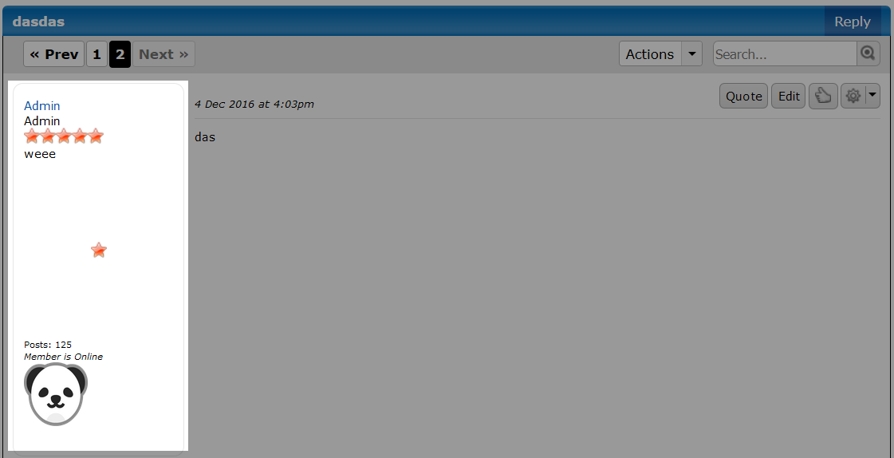
If we look at the mini profile, we should see the pet that was selected. Also, if we entered a name, that will show up when we hover over it.

Handling Page Change

The plugin is working as expected, however there is an issue we need to fix. If you have a thread that has multiple pages, and you navigate these pages, you will notice that any mini profile that should have the pet showing, will not show on new pages.

ProBoards loads in new pages via AJAX and appends the loaded posts to the DOM. And our code to add the pet to the mini profiles has already been run, so it will not see these new posts that have mini profiles. Luckily there is an easy solution, and that is using an event that ProBoards gives us called afterSearch.

The afterSearch event gets fired by ProBoards for us, so we need to do is pass a function that will get called.

pb.events.on("afterSearch", this.add_pet_image_to_mini_profiles.bind(this));

This line needs to be added to the ready method under the call to add_pet_image_to_mini_profiles. We pass in the add_pet_image_to_mini_profiles method which will get invoked.

Final JavaScript

({

images: {},
settings: {},

init: function(){
if(this.setup()){
$(this.ready.bind(this));
}
},

setup: function(){
var plugin = pb.plugin.get("pet_picker");

if(plugin){
this.settings = plugin.settings;
this.images = plugin.images;

return true;
}

return false;
},

ready: function(){
if(pb.data("route").name == "user" || pb.data("route").name == "current_user"){
var member_id = parseInt(pb.data("page").member.id, 10);
var user_id = parseInt(pb.data("user").id, 10);

if(member_id == user_id || pb.data("user").is_staff){
this.add_button_to_profile();
}
} else {
var route = (pb.data("route").name == "thread" || pb.data("route").name == "conversation" || pb.data("route").name == "all_recent_posts" || pb.data("route").name == "search_results");

if(route){
this.add_pet_image_to_mini_profiles();
pb.events.on("afterSearch", this.add_pet_image_to_mini_profiles.bind(this));
}
}
},

add_button_to_profile: function(){
var $button = $("<a class='button' id='pet-picker-button' href='#' role='button'>Edit " + this.settings.pet_text + "</a>");
var $conversation_button = $(".controls a.button[href^='/conversation/new/']");

if($conversation_button.length){
$button.on("click", this.show_pet_dialog.bind(this));
$button.insertAfter($conversation_button);
}
},

add_pet_image_to_mini_profiles: function(){
var $mini_profiles = $(".mini-profile");

if(!$mini_profiles.length){
return;
}

var my_key = pb.plugin.key("pet_name");
var self = this;

$mini_profiles.each(function(){
var $mini_profile = $(this);
var $user_link = $mini_profile.find("a.user-link[href*='user/']");
var $info = $mini_profile.find(".info");

if($info.length == 1 && $user_link.length == 1){
var user_id_match = $user_link.attr("href").match(/\/user\/(\d+)\/?/i);

if(!user_id_match || !parseInt(user_id_match[1], 10)){
return;
}

var user_id = parseInt(user_id_match[1], 10);
var data = my_key.get(user_id);

if(data){
var name = (data.name)? data.name.toString().replace(/[^\w\s]+/g, "").substring(0, 40) : "";
var selected = (data.selected)? data.selected.toString().replace(/[^\w]+/g, "") : "";
var $elem = null;

if(selected && self.images[selected]){
$elem = $("<div><img class='pet-picker-image' src='" + self.images[selected] + "' /></div>");

if(name){
$elem.attr("title", name);
}
}

if($elem){
$info.append($elem);
}
}
}
});
},

update_user_pet: function(){
var name = ($("#pet-picker-name").val() || "").replace(/[^\w\s]+/g, "").substring(0, 40);
var selected = ($(".pet-picker-item-selected img").attr("data-pet-picker-id") || "").replace(/[^\w]+/g, "");

if(selected.length){
var my_key = pb.plugin.key("pet_name");
var member_id = parseInt(pb.data("page").member.id, 10);

my_key.set({

object_id: member_id,
value: {

name: name,
selected: selected

}

});
}
},

show_pet_dialog: function(){
pb.window.dialog("pet-picker-dialog", {

title: "Edit " + this.settings.pet_text,
html: this.build_dialog_html(),
modal: true,
resizable: false,
height: 400,
width: 500,

buttons: [

{

text: "Close",
click: function(){
$(this).dialog("close");
}

},

{

text: "Save",
click: this.update_user_pet

}

]

});

$(".pet-picker-item").on("click", function(){
$(".pet-picker-item-selected").removeClass("pet-picker-item-selected");
$(this).addClass("pet-picker-item-selected");
});

return false;
},

build_dialog_html: function(){
var my_key = pb.plugin.key("pet_name");
var member_id = parseInt(pb.data("page").member.id, 10);
var data = my_key.get(member_id);
var name = "";
var selected = "";

if(data){
name = (data.name)? data.name.toString().replace(/[^\w\s]+/g, "").substring(0, 40) : "";
selected = (data.selected)? data.selected.toString().replace(/[^\w]+/g, "") : "";
}

var html = "";

html += this.settings.pet_text + " Name: <input type='text' value='" + name + "' maxlength='40' id='pet-picker-name' />";
html += "<div class='pet-picker-images'>";

for(var img in this.images){
if(this.images.hasOwnProperty(img)){
var klass = (img == selected)? " pet-picker-item-selected" : "";

html += "<span class='pet-picker-item" + klass + "'><img class='pet-picker-image' src='" + this.images[img] + "' data-pet-picker-id='" + img + "' /></span>";
}
}

html += "</div>";

return html;
}

}).init();

Final CSS

img.pet-picker-image {

width: 64px;
height: 64px;

}

span.pet-picker-item {

opacity: 0.4;
padding: 5px;
cursor: pointer;
display: inline-block;
margin: 3px;

}

span.pet-picker-item:hover {

box-shadow: 0 0 0 2px black;
border-radius: 4px;

}

div.pet-picker-images {

margin-top: 15px;

}

span.pet-picker-item-selected {

opacity: 1;
box-shadow: 0 0 0 2px black;
border-radius: 4px;

}

Chapter 5: ProBoards API

In this chapter we will take a look at some of the general API that ProBoards provides us. This API has some useful methods to help make things easier for you. Nearly all methods are a child of the pb namespace.

We won’t be covering every single method, just the more useful ones that will help you when creating a plugin.

If you want to see all the methods that ProBoards supports, have a look at the API documentation.

https://proboards.com/developer/js/

We have already covered the plugin and key a API, so these will not be discussed in this chapter.

Data

This will likely be the method you use most, as it contains a lot of data that you can access.

pb.data(key);

The data method requires a key to be passed as the parameter. This needs to be String. There are quite a few keys you can pass.

This method also allows you to set your own data, although this is rarely used by plugin authors.

The data available to you can change depending on the page you are on.
For example, viewing a thread gives you access to the list manager keys. Whereas, on the forum home page, these keys do not exist.
It’s best to use a route check as well when using the data method. I see a lot of plugins throwing an error due to using a property that doesn’t exist on certain pages.

Some values that you expect to be of a certain type is not always the case, and is something to watch for.
For example; some Boolean values are Strings, some Integers are Strings.

Let’s take a look at some of the keys that will be helpful to know. We won’t be covering all of them, as there are a lot. If you want to see all the possible keys you can pass to the data method, then you can log out the dataHash Object. Just remember, not all keys are available on every single page.

- ad_free (Integer)
pb.data("ad_free")
Will return either 0 for the forum not being ad free, or 1 for it being ad free.
- all_messages_count (String)
pb.data("all_messages_count")
Returns the total conversations the user has.
- default_avatar (String)
pb.data("default_avatar")
Returns a URL pointing to the default avatar that is used for members who have not setup an avatar of their own.
- forum_id (String)
pb.data("forum_id")
Will return the unique ID for the forum.
- is_current_user_guest (String)
pb.data("is_current_user_guest")
Returns "0" if the user is not a guest, and "1" if they are a guest.
- login_url (String)
pb.data("login_url")
Returns the login URL of the forum.
- message_mode (String)
pb.data("message_mode")
Returns the editor mode the user is using (e.g. "bbcode").
- plugin_max_key_length (Integer)
pb.data("plugin_max_key_length")
Returns the maximum character length of plugin keys
- plugin_max_super_forum_key_length (Integer)
pb.data("plugin_max_super_forum_key_length")
Returns the maximum character length of the super forum key.
- register_url (String)
pb.data("register_url")
Returns the register URL for the forum.
- serverDate (Integer)
pb.data("serverDate")
Returns the server date as a time stamp.

There are a lot more. And there may be some that aren’t listed here that may be of more value to you.

Page

What is available in the page Object depends on what page you are viewing on the forum. For example, viewing a thread will not contain member information that is tied to profiles.

If you try to access page data when there isn’t any, then you will get an empty Object back.

pb.data("page")

Board

The board data provides you with everything you need to know about the board the user is currently in.

pb.data("page").board

- description (String)
pb.data("page").board.description
Returns the description for the board the user is currently in.
- disable_post_counts (String)
pb.data("page").board.disable_post_counts
Returns "1" if post count is disabled for the board the user is currently in, otherwise, "0" is returned.
- display_posting (String)
pb.data("page").board.display_posting
Returns "1" if posting is disabled in the board the user is currently in, otherwise, "0" is returned.
- display_name (String)
pb.data("page").board.display_name
Returns the name of the board that the user is currently in.
- hidden (String)
pb.data("page").board.hidden
Returns "1" if the board the user is currently in is hidden, otherwise, "0" is returned.
- id (Integer)
pb.data("page").board.id
Returns the ID of the board the user is currently in. This is useful if parts of your plugin are not meant to be run in specific boards.
- posts (Integer)
pb.data("page").board.posts
Returns the total posts made in the board that the user is currently in.
- show_announcements (String)
pb.data("page").board.show_announcements
Returns "1" if announcements are shown in the board the user is currently in, otherwise, "0" is returned.
- threads (Integer)
pb.data("page").board.threads
Returns the total threads made in the board the user is currently in.
- url (String)
pb.data("page").board.url
Returns the URL to the board that the user is currently in.

Category

The category data provides you with everything you need to know about the category the user is currently in.

pb.data("page").category

- id (Integer)
pb.data("page").category.id
Returns the category ID the user is currently in.
- name (String)
pb.data("page").category.name
Returns the name of the category the user is currently in.

Member

Member data is data that is available to you on the profile page. When using this, it’s recommended to use a route check to make sure you are on the pages where this data is available.

pb.data("page").member

- display_group_id (Integer)
pb.data("page").member.display_group_id
Returns the group ID of the group that is set as being displayed for the user for the profile being viewed.
- id (Integer)
pb.data("page").member.id
Returns the ID of the user for the profile being viewed. This is extremely useful if you need to see if the user viewing the page is the owner of the profile.
- Name (String)
pb.data("page").member.name
Returns the name of the user for the profile being viewed.
- url (String)
pb.data("page").member.url
Returns the URL for the profile being viewed.

Thread

The thread data provides you with everything you need to know about the thread the user is currently in.

pb.data("page").thread

- board_id (Integer)
pb.data("page").thread.board_id
Returns the board ID that the thread belongs to for the thread the user is currently viewing.
- created_by (Integer)
pb.data("page").thread.created_by
Returns the user ID of the user that created the thread for the thread currently being viewed by the user.
- created_on (Integer)
pb.data("page").thread.created_on
Returns a time stamp for when the thread was created for the thread the user is currently viewing.
- first_post_id (Integer)
pb.data("page").thread.first_post_id
Returns the ID of the first post in the thread that the user is currently vieiwng.
- id (Integer)
pb.data("page").thread.id
Returns the ID of the thread currently being viewed by the user.
- is_announcement (Integer)
pb.data("page").thread.is_announcement
Returns 1 if the thread is an announcement, otherwise returns 0 for the thread the user is viewing.
- is_bookmarked (Integer)
pb.data("page").thread.is_bookmarked
Returns 1 if the thread has been bookmarked by the user currently viewing the thread, otherwise, 0 is returned.
- is_falling (Integer)
pb.data("page").thread.is_falling
Returns 1 if the thread is falling for the thread currently being viewed by the user.
- is_locked (Integer)
pb.data("page").thread.is_locked
Returns 1 if the thread currently being viewed by the user is locked, otherwise, 0 is returned.
- is_new (Integer)
pb.data("page").thread.is_new
Returns 1 if the thread currently being viewed by the user is new, otherwise, 0 is returned.
- is_poll (Integer)
pb.data("page").thread.is_poll
Returns 1 if the thread currently being viewed by the user has a poll attached, otherwise, 0 is returned.
- is_sticky (Integer)
pb.data("page").thread.is_sticky
Returns 1 if the thread being viewed by the user is stickied, otherwise, 0 is returned.
- last_post_id (Integer)
pb.data("page").thread.last_post_id
Returns the last post ID for the thread currently being viewed by the user.
- last_post_time (Integer)
pb.data("page").thread.last_post_time
Returns a time stamp of when the last post was made for the thread currently being viewed by the user.
- subject (String)
pb.data("page").thread.subject
Returns the subject of the thread currently being viewed by the user.
- url (String)
pb.data("page").thread.url
Returns the URL to the thread currently being viewed by the user.
User

The user key is an extremely useful one. It has a lot of data about the user that you can access in your plugin.

The user Object is an Object which is a child of the data Object. We can access the user Object by passing in the user key as the parameter.

pb.data("user")

Let’s take a look at some of the keys we have access to. We won’t be listing all of them. You can easily experiment yourself to see the other keys under the user object.

- avatar (String)
pb.data("user").avatar
Returns the avatar for the user viewing the page.
- birthday (Object)
pb.data("user").birthday
Returns an Object containing the day, month, year, and string properties. This will be empty if the user has their birthday not to show.
- date_format (String)
pb.data("user").date_format
Returns the date format for the user. This is a useful one when you are outputting dates, as you can format it based on what the user wants to see.
- group_ids (Array)
pb.data("user").group_ids
Returns an Array with all the group IDs the user is in. This is very useful when your plugin needs to see if a user is in a specific group.
- id (Integer)
pb.data("user").id
Returns the ID for the user. This is useful when you need the ID for setting a key.
- is_invisible (Integer)
pb.data("user").is_invisible
Returns 0 if the user is not invisible, 1 if they are.
- is_logged_in (Integer)
pb.data("user").is_logged_in
Returns 0 if the user is not logged in, or 1 if they are. This is another useful property for plugins that only want to show content for logged in users.
- is_staff (Integer)
pb.data("user").is_staff
Returns 0 if the user is not staff, or 1 if they are. This is very useful when dealing with permissions in your plugin. Maybe you have a feature that only staff can access.
- name (String)
pb.data("user").name
Returns the display name for the user.
- posts (Integer)
pb.data("user").posts
Returns the total posts the user has made.
- status (String)
pb.data("user").status
Returns the status the user entered on their profile.
- theme_id (Integer)
pb.data("user").theme_id
Returns the theme ID the user has selected.
- time_format (String)
pb.data("user").time_format
Returns the time format the user prefers. Another useful one that goes along with the date format property.
- username (String)
pb.data("user").username
Returns the username for the user.
There are lots of other keys that provide useful information that haven’t been listed here. So have a closer look, as some of them might be helpful for you and your plugin.

Events

ProBoards has a couple of methods to help invoke a method for some custom events that ProBoards has created.

On
This method allows you to bind your method to a specific event that you pass in.
pb.events.on(event, method)

Example using the afterSearch event.
pb.events.on("afterSearch", function(){
console.log("After search event fired");
});

One
This method behaves like the on method, only it fires once.
pb.events.on(event, method)

Example using the afterSearch event.

pb.events.on("afterSearch", function(){
console.log("After search event fired");
});

If the event is triggered again, it will not invoke the function binded to it.

There are five documented events that you can use.

- afterSearch
Triggered after an auto search is done (e.g. board, thread, conversation).
This is commonly used in plugins that need to modify the DOM when inside threads.
- columnSort
Triggered after a column has been sorted.
- moreActivity
Triggered when the "Show More" link is clicked on profiles.
- moreNotification
Triggered when the "Show More" link is clicked on profiles.
- pageChange
Triggered when pagination occurs in a thread or conversation.
When you are attempting to do things inside a thread with your plugin, the "afterSearch" event is the better choice, as it covers this event as well.

Text

ProBoards has some useful text methods to help you.

All the text methods are under the pb.text Object.

Capitalize

This method will capitalize the first character of a String and return it back.

console.log(pb.text.capitalize("hello world")); // "Hello world"

Escape HTML

Replaces the following characters with their HTML entity counterparts: &, <, >, ", '.

console.log(pb.text.escape_html("hello <strong>world</strong>")); // "hello &lt;strong&gt;world&lt;/strong&gt;"

Mono

Replaces tabs, spaces, &, <, >, ", and ' with their HTML entity counterparts and newlines with linebreak HTML tags.

console.log(pb.text.mono("hello \n<strong>world</strong>")); // "hello <br />&lt;strong&gt;world&lt;/strong&gt;"

NBSP

Formats tabs and spaces into HTML that will display as intended.

console.log(pb.text.nbsp("hello \n<strong>\tworld</strong>")); // "hello <strong>&nbsp; &nbsp; world</strong>"

New Lines 2 BR

Replaces newlines with line break HTML tags.

console.log(pb.text.nl2br("hello\nworld\n")); // "hello<br />world<br />"

Window

ProBoards has some short hand methods that are basically wraps around jQuery UI Dialog to display certain types of dialogs to the user. Some of these methods use the ProBoards dialog class which uses the jQuery UI dialog class. Some options aren’t supported in the ProBoards dialog class. So if you need to do more complex work with your dialog, then it will likely be better to go straight to using the jQuery UI Dialog class.

Alert

The alert dialog will display a dialog to the user. You can pass in a title and the message.

pb.window.alert("Hi", "I’m an alert.");

The title is optional, and also this method supports a third parameter that is an Object contain options that pb.window.dialog supports.

Confirm

The confirm method will show a dialog to the user to show the option to choose "Yes" or "No".

pb.window.confirm("Do you like prawn pringles?", function(){
console.log("Me too.");
}, {

title: "Food",
overlay: true,
onNo: function(){
console.log("What a shame.");
},

onClose: function(){
console.log("I was closed.");
}

});

The first parameter of the method is the question you want to ask. The second parameter is the method to invoke if the answer is "Yes". The 3rd parameter is the optional options you can pass as an Object.

- title
The title of the dialog.
- overlay
If true, it will make the dialog act more like a modal; meaning it needs to be closed before the user can interact with the page.
- onNo
The method to invoke if the answer "No" is selected.
- onClose
The method to invoke when the dialog is closed. This will also get invoked when an answer is selected.
The method will also return the dialog back that is jQuery wrapped.

Error

Displays an error dialog to the user.

pb.window.error("There was an error.");

Chapter 6: Additional Topics

In this chapter we will have sections about different things that don’t really fit into any of the other chapters. There will be some useful tips and code snippets.

Any JavaScript that appears in these sections will be written using ES 6 syntax. These sections aren’t really aimed at the beginner, so don’t worry too much if you don’t understand.

Yootil

Yootil is a utilities library to help plugin developers.

The idea behind the library was because I was finding myself copying bits and pieces from my other plugins to use in newer plugins. Which resulted in duplicate code if a forum was using multiple plugins of mine. So it made sense to me to have a library for this, as I planned to release big plugins that worked together (e.g. Monetary System and Shop).

Yootil has wrappers around a lot of the ProBoards API. The reason for this was to handle additional error checking, and making sure that the returned type was correct (e.g. true instead of "1").

The first version of Yootil that currently exists is very far from perfect. There is a lot that I am not happy with. Eight months ago, I set out to attempt a first rewrite draft for version 2. This new version is a lot better, but still needs work. The goal for version 2 is to have it released for ProBoards v6. And hopefully a lot of the wrappers I have in place will become redundant.

If you are interested in using Yootil, there is API documentation.

https://yootil.pixeldepth.net
https://proboards.com/library/plugins/item/38

Version 2 rewrite: https://github.com/PopThosePringles/ProBoards-Yootil

ECMAScript 6

In every chapter prior to this one, the code samples are all ES 5. The reason for this, is so that it works in all browsers without the need to transpile. I would encourage users to learn how to setup an environment so that you can write your JavaScript using the last version of JavaScript.

Some browsers are trying to catch up, but it prevents you from using the newest JavaScript syntax. So for now, you are forced to transpile your JavaScript.

For more information about transpiling, take a look at Babel.

https://babeljs.io
If you are a beginner to JavaScript, don’t worry about this section. Continue writing your JavaScript the way you want, however sections that follow from this will be written in ES 6.

Security

Security is a big problem in software, and it also applies to plugins. The more complex your plugin gets, the higher chance a security vulnerability could creep in. This could be due to carelessness on your part, or could be a bug that wasn’t caught in testing.

Having a vulnerability in your plugin is nothing to be embarrassed about, as long as you take it seriously and address the problem as soon as you can.

We will look at a common way a user could inject a vector into the plugin that could effect other users of the forum. This section cannot cover everything. Security is a big subject to cover, and we will be focusing on basic XSS (Cross Site Scripting).

Over the years there have been improvements to prevent authentication theft via XSS. Usually this would be stealing cookies. But now a lot of sites are using the "HttpOnly" cookie supported by browsers to prevent client side code from accessing them. This doesn’t mean it isn’t possible, but it’s an additional step in the right direction.

I don’t claim to be a security specialist. What I know is what I have picked up over the years writing client side and server side software. There are much cleverer people out there than myself who know more about this area. My goal in this section is to open your eyes to what could be possible, and looking at a possible simple solution to help harden your plugin.

Common Mistake

There are some common mistakes that plugin authors tend to make. From the few plugins I have security tested out of interest, the most common issue is not safely out putting the content to the page.

Any content that has come from the user should be treated as malicious.
This should not apply to just regular members. It should apply to everyone, including your staff.

Let’s look at an example of a plugin that uses a key that has a vulnerability.

$(() => {
let my_key = pb.plugin.key("security");

my_key.set({

value: "Welcome <b>to my</b> profile."

});

$("#content").prepend("<span>" + my_key.get(pb.data("page").member.id) + "</span>");
});

Let’s assume that we have a plugin that allows users to add a message to their profile page that shows for other users that view the profile.

In the example we set the key with a string that could come from the user.

$("#content").prepend("<span>" + my_key.get(pb.data("page").member.id) + "</span>");

This line then outputs the message to the profile page. This would show to anyone that viewed that member’s profile. Running this code in a plugin that has a key with an ID of "security", you will see that the content is displayed with the HTML getting parsed. If a user really wanted too, they could inject some JavaScript into the page instead. This is not good, and is an excellent example of a common problem that I have seen in a few plugins (which have been patched).

This type of example can get even worse, as the key is a super user key. This means any user could write to it and could easily inject a malicious vector into the key.

Solutions

There are many solutions that help solve this problem, ProBoards offers one solution in their API called escape_html. There are a few different solutions that I have used over the years, but let’s take a look at using one and fix the issue.

$(() => {
let my_key = pb.plugin.key("security");

my_key.set({

value: "Welcome <b>to my</b> profile."

});

let content = $("<div />").text(my_key.get(pb.data("page").member.id)).html();

$("#content").prepend("<span>" + content + "</span>");
});

This simple solution converts the HTML into entities by setting the text of the div, and then grabbing the HTML. This now makes it safer to output to the page. We could change the prepend line and set the text directly for the span element, but I decided to show you a different solution in case you need to mix HTML with the user content.

We go from this:

Welcome <b>to my</b> profile.

To this:

Welcome &lt;b&gt;to my&lt;/b&gt; profile.

A very brief talk about security, however there are lots of articles out there for you to read. I will also share an interesting link to a Stack Overflow question that has a good discussion on the various solutions to the above problem.

https://stackoverflow.com/questions/1219860/

Stale Key Data

There may come a time where you may consider possible solutions to prevent key data from becoming stale. With browsers making it so easy to open new tabs and windows, this is proving to be an issue for those plugins that use keys.

User To User

To understand this problem, let's explain it with an example.

The Monetary System plugin allows staff to edit the amount of money users have earned. This money is earned when posting.

- User #1 is currently not online on the forum.
- Staff User #2 wants to edit the money of User # 1.
- Staff User #2 visits the profile of User #1 and then decides to open another tab and watch YouTube videos.
- User #1 is now online on the forum and replies to some posts, which has earned them some virtual money.
- Staff User #2 decides to switch back to the tab with the profile of User #1 but doesn't refresh, and edits the money value of User # 1.

What happens?

All the hard work that User #1 has done while Staff User #2 was watching videos has just been wasted. The reason for this is that key data is left sitting on the page and becomes stale.

Why not just query the server with an AJAX call to fetch the latest key data?

Unfortunately ProBoards doesn't want us to do this, as it creates extra requests to the servers. Unless we get an official API call to do this, then we need to look at ways to help try to keep the data as fresh as we can between all open tabs / windows.

Nearly any AJAX call performed on the page will return fresh key data, For example; liking a post will pull back key data, but it's not something you can really rely on happening.

How can you try to reduce this from happening?

It's actually quite simple. Time out the feature to update the key.

In the Monetay System plugin, if a member or staff member has the ability to change the data of another user's key, then we start a timer for how long that data can last for. Once the timer is up, then the user can no longer use that feature. They would need to refresh the page which will get fresh key data.

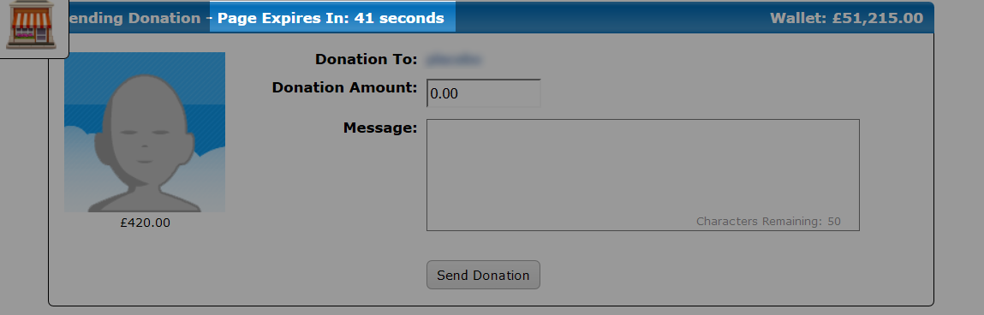
It's not perfect, but it helps.

Owner Data

Owner data is key data that is on the page that is owned by that user viewing the page. This also has the same problem as user to user. If the user opens multiple tabs on the forum and performs actions in one tab that would modify the key data, then all the other tabs will have stale data. If the user was then to use one of the other tabs, then they will be updating their key with stale data and lose anything from other tabs that may have more recent data in the key.

You could use the same solution to the user to user problem. But timing out a feature for the user who owns that data, is not a great solution.

Syncing Owner Data

Wouldn't it be great if we could synchronise the key data between multiple open tabs / windows that are opened for the forum? In this way, any key data that is changed in one tab will get copied to all the other tabs. And if the user was then to switch to another tab, it will have the latest key data available. This is a great way to prevent stale data for the user, and is something that I have used myself.

Unfortunately there is no simple JavaScript call to sync the data between all the open tabs that point to the same forum. We have to hack something together to do this for us. Luckily it's not that difficult to do.

Sync Class

The Sync class below comes from Yootil version 2. This class will help making syncing between tabs a lot easier.

https://github.com/PopThosePringles/ProBoards-Yootil/blob/version-2/src/sync.js

class Sync {

constructor({key = "", data = {}, handler = {}} = {}){
if(!key){
return;
}

this._trigger_caller = false;
this._change = (handler && handler.change)? handler.change : this.change;
this._key = key;
this._ls_key = key + "_data_sync_" + pb.data("user").id;

// Need to set the storage off the bat

localStorage.setItem(this._ls_key, JSON.stringify(data));

// Delay adding event (IE issues yet again)

setTimeout(() => $(window).on("storage", (evt) => {
if(evt && evt.originalEvent && evt.originalEvent.key == this._ls_key){

// IE fix

if(this._trigger_caller){
this._trigger_caller = false;
return;
}

let event = evt.originalEvent;
let old_data = event.oldValue;
let new_data = event.newValue;

// If old == new, don't do anything

if(old_data != new_data){
this._change.bind((handler && handler.change)? handler : this, JSON.parse(new_data), JSON.parse(old_data))();
}
}
}), 100);
}

// For outside calls to trigger a manual update

update(data = {}){
this._trigger_caller = true;
localStorage.setItem(this._ls_key, JSON.stringify(data));
}

change(new_data, old_data){
let internal_key_data = proboards.plugin.keys.data[this._key];

if(internal_key_data){
internal_key_data[pb.data("user").id] = new_data;
}
}

get key(){
return this._key;
}

get local_key(){
return this._ls_key;
}

};

This class will handle syncing the data between the tabs. Each tab will listen for the storage event and update the key with the new data. This update of the key is a swap, so we aren't performing an actual normal key update. When the user switches to another tab, the data will all be in sync.

To use the Sync class, we need to create an instance of it.

let my_key = pb.plugin.key("syncing_test");
let sync = new Sync({

key: syncing_test,
data: my_key.get(pb.data("user").id)

});

The parameter of the Sync class is an Object containing a few options.

- key
The key that will be synced.
- data
The data from the key. This gets set right away in localStorage on each page load.
- handler
An Object or Class to handle overwriting certain methods. Currently, there is only one method to overwrite called change. You would overwrite this method if you need to do any DOM manipulating on other tabs that get synced to. You will also need to handle the key update here (see the change method in the Sync class).

sync.update(my_key.get());

Finally, to actually trigger the sync, we call the update method and pass in the data that we want to sync. This call would generally be added to places where you are updating the key on the page, as that is when it makes sense to sync the new key data to all the other tabs. Those tabs will be listening. And when it hears it, it will update the data sitting on their page.

Route Caching

A quick tip for an issue that you may come across.

If you need to check the route much later on in your code, then make sure to check against a cached version of the route. The reason for this, is that any AJAX call (e.g., liking a post) will override the previous route and possibly change it.

It is a good idea to cache it in your plugin as soon as you can.

let route_name = pb.data("route").name;

ProBoards JavaScript Style

Most plugin authors write code differently to each other. Some have easy to read code, some have ugly code that is hard to follow that no one will want to touch. Following a common style can help you and other plugin authors to read and understand your code, as well as help avoid bugs.

ProBoards uses a popular style amongst the JavaScript community that was released by AirBnB back in 2012. The AirBnB style guide cover every aspect of JavaScript.

You aren't forced to adopt a different style, however I would definitely consider taking a look, as there is some good practices to follow. I myself do not follow everything in the guide below, and the keyword here is "guide", it's not a requirement that you follow it to the letter.

https://github.com/ProBoards/javascript

Conclusion

I hope I have succeeded in making the process of creating plugins more easily understood. And I hope it inspires many of you to come up with a plugin idea, and to bring that idea to life for the community to enjoy.

Wishing you all the best in your endeavors,

Peter

